Cardiff University
School of Medicine

Dissertation project for the award of Master of Science (MSc) Degree in Pain Management

The association between lumbar MRI exposure and pain interference and pain self-efficacy in adults with chronic non-specific low back pain who did not respond to pain education:
a cohort study

Module Code: 24/25-MET131R Student Number: 22102695

Word count: 21,147

DECLARATION

This work has not previously been accepted in substance for any degree and is not concurrently submitted in candidature for any degree.
Signed …… ..… (candidate) Date ……1.2.2026………

STATEMENT 1
This thesis is being submitted in partial fulfilment of the requirements for the degree of MSc in Pain Management
Signed ………… (candidate) Date ……1.2.2026………

STATEMENT 2
This thesis is the result of my own independent work/investigation, except where otherwise stated. Other sources are acknowledged by explicit references.
Signed …………… (candidate) Date ………1.2.2026………

STATEMENT 3
I hereby give consent for my thesis, if accepted, to be available for photocopying and for inter-library loan, and for the title and summary to be made available to outside organisations.
Signed ……………… (candidate) Date …...1.2.2026……

STATEMENT 4: PREVIOUSLY APPROVED BAR ON ACCESS
I hereby give consent for my thesis, if accepted, to be available for photocopying and for inter-library loans after expiry of a bar on access previously approved by the Graduate Development Committee.
Signed ……………… (candidate) Date ……1.2.2026………
ACADEMIC INTEGRITY COVER SHEET

Assignment Title:
The association between lumbar MRI exposure and pain interference and pain self-efficacy in adults with chronic non-specific low back pain who did not respond to pain education:
a cohort study
Module Code and Title:
24/25-MET131 Dissertation: Pain Management
Word Count:
21,147
Date Submitted:
8/2/2026

PRIOR TO SUBMITTING YOUR ASSIGNMENT YOU MUST READ, UNDERSTAND AND AGREE TO THE DECLARATIONS LISTED BELOW.

I declare that:
- I have received, read, and understood the documentation from Cardiff University including the required course on plagiarism and unfair practice and understand the nature and consequences of plagiarism and unfair practice.
- The work submitted is my own work and written in my own words, except where explicitly stated otherwise.
- All images used are my own, or the owner of the image is appropriately acknowledged.
- Any text that I have paraphrased/summarised or copied is correctly cited.
- I have cited and referenced all my sources correctly and accurately using the style recommended in the handbook/by the course.
- I have not submitted any part of this work before (including submissions to Cardiff University, or any other institution or journal at any time in the past).
- I have acknowledged all collaborations and explicitly identified the extent of my own role in these.
- I am aware that any submissions I upload may be scanned by software to detect instances of plagiarism.
- I have only used computers/devices with up-to-date protection software so that file(s) I submit are to the best of my knowledge free from viruses and other malware.
- I have made a true and accurate ‘Student Declaration of the Use of Gen AI Tools in Assessment’ below.

By typing your student number in the box below, you declare that all the above statements are true.

Student Number: | 22102695
GenAI Part 1:
Student Declaration of the Use of GenAI Tools in Assessment

Please tick the appropriate ‘use of GenAI’ declarations and provide all relevant information in relation to how you have completed your assessment.

EITHER (“✓” or “X”):
I declare that this work is entirely my own and no part of it has been produced, generated or supported using Generative AI tools.
If ticking the above box, GenAI Part 2 is not required and please proceed to your assignment below. However, please read the sections below carefully to ensure that your declaration is accurate.

OR (“✓” or “X”) (if you have used ANY GenAI, you must complete all sections below in both GenAI Part 1 and GenAI Part 2 to be considered a valid submission):

I declare that:  - I have used Generative AI software to support me in producing parts of this work. I have used Gen AI in line with the usage defined by the assessment guidance and have maintained academic integrity throughout my work.  - I have rewritten any Gen AI content in my own words and validated it using reliable independent sources.  - I understand that if I have used Gen AI tools within or for any part of this submission, I am required to clearly disclose the nature and extent of their use (below and in GenAI Part 2). | ✓
Failure to declare the use of AI tools may be considered a breach of academic or professional integrity and may be treated as unfair practice, subject to investigation and potential disciplinary action.

AND I acknowledge my use of Gen AI tools to ...
(please tick all that apply and then provide details in the table below):

- Generate initial ideas or structures, to help understand core concepts or other preparatory activities: | X
Detail:
- Generate other aspects of the assignment: | ✓
Detail: Used sparingly to improve the clarity of sentences I had already written (including grammar and punctuation corrections). No new ideas generated.
You MUST now include your GenAI outputs in GenAI Part 2 and full outputs as an Appendix to the assignment.
GenAI Part 2:
Documenting your use of GenAI

When you have used GenAI, it is your responsibility to retain copies of all GenAI prompts and outputs after submission in case of any academic misconduct concern. You may be asked to produce these as evidence of how you have used Gen AI as part or any investigation into academic misconduct. You may also wish to retain a ‘Track Changes’ version of your work to show how you have developed your work.
Please provide further details below…

Please provide the following details if you have used Gen AI tools in this assignment:
Which generative AI tool did you use (name and version) | Copilot
What did you use the tool for? | I used AI sparingly to check sentence structure and improve clarity, grammar, and academic tone in sentences I had already written.
What prompts did you provide? | “Is this sentence structure appropriate for academic writing?”
Include a short summary of the output here. (In addition to providing a full output as an appendix or uploaded as a separate document as per programme instructions – NB most programmes require a single document only is uploaded). | The tool provided minor suggestions to improve sentence clarity and flow, such as adjusting word order or removing redundancy. No new content, ideas, or references were introduced.
How have you used or changed the generative AI’s output? | All AI suggestions were selectively applied. Where changes were made, wording was rewritten in my own words, and all content remained my own.

Thank you for providing all the above information in compliance with academic expectations.
You should refer to your programme documentation or discuss with your tutors or programme director regarding the extent to which Gen AI is allowable and/or is helpful for each specific assignment.

Acknowledgements and Reflections

I would like to express my sincere gratitude to my dissertation supervisor, Sharon Norman, for her advice and guidance throughout this dissertation module. Her encouragement to challenge myself was fundamental when deciding to take on a research project, and whilst at times it has been hard, I am now incredibly happy to have taken this path.

The last few years studying have been memorable in so many ways. From moving house, to spending time in Norway, to playing football in the garden, to building fires and surfing at Splash. Life is indeed what happens to you while you’re busy making other plans; and writing this reflection has made me realise the importance of being present and mindful.

I would like to thank my wife, Hannah. My immobility to spell and gasp the rules of England gamma has, made checking my work challenging :) To Louis and Neve, we are so proud of the kind and caring individuals that you are. Your willingness to be involved in all aspects of home, school, sport and life in general has inspired me to make the most of every opportunity.

On completing this research study I sit with a smile, knowing that my academic ambitions have far exceeded my talent. My wish is to remain curious and not judgemental in all aspects of life, work, and research. I hope that by submitting this research study it proves to Louis and Neve that hard work beats talent, especially when talent doesn’t work hard.

Last but not least, I would like to thank my wonderful work colleagues; it has been emotional.
SUMMARY

BACKGROUND: Clinical guidelines advise against routine lumbar MRI for chronic non-specific low back pain (CNSLBP) due to limited diagnostic utility and potential psychosocial harm. However, patients frequently seek imaging for reassurance, particularly when first-line guideline-recommended pain education (PE) has not produced meaningful benefit.

AIMS: To explore whether MRI, delivered with clinically framed reporting and multimodal communication, is associated with changes in pain interference and pain self-efficacy in adults with CNSLBP who did not demonstrate a clinically meaningful response to PE.

METHOD: A prospective within-participant observational study was conducted within a specialist spinal service. MRI exposure was conceptualised as a communication process incorporating pre-MRI education and verbal, visual, and written explanation of findings. Adults with CNSLBP who completed PE without clinically meaningful improvement were included. Outcomes were collected pre-PE (Stage 1), post-PE (Stage 2; analytic baseline), and post-MRI communication (Stage 3). Primary outcomes were the Pain Interference Questionnaire (PIQ) and the Pain Self-Efficacy Questionnaire (PSEQ); secondary outcomes included the Pain Severity Questionnaire (PSQ) and global perceived change.

RESULTS: Fourteen participants completed all stages with no missing data. Following MRI communication, PIQ scores improved by −18.79 (95% CI −29.87 to −7.70; p=0.003; dz=0.98) and PSEQ scores improved by +17.93 (95% CI 6.03 to 29.83; p=0.007; dz=0.87). Most participants exceeded clinically important improvement thresholds for PIQ (78.5%) and PSEQ (64.3%). Pain severity showed modest, statistically uncertain change (−4.64; p=0.096). Improvements in self-efficacy were inversely associated with reductions in pain interference.

CONCLUSION: In adults with CNSLBP who had not responded to first-line PE, MRI delivered with clinically framed, multimodal communication was associated with improved function and confidence despite minimal change in pain severity. The findings suggest that the psychosocial impact of MRI is context dependent and that MRI may function as a secondary reassurance intervention for selected PE non-responders. Given the observational design, causal inference is limited.

CONTENTS
Page
Title ........................................................................................................................ 1
Declaration Statements .................................................................................... 2
Academic Integrity Cover Sheet ........................................................................ 3
Acknowledgements and Reflections ........................................................................ 6
Summary ............................................................................................................ 7
Contents ............................................................................................................ 8
List of Tables ............................................................................................................ 12
List of Figures ............................................................................................................ 13
Abbreviations ............................................................................................................ 14

CHAPTER 1: INTRODUCTION ............................................................................... 16
1.1: Aims, Objectives and Hypothesis ................................................ 23
1.2: Search Strategy ........................................................................ 26

CHAPTER 2: LITERATURE REVIEW .................................................................... 29
2.1: Introduction .................................................................................... 29
2.2: Systematic Review Study Design ................................................ 30
2.2.1: Witherow et al. (2022): Theme 2 .................................... 31
2.2.2: Shraim et al. (2021): Theme 1 ................................................ 37
2.3: Randomised controlled trial study design .................................... 40
2.3.1: Rajasekaran et al. (2021): Theme 2 .................................... 42
2.4: Observational Study Design ............................................................ 48
2.4.1: Jenkins et al. (2021): Theme 1 ................................................ 50
2.4.2: Sajid et al. (2021): Theme 1.................................................... 54
2.4.3: Jacobs et al. (2020): Theme 1 ................................................ 57
2.5: Qualitative Study Design ............................................................ 61
2.5.1: Lullo et al. (2025): Theme 3 ................................................ 63
2.5.2: Andersen et al. (2025): Theme 3 .................................... 66
2.5.3: Rizzo et al. (2024): Theme 3 ................................................ 70
2.5.4: Alhowimel et al. (2022): Theme 3 .................................... 73
2.6: Summary of Literature Review ................................................ 76

CHAPTER 3: METHODOLOGY ..................................................................... 78
3.1: Research Aims ..................................................................................... 78
3.2: Statement of Problem ......................................................................... 78
3.3: Broad Research Approach ............................................................. 80
3.3.1: Study Setting and Triage Process .................................... 82
3.3.2: Spinal Health Course (SHC) ................................................ 82
3.3.3: Research pathway pre-MRI (Phase 1) .................................... 83
3.3.4: Research pathway post-MRI (Phase 2) ........................ 83
3.3.5: Stages of data collection ................................................ 84
3.4: Sample and Sampling Method ................................................ 87
3.5: Data Collection Tools ....................................................................... 90
3.5.1: Pain Severity Questionnaire ................................................ 91
3.5.2: Pain Interference Questionnaire .................................... 92
3.5.3: Pain Self-Efficacy Questionnaire .................................... 92
3.5.4: Patient Global Impression of Change scale ........................ 93
3.5.5: Additional Data Collection ................................................ 93
3.5.6: Mode of Data Collection ................................................ 94
3.6: Sample Size and Pragmatic Power ................................................ 96
3.7: Statistical Analysis ......................................................................... 97
3.8: Ethical Considerations ............................................................. 99

CHAPTER 4: RESULTS ........................................................................................... 101
4.1: Participant flow between Phase 1 and Phase 2 .......................... 101
4.1.1: Sample Characteristics and trends ...................................... 104
4.2: Patient Reported Outcome Measures (PROMs) ........................... 105
4.2.1: Changes between post-SHC (Stage 2) & post-MRI (Stage 3) ... 106
4.2.2: Pain Severity (PSQ) .............................................................. 107
4.2.3: Pain Interference (PIQ) .................................................. 108
4.2.4: Pain Self-Efficacy (PSEQ) .................................................. 111
4.2.5: Patient Global Impression of Change (PGI-C) .......................... 112

CHAPTER 5: DISCUSSION .................................................................................. 114
5.1: Overview of key findings ............................................................... 114
5.2: Interpretation of findings ............................................................... 115
5.3: Comparison with existing literature ................................................... 118
5.4: Clinical implications ........................................................................... 120
5.4.1: Individual clinician level implications ....................................... 120
5.4.2: Service and pathway level implications ........................... 121
5.4.3: Ethical and Guideline implications ....................................... 123
5.4.4: Summary of Clinical implications ....................................... 125
5.5: Strengths ....................................................................................... 126
5.6: Limitations ....................................................................................... 127
5.7: Implications for future research ................................................... 129

CHAPTER 6: CONCLUSION ................................................................................... 131

REFERENCES .......................................................................................................... 133

APPENDIX

- A: Spinal Assessment Service information and data:
    - SAS mission statement
    - SAS referral pathway
    - Spinal Health Course (SHC) patient information
    - Audit data; BPI (PSQ & PIQ) & PSEQ pre & post SHC attendance (2022)
    - SAS exclusion criteria for attendance on the SHC
    - Rockwood Frailty Scale
    - Standard SAS clinical pathway for patients with CNSLBP
- B: Extracts from National Guidelines:
    - NICE Guidelines (updated 2020); LBP & Imaging recommendations
    - LBP: Clinical Standard Care. Australian Commission, (2022).
    - Red Flags Symptoms and Signs (NICE LBP guidelines, updated 2024)
- C: Data Collection Tools (Patient Reported Outcome Measures):
    - Brief Pain Inventory Pain Severity & Pain Interference Questionnaire
    - Pain Self-Efficacy Questionnaire (with scoring table)
    - Patients’ Global Impression of Change Scale
- D: Clinic Letter examples:
    - MRI clinical report (cc patient); alongside corresponding image report
    - CLBP: Initial assessment clinic letter (cc patient)
    - Letter on completion of SHC: MRI information (cc patient)
    - Letter following MRI explanation to patient (cc patient)
- E: Participant information and forms:
    - Demographic data
    - Letter of invitation to Participants
    - Participant consent form
    - Body Chart
- F: Participant MRI information:
    - Contraindications and cautions for undergoing MRI
    - Patient information leaflets
    - Patient checklist
- G: Ethical Approval Documents:
    - Research Ethical Review Application
    - Research Ethics Committee; favourable outcome letter (conditional)
    - Research Ethics Committee; evidence of condition approval
    - Research Integrity test: evidence of achieving a pass (>80%)
- H: Data Collection:
    - Checklist for participation in study
    - Participant Demographic Data
    - Raw data collected PSQ, PIQ PSEQ
    - Raw data collected PGI-C
    - Scatterplots: participant demographics and PIQ or PSEQ scores
    - Shapiro–Wilk normality test results (Change Scores: Stage 2 - Stage 3)

LIST OF TABLES

Table 1: SAS data on patient case load and diagnosis (2022-2024) .................................... 17
Table 2: Characteristics of affective, cognitive and experimental reassurance ............ 18
Table 3: IASP recommended messages for back pain education (IASP, 2021) ............ 19
Table 4: SAS referral rates for a spinal MRI (2022-2024) ................................................ 20
Table 5: Image reporting compared with clinical reporting ................................................ 22
Table 6: Problem, Exposure, Comparison, Outcome (PECO) ................................................ 24
Table 7: Database search strategy and screening steps ................................................ 26
Table 8: Spinal related leg pain as defined by the NeuPSIG; Schmid et al. (2023) ............ 27
Table 9: Themes used to structure the literature review ................................................ 29
Table 10: Overview of included systematic reviews ............................................................ 32
Table 11: Overview of included randomised controlled trial (RCT) .................................... 41
Table 12: Overview of included observational studies ................................................ 49
Table 13: Unadjusted/adjusted outcomes by imaging status (Jenkins et al., 2021) ............ 52
Table 14: Adjusted downstream outcomes associated with MRI (Jacobs et al., 2020) ........ 59
Table 15: Overview of included qualitative studies ........................................................... 62
Table 16: Psychosocial themes identified by Alhowimel et al. (2020) ....................... 75
Table 17: Key evidence gaps and how the present study addresses them ....................... 80
Table 18: Educational content of the SAS Spinal Health Course ................................... 83
Table 19: Phase 1: standard clinical care ....................................................................... 85
Table 20: Phase 2: research exposure ....................................................................... 86
Table 21: Inclusion criteria .............................................................................................. 88
Table 22: Exclusion criteria .............................................................................................. 89
Table 23: Patient screening and flow through the standard SAS Pathway (Phase 1) ........ 100
Table 24: Reasons for non-enrolment onto the Spinal Health Course (CNSLBP cohort) ...... 101
Table 25: Demographic and clinical characteristics of the study sample ..................... 103
Table 26: PROMs for each stage of data collection ......................................................... 104
Table 27: Summary of changes in PROMs between Stage 2 and Stage 3 ..................... 105

LIST OF FIGURES

Figure 1: Common terminology used in research to describe spinal related leg pain ....... 27
Figure 2: PRISMA flowchart detailing the pathway for identifying articles ......................... 28
Figure 3: Research pathway timeline and associated data collection: Stages 1 – 3 .............. 81
Figure 4: Application of inclusion and exclusion criteria for Phase 2 ..................................... 102
Figure 5: Individual PSQ trajectories across Stages 1–3 (spaghetti plot) ...................... 106
Figure 6: Distribution of PSQ scores across Stages 1–3 (box plot) .................................. 107
Figure 7: Individual PIQ trajectories from Stage 2 to Stage 3 (spaghetti plot) .......... 108
Figure 8: Distribution of PIQ scores at Stages 2 and 3 (box plot) .................................. 108
Figure 9: Change in PSEQ vs change in PIQ between Stage 2 and Stage 3 (scatterplot) ....... 109
Figure 10: Individual PSEQ trajectories from Stage 2 to Stage 3 (spaghetti plot) .......... 110
Figure 11: Distribution of PSEQ scores at Stages 2 and 3 (box plot) .................................. 111
Figure 12: Distribution of Patient Global Impression of Change (PGI-C) scores .......... 112

ABBREVIATIONS

ACSQHC: Australian Commission on Safety and Quality in Health Care
BMI: Body Mass Index
BPI: Brief Pain Inventory
BPS: British Pain Society
CASP: Critical Appraisal Skills Programme
CEM: Coarsened Exact Matching
CES: Cauda Equina Syndrome
CI: Confidence Interval
CLBP: Chronic Low Back Pain
CNSLBP: Chronic Non-Specific Low Back Pain
CONSORT: Consolidated Standards of Reporting Trials
CPMP: Chronic Primary Musculoskeletal Pain
EBP: Evidence Based Practice
EPOC: Cochrane Effective Practice and Organisation of Care
GP: General Practitioner
GRADE: Grading of Recommendations Assessment, Development and Evaluation
IASP: International Association for the Study of Pain
ICD-11: International Classification of Diseases 11
IMMPACT: Initiative on Methods, Measurement, and Pain Assessment in Clinical Trials
LBP: Low back pain
LoD: Length of Disability
MCID: Minimum Clinically Important Difference
MDT: Multidisciplinary team
MRI: Magnetic Resonance Imaging
MSK: Musculoskeletal
NeuPSIG: Neuropathic Pain Special Interest Group
NHS: National Health Service
NOS: Newcastle–Ottawa Scale
NSLBP: Non-Specific Low Back Pain
NSSP: Non-Specific Spinal Pain
NICE: National Institute for Health and Care Excellence
PE: Pain education
PECO: Problem, Exposure, Comparison, Outcome
PI: Pain Interference
PIQ: Pain Interference Questionnaire
PGI-C: Patient Global Impression of Change
PMP: Pain Management Programme
PRISMA: Preferred Reporting Items for Systematic Reviews and Meta-Analyses
PROMs: Patient-Reported Outcome Measures
PROSPERO: Prospective Register for Systematic Reviews
PSE: Pain Self-Efficacy
PSQ: Pain Severity Questionnaire
PSEQ: Pain Self-Efficacy Questionnaire
QoL: Quality of Life
RCT: Randomised Controlled Trial
RoB: Risk of Bias
SAS: Spinal Assessment Service
SD: Standard Deviation
SR: Systematic Review
SSP: Serious Spinal Pathology
STROBE: Strengthening the Reporting of Observational Studies in Epidemiology
SHC: Spinal Health Course
UK: United Kingdom
USA: United States of America
WHO: World Health Organization
WMA: World Medical Association
VAS: Visual Analogue Scale

CHAPTER 1: INTRODUCTION

Chronic low back pain (CLBP) is the leading global cause of years lived with disability and is associated with a substantial personal, societal, and economic burden (Ward & Goldie, 2024). The Global Burden of Disease Study (2021) estimates that low back pain (LBP) affects approximately 7.5% of the global population (Ward & Goldie, 2024). Of those presenting with LBP, the International Association for the Study of Pain (IASP) reports that approximately 85–95% do not have a specific identifiable pathoanatomical cause for their pain (IASP, 2021).

The National Institute for Health and Care Excellence (NICE) defines LBP that cannot be attributed to a recognisable pathology as non-specific low back pain (NSLBP) (NICE, NG59, updated 2020). NSLBP is widely recognised as a multifactorial condition influenced by a combination of physical, psychological and social factors (Holopainen et al., 2021). In this dissertation, the population of interest is adults with chronic non-specific low back pain (CNSLBP) managed within a specialist spinal service.

The author of this dissertation is employed as a physiotherapist within the Spinal Assessment Service (SAS). The SAS is a multidisciplinary team (MDT) with clinical staff consisting of pain specialist doctors, nurses, physiotherapists, occupational therapists, and psychologists. The SAS mission statement can be found in Appendix A1. In accordance with the SAS referral pathway (Appendix A2), all patients presenting at initial assessment report spinal pain of greater than three months’ duration and therefore meet the International Classification of Diseases 11th Revision (ICD-11) definition of chronic pain as defined by the World Health Organization (WHO). Table 1 presents SAS caseload and diagnostic data from 2022-2024, with NSLBP being the most commonly seen condition.

Table 1: SAS data on patient caseload and diagnosis (2022-2024)
Year | 2024 | 2023 | 2022
Patients seen (n) | 2,483 | 2,248 | 2,210
 | % total | % total | % total
Non-specific low back pain | 31% | 29% | 32%
Non-specific neck pain | 7% | 7% | 8%
Thoracic | 2% | 4% | 2%
Lumbar radicular pain / radiculopathy | 22% | 23% | 21%
Cervical radicular pain / radiculopathy | 6% | 6% | 6%
Serious Spinal Pathology | 1% | 1% | 1%
Multiple sites | 11% | 12% | 9%
Widespread persistent pain | 5% | 4% | 5%
Stenosis | 3% | 2% | 1%
Fracture | 3% | 3% | 1%
Surgery | 3% | 4% | 2%
Other | 7% | 6% | 5%

NICE guidelines (NG59, updated 2020) recommend education as a core component of care for LBP, with reassurance identified as a central element of management (Guideline 1.2.1; Appendix B1). Similarly, the Australian Clinical Standards of Care (ACSQHC) for LBP identify reassurance as a core feature of management for NSLBP (ACSQHC, 2022; Standard 4, Appendix B2). Within pain education (PE), reassurance typically targets beliefs about structural safety, with the aim being to address unhelpful beliefs and promote physical activity as being safe and beneficial for recovery (IASP, 2021; Moseley et al., 2024).
Shavit et al. (2025) propose that reassurance within LBP consultations comprises affective, cognitive, and experimental components (Table 2). This framework is clinically relevant given that individuals with CNSLBP frequently report fear of serious underlying pathology or misdiagnosis (Mintz et al., 2020), and such fears are known to negatively influence pain-related outcomes (Doménech-Fernández et al., 2025). Accordingly, cognitive reassurance delivered through PE is positioned within clinical guidance as a key mechanism for addressing fear and unhelpful beliefs. However, evidence suggests that PE alone may not fully address reassurance needs for all individuals with CNSLBP (Wood & Hendrick, 2019; Rizzo et al., 2024).

Table 2: Characteristics of affective, cognitive & experimental reassurance (Shavit et al. 2025)
Characteristic | Affective Reassurance | Cognitive Reassurance | Experimental Reassurance
Focus | Emotional support and therapeutic alliance | Information provision and belief change | Functional experience and behavioural change
Mode of delivery | Empathic listening and patient-centred communication | Education, explanation, and reframing of unhelpful beliefs* | Supervised, individualised functional movement and practice*
Intended effect | Reduced anxiety and increased trust | Improved understanding and empowerment* | Increased confidence and functional self-efficacy*

* Aligns with SAS mission statement (Appendix A1)

Within the SAS, cognitive reassurance for individuals with CNSLBP is delivered through the Spinal Health Course (SHC) (Appendix A3). The SHC aligns with the IASP “Back Pain Education Recommendations” (IASP, 2021), which are summarised in Table 3. Despite guideline endorsement of PE as a first-line reassurance strategy, audit data from the SHC (Appendix A4), alongside published research, indicate that PE does not consistently result in improved outcomes (Wood & Hendrick, 2019; Shin et al., 2023; Rizzo et al., 2024). Consequently, a subgroup of individuals with CNSLBP may continue to experience uncertainty or perceived invalidation despite completing guideline-consistent PE.
IASP Recommended Education Message | Purpose and Rationale
Reassure individuals about the non-life-threatening but recurrent nature of LBP. | Reduces fear and catastrophic beliefs, thereby promoting confidence and self-management.
Encourage individuals to remain active and resume usual activities despite pain. | Supports functional recovery and helps to prevent deconditioning.
Assess and address misconceptions about LBP. | Corrects unhelpful beliefs associated with persistent pain and disability.
Explain why imaging may not be required. | Prevents misinterpretation of incidental findings and helps to reduce fear related behaviours.
Inform individuals about evidence-based options for back pain management. | Encourages informed decision-making, improves health literacy and increases internal locus of control.
Table 3: IASP recommended messages for back pain education (adapted from IASP, 2021)

Imaging has been proposed as an alternative means of providing reassurance for individuals with CNSLBP (Andersen et al., 2025; Lullo et al., 2025; Cox et al., 2020). However, this approach remains contentious due to associations with increased healthcare utilisation and prolonged disability (Jacobs et al., 2020; Shraim et al., 2021; Hall et al., 2021; Jenkins et al., 2022). Accordingly, NICE recommends that imaging be reserved for situations in which results are likely to change management (NICE, NG59, updated 2020).

Evidence-based practice (EBP) integrates research evidence with clinical expertise and patient values to inform individualised care decisions (Tringale et al., 2022). Despite guidance discouraging routine imaging for CNSLBP (NICE NG59, updated 2020), patients attending the SAS frequently express an expectation of further radiological investigation. This is reflected both in local patient co-design events and in wider evidence, with Farmer et al. (2024) reporting that 71% of patients attending a specialist spinal clinic expected a referral for imaging.
As a specialist spinal service, the SAS refers approximately 25% of patients for a spinal MRI (Table 4), highlighting a gap between patient expectations, guideline recommendations, and clinical delivery. In line with NICE guidance on shared decision making (NICE NG197, 2021) decisions regarding imaging should balance best available evidence with patient values and preferences, with explicit discussion of potential benefits, harms, and alternatives. Clinicians must therefore contextualise evidence in relation to patient expectations while considering whether imaging is safe, ethical, and cost-effective in selected circumstances. Clinically, addressing imaging expectations may also influence patient satisfaction and adherence to guideline-recommended care (Vroom, 1964; Rossettini et al., 2018; Zhou et al., 2024).

Table 4: SAS referral rates for a spinal MRI (2022-2024)
Year |  | 2024 | 2023 | 2022
Patients seen (n) |  | 2,483 | 2,248 | 2,210
 |  | % of total | % of total | % of total
Reason for MRI referral | Suspected serious spinal pathology (SSP):  To assess for sinister pathology. | 5% (n=123) | 3% (n=68) | 3% (n=65)
Reason for MRI referral | Suspected radicular pain / radiculopathy:  To plan for elective medical interventions. | 21% (n=515) | 19% (n=427) | 20% (n=442)
Reason for MRI referral | Routine: Non-Specific Spinal Pain (NSSP)  To assist with behavioural change | 2.1% (n=51) | 3.2% (n=68) | 1.8 % (n= 37)
Total as a % |  | 28% | 25% | 25%

MRI is commonly used when the clinical aim is to identify a structural contributor to spinal pain (Kim et al., 2020). However, evidence indicates that many findings identified on a lumbar MRI have little or no association with reported levels of LBP (Kasch et al., 2022). For example, Brinjikji et al. (2015) reported radiological evidence of facet degeneration in approximately half of the asymptomatic 60-year-olds, highlighting that many degenerative features reflect normal ageing rather than pain-generating pathology.
Despite the limited diagnostic specificity, MRI requests for CNSLBP remain common (Pike et al., 2022). This overuse has been attributed to multiple factors, including defensive medicine, system-level barriers to implementing EBP, and concerns about negatively impacting the therapeutic alliance (Cormier et al., 2024).

Reflecting these diagnostic challenges, NICE defines LBP without a recognisable pathology as NSLBP (NICE, NG59, updated 2020), while the IASP classifies persistent spinal pain lasting longer than three months, associated with emotional distress and/or functional impairment and not attributed to a known pathology, as Chronic Primary Musculoskeletal Pain (CPMP) within the ICD-11 framework (IASP, 2021). Both CNSLBP and CPMP are diagnoses of exclusion that some patients may perceive as invalidating, potentially contributing to further healthcare seeking, including requests for imaging (O’Keeffe et al., 2022).

Given the high prevalence of incidental and potentially false-positive findings on a lumbar MRI (Brinjikji et al., 2015; Han et al., 2022; Balza et al., 2024; Kasch et al., 2022), clinical contextualisation of imaging results is essential. Evidence suggests this is best achieved through reassurance-based clinical reporting, in which image findings are interpreted alongside the patient’s clinical history and presentation, rather than through factual image reporting alone (Rajasekaran et al., 2021; Alhowimel et al., 2020). Key differences between image reporting and clinical reporting are outlined in Table 5.

Table 5: Image reporting compared with clinical reporting
 | Image Reporting | Clinical Reporting
What | Anatomical description of a radiological study (MRI, CT, X-ray) | Interpretation of imaging findings in conjunction with the patient’s clinical history and presentation
Who | Radiologist | Radiologist, referring clinician and any healthcare professional involved in the patient’s care
Why | To describe imaging findings  and support diagnosis | To determine the clinical relevance of  imaging findings for the individual patient

Note: adapted from qualitative and experimental literature on imaging communication and reporting (Alhowimel et al., 2020; Rajasekaran et al., 2021; Farmer et al., 2022).

Qualitative research indicates that individuals with CNSLBP may interpret MRI findings as validation that their pain is “real” (Lullo et al., 2025). Validation is recognised as a fundamental psychological need among LBP populations (O’Hagan et al., 2023). Accordingly, the language used when explaining MRI findings must sensitively communicate the complex relationship between structural findings and pain, avoiding inadvertent dismissal or reinforcement of structural threat.

For this reason, the present study conceptualises an MRI as a psychosocial communication exposure rather than solely as a diagnostic test. Despite guidelines cautioning against routine imaging, uncertainty remains as to whether undergoing MRI, when delivered after PE and communicated using clinical reporting principles, may provide meaningful reassurance for selected PE non-responders.

The British Pain Society (BPS) emphasises that pain relief is not typically the primary aim of educational interventions; rather, the focus is on improving daily functioning without assuming that pain reduction is necessary for functional gain (BPS, 2021). A commonly cited rationale for MRI in CNSLBP is that it may provide cognitive reassurance (Andersen et al., 2025; Lullo et al., 2025; Cox et al., 2020), potentially influencing beliefs and confidence in a manner similar to PE. Consequently, evaluation of MRI in this population should prioritise outcomes aligned with reassurance-based mechanisms, such as function and self-efficacy, rather than pain intensity alone.

At present, there is no validated instrument specifically designed to directly measure reassurance following an intervention (Young et al., 2025; De Paepe et al., 2025). Accordingly, this study adopts pain interference (PI) and pain self-efficacy (PSE) as theoretically informed proxy outcomes through which reassurance-related change may be examined. The selection and application of these measures are described in the Methods chapter.

1.1: Aims, Objectives and Hypotheses:
Aims: To explore whether undergoing a lumbar MRI following completion of a spinal biopsychosocial education programme without clinically meaningful benefit is associated with changes in pain interference (PI) and pain self-efficacy (PSE) in adults with CNSLBP.

Objectives: To critically appraise the literature examining lumbar MRI communication, clinical reporting, and reassurance mechanisms in CNSLBP, in order to inform the methodological design and outcome selection of the present study.

Hypothesis: In adults with CNSLBP who do not demonstrate a clinically meaningful benefit to biopsychosocial pain education, exposure to a lumbar MRI, combined with clinically framed reporting, will be associated with reductions in PI and increases in PSE.

Null Hypothesis: In adults with CNSLBP who do not demonstrate a clinically meaningful response to biopsychosocial pain education, exposure to a lumbar MRI, combined with clinically framed reporting, will not be associated with reductions in PI and increases in PSE.

A problem, exposure, comparison, outcome (PECO) framework was used to formulate the research question (Table 6). PECO is recommended for exposure-based research designs as it helps to clearly define the population, exposure, comparison, and outcomes without implying the presence of an intervention (Morgan et al., 2018). This approach ensures that the research question appropriately reflects the non-interventional nature of the present study.

Table 6: Problem, Exposure, Comparison, Outcome (PECO)
Problem | Adults with chronic non-specific low back pain (CNSLBP) who have completed a biopsychosocial pain education programme without achieving a clinically meaningful benefit (non-responders) and are seeking further investigation in the form of a lumbar MRI.
Exposure | Exposure to a lumbar MRI following completion of biopsychosocial pain education, with post-imaging communication of findings delivered using clinically framed, multimodal reporting (verbal, visual, and written).
Comparison | Within participant pre and post exposure comparison, with participants acting as their own controls.
Outcome | Primary outcomes:  Pain Interference (Brief Pain Inventory; Pain Interference Questionnaire)  Pain Self-Efficacy (Pain Self-Efficacy Questionnaire)  Secondary outcomes:  Pain Severity (Brief Pain Inventory; Pain Severity Questionnaire)  Patient Global Impression of Change (PGI-C)
A literature search was conducted in accordance with the aims and objectives of this study (Table 7). A Preferred Reporting Items for Systematic Reviews and Meta-Analyses (PRISMA) flow diagram (Page et al., 2021) was used to illustrate how studies were identified, screened, excluded, and included (Figure 2). This enhances the transparency and replicability of the search process. Each included study was critically appraised using the appropriate Critical Appraisal Skills Programme (CASP) evaluation tool. The strength of evidence will be assessed using the Harbour and Miller (2001) Hierarchy of Evidence framework. In addition, the Grading of Recommendations Assessment Development and Evaluation (GRADE) framework will be considered to support interpretation of evidence quality and to contextualise how clinical recommendations, such as those underpinning NICE imaging guidance (NG59, updated 2020), are formulated.

1.2: Search Strategy:

Table 7: Database search strategy and screening steps
Search Strategy |  |  | Boolean operators used
Keywords | Imaging  terms | MRI  Magnetic resonance imaging  Radiology  Imaging | “OR” | “AND”
Keywords | Population  terms | Non-specific pain  Lumbar pain  Low back pain  Spinal pain  Chronic pain  Musculoskeletal pain | “OR” | “AND”
Keywords | Communication  terms | Reassurance  Clinical reporting  Image reporting  Communication | “OR” | “AND”
Inclusion criteria |  | 2020-current  All study designs eligible (qualitative and quantitative)  English  Humans  Adults (>18 years old)
Database results
  Database: | Results Found:
  Medline via Ovid | 97
  CINAHL | 43
  SCOPUS | 104
  Cochrane | 5
  Web of Science | 71
Screening process |  | Duplicates removed  Feasibility and pilot studies excluded  Letters, commentaries, and scoping reviews excluded  Terminology used in studies to describe spinal related leg pain excluded (Figure 1)  Reference lists of included studies were hand searched (backward chaining)  Cited work (forward chaining) was performed to identify additional relevant papers

In 2023, a working group commissioned by the Neuropathic Pain Special Interest Group (NeuPSIG) of the IASP proposed a revised classification framework for spinal-related leg and arm pain (Table 8) (Schmid et al., 2023). This work highlighted substantial inconsistency in terminology across research and clinical practice, with overlapping labels often used to describe distinct pain mechanisms (Figure 1).

To ensure that the present literature search focused specifically on CNSLBP, terminology corresponding to NeuPSIG-defined radicular and neuropathic subgroups was excluded during screening. This approach was used to improve conceptual clarity and reduce heterogeneity within the included evidence base.

Table 8: Spinal related leg pain as defined by the NeuPSIG; Schmid et al. (2023)
Terminology | Conceptual definition | Characteristics & Distribution
Somatic-referred pain | Pain referred from spinal or paraspinal structures without nerve root involvement | Non-dermatomal, poorly localised pain; dull or aching quality; no neurological deficits
Radicular pain (with or without radiculopathy) | Pain arising from irritation or dysfunction of a spinal nerve root, which may occur with or without objective neurological deficit | Radiating limb pain in a nerve-related distribution; may be sharp, electric, or shooting; sensory symptoms may be present
Radiculopathy | A lesion affecting a nerve root, associated with objective neurological impairment | Dermatomal sensory loss, myotomal weakness, or reflex changes; +/- pain

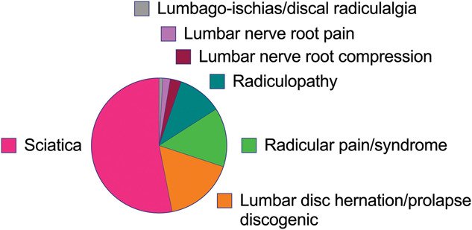
Figure 1: Terminology used in clinical trials to describe a population with
spinal related leg pain; figure reproduced from Schmid et al. (2023).
Figure 2: PRISMA flow diagram
Identification via other methods
Identification via databases

Records identified from citation searching
N=4
Records removed before screening
Duplicates (n=42)
Identification
Records Identified from databases

Medline via Ovid | 97
CINAHL | 43
SCOPUS | 104
Cochrane | 5
Web of Science | 71

Titles Screened
n= 278
Screening
Titles Screened
n= 4
Records excluded (n = 232)
Not relevant (n=221)
Feasibility study (n=5)
Scooping review (n-2)
Letter to editor (n=3)
Commentary (n=1)

Abstracts Screened
n= 46

Abstract Screened
n= 4

Abstracts Excluded (n = 30)
Not relevant (n=21)
Full article not available (n=2)
Did not meet inclusion criteria (n = 7)

Full text articles
assessed for eligibility
n= 16
Full text article
assessed for eligibility
n= 5
Total number of studies included
n=11
Studies included
n=9
Inclusion
Studies included
n=2
Full text articles excluded
Not relevant (n=2)
Full text articles excluded
Not relevant (n=7)
Studies including terms for spinal related leg pain (n=7)
CHAPTER 2: LITERATURE REVIEW

2.1: Introduction
The purpose of this chapter is to critically analyse and synthesise the literature on the value, risks, and clinical application of lumbar MRI exposure in CNSLBP populations. The strengths and limitations of the methods used within the literature will be examined to help inform the development of the research protocol for the present study.

Studies will be grouped by design and presented in order of hierarchical evidence. Within each design, evidence will be appraised through three themes relevant to the aims and objectives of this dissertation (Table 9): (1) harms and benefits of MRI in CNSLBP; (2) how MRI reporting and communication influence outcomes; and (3) why patients seek MRI, with emphasis on reassurance and perceived validation.

In keeping with the aims of this study, lumbar MRI is treated as a communication exposure rather than a diagnostic test. Accordingly, this review focuses on the psychosocial and behavioural implications of imaging in CNSLBP, informing both the outcome selection and methodological design of the present study.

Table 9: Themes used to structure the literature review
Description
Theme 1 | Harms and benefits associated with undergoing MRI for CNSLBP
Theme 2 | Influence of MRI communication and reporting on outcomes in CNSLBP
Theme 3 | Patient motivations for MRI in CNSLBP, with emphasis on reassurance
2.2: Systematic Review Study Design
Systematic reviews (SRs) aim to synthesise existing evidence by using transparent and reproducible methods (Higgins & Thomas, 2024). By employing structured search strategies and explicit eligibility criteria, SRs seek to minimise selection bias and reduce the risk of missing relevant studies. When conducted rigorously, SRs are considered high level evidence for informing clinical practice and guideline development (De Cassai et al., 2025).

SRs do not generate new empirical data; rather, their conclusions depend on the studies they synthesise. As such, SR findings are constrained by the quality of the evidence they include. Within SRs, publication bias can reduce credibility of findings, as studies reporting statistically significant or positive findings are more likely to be published than null or negative studies (Lunny et al., 2024). Other factors, such as heterogeneity in study populations, interventions, and outcome measures, can also limit quantitative synthesis and generalisability.

SRs by Witherow et al. (2022) and Shraim et al. (2021) were identified for inclusion in this literature review. To enhance transparency, both adhered to Preferred Reporting Items for Systematic Reviews and Meta-Analyses (PRISMA) guidance (Page et al., 2021), and included PRISMA flow diagrams documenting study identification, screening, exclusion, and inclusion. Both reviews were also prospectively registered on the Prospective Register of Systematic Reviews (PROSPERO), enhancing methodological and ethical rigour by reducing the risk of selective outcome reporting and unnecessary duplication of research (Booth et al., 2012). Table 10 summarises the populations, MRI exposures, outcomes, and key methodological limitations of the SRs included in this section.

In addition to methodological transparency, SRs must ensure ethical use of evidence, including appropriate attribution, transparency, and disclosure of conflicts of interest (Higgins & Thomas, 2024). Without such safeguards, SRs risk amplifying biased or ethically compromised evidence, undermining their role within EBP (Cumpston et al., 2022). In practice, this includes avoiding plagiarism, checking for retractions and appraisal of ethical oversight in included studies. Accordingly, ethical integrity is critically appraised in the studies reviewed in subsequent sections.

2.2.1: Witherow et al. (2022): Theme 2; Communicating and reporting an MRI in CNSLBP
Witherow et al. (2022) conducted a SR examining whether the communication, reporting, or reinterpretation of lumbar MRI findings influences patient outcomes. Meta-analysis was not performed due to substantial heterogeneity in study designs, interventions and outcome measures. As a consequence, statistical methods used to assess publication bias, such as funnel plots or Egger’s regression, could not be meaningfully applied, particularly as most comparisons were informed by single studies or very small samples. This limitation reduces the ability to determine the extent of publication bias and therefore lowers confidence in the certainty of the evidence.

Study | Review focus | Population | Included studies | Approximate sample size | MRI exposure | Outcomes assessed | Primary Outcome emphasis | Follow up duration | Key methodological limitations | Relevance to  present study
Witherow et al. (2022) | Impact of communication, reporting, and reinterpretation of a lumbar MRI | Acute, subacute, and CNSLBP | N = 7 | 416,000 total; majority from one dataset (239,000) | MRI report framing  post-MRI communication | Pain, disability, QoL, healthcare utilisation | Psychosocial and utilisation outcomes | Short (<3 months), intermediate (3–6 months), long (>6 months) | High heterogeneity; no meta-analysis; evidence dominated by one large dataset; absence of pre-MRI education studies | Supports conceptualising MRI as a communication exposure; highlights the absence of pre-MRI education studies and the need for reassurance-aligned outcomes
Shraim et al. (2021) | Early lumbar MRI impact on disability outcomes | Acute NSLBP (workers’ compensation cohorts) | N = 7 | 1,200 to >400,000 across cohorts | Early MRI (≤ 4–6 weeks) | Length of disability; work outcomes | Work disability duration | Up to 1 year | Non-randomised designs; residual confounding; occupational context limits generalisability | Contextualises potential harms of MRI exposure and supports harm-mitigation strategies when imaging occurs
Table 10: Overview of included systematic reviews

The SR by Witherow et al. (2022) pooled data from seven studies; however, most participants were derived from a single dataset (Table 10). Smaller trials contributed disproportionately to uncertainty, as limited sample sizes are associated with larger standard errors and wider confidence intervals (CI), thereby reducing precision and increasing the risk of Type II error. A 95% CI provides a plausible range for the true effect estimate; narrower intervals indicate greater precision, whereas wide intervals or intervals crossing the null indicate uncertainty in effect direction. Consequently, potentially meaningful effects of communication-based interventions may have remained undetected despite true underlying effects.

Witherow et al. (2022) conducted searches across major biomedical, psychological, and clinical trial databases, consistent with PRISMA recommendations (Page et al., 2021). Although citation tracking was performed, there was limited reporting of broader manual searching. Whilst not mandated by PRISMA, the absence of manual searching increases the possibility that relevant studies were missed. Witherow et al. (2022) did not apply language restrictions, which is consistent with PRISMA recommendations to avoid language bias. There were no date restrictions either. Both of these factors increase the chance of capturing all relevant studies and strengthen the rigour of the review.

Eligibility criteria were informed by Cochrane Effective Practice and Organisation of Care (EPOC) guidance, which is appropriate given that MRI communication and reporting represent service delivery and clinician behaviour interventions rather than a specific biomedical treatment (Cochrane EPOC Group, 2017). This is methodologically important as exposure to MRI reporting involves a complex multifactorial communication process, through which patient beliefs, expectations and behaviours may be influenced (O’Sullivan et al., 2018). This aligns closely with the objectives of this dissertation, in which the potential benefit or harm of MRI exposure is hypothesised to arise from communication and behavioural change, rather than diagnostic yield alone. However, because included studies varied in whether participants had acute, subacute, or chronic LBP, the applicability of these findings to a clearly defined CNSLBP population is uncertain.

Study selection and data extraction was undertaken independently by two reviewers, with disagreements resolved through discussion or third-party arbitration, thereby reducing selection bias. Data extraction was conducted using the Template for Intervention Description and Replication (TIDieR) checklist, which supports the quality of reporting and enhances the practical application of interventions in clinical settings (Hoffmann et al., 2014). Outcome data was extracted at short, intermediate, and long-term follow up. Due to CNSLBP often being managed over many years (IASP, 2021), knowing the longer-term impact of an intervention helps assist service design; particularly when considering cost implications.

Risk of Bias (RoB) was independently assessed using Cochrane RoB 2.0 for randomised studies and the Risk of Bias in Non-randomised Studies of Interventions (ROBINS-I) tool for non-randomised designs. Only one included study was judged to be at a low risk of bias; notably, this study had the largest sample size (n = 238,886), with three publications derived from the same dataset. Overall certainty of evidence was assessed using GRADE, with most outcomes downgraded for RoB, inconsistency, and imprecision. These downgrades have important implications for interpreting psychosocial outcomes, as small samples and the absence of meta-analysis increase the risk of Type II error, whereby meaningful effects may remain undetected. This limitation is particularly relevant for psychosocial outcomes, which typically demonstrate small-to-moderate effect sizes and therefore require larger samples for adequate statistical power (Cumming, 2014).

All included studies were conducted in the USA, Australia, or India. Differences in healthcare systems and socioeconomic context may limit transferability to other settings, including the SAS. This concern is supported by Shraim et al. (2021), who found substantial regional variation in the impact of an MRI on length of disability (LoD) in CNSLBP, suggesting that imaging outcomes are strongly context dependent.

Within Theme 2, the review primarily evaluated whether modifying the content, framing, or delivery of an MRI report influenced patient-centred outcomes. Witherow et al. (2022) addressed two questions directly relevant to the present dissertation: (1) whether outcomes differ depending on how MRI findings are communicated, and (2) whether combining MRI with physiotherapist-led post-MRI pain education (PE) improves outcomes. Across the seven studies, Witherow et al. (2022) found no consistent evidence that post-MRI communication interventions improved pain, disability, or quality of life (QoL). The strongest evidence, derived from a large stepped-wedge cluster randomised trial (n=238,886), demonstrated no effect of inserting prevalence information into MRI reports on overall healthcare utilisation or invasive procedures (median difference −0.7%; 95% CI −2.9% to 1.5%), although a small reduction in opioid prescribing was observed in both the short- and long-term (odds ratio = 0.95), indicating a modest 5% reduction in the odds of opioid prescription compared with standard reporting. While these outcomes are relevant at a health-system level, they do not directly capture the primary therapeutic priorities in CNSLBP, where improvements in function, beliefs, and self-management are prioritised over pain reduction (NICE NG59, updated 2020; BPS, 2021). This supports the selection of pain interference and pain self-efficacy as primary outcomes in the present study, as they map more directly onto behavioural change and reassurance mechanisms than utilisation metrics.

Interventions involving withholding MRI results or post-hoc reinterpretation of imaging findings were supported only by very low-certainty evidence. Withholding imaging reports (n = 246) showed no effect on pain, disability, fear of movement, or self-efficacy. Similarly, a small feasibility study evaluating post-imaging educational reinterpretation (n = 31) demonstrated no meaningful effects on pain or disability, with estimates downgraded for risk of bias, inconsistency, and imprecision. Notably, the only intervention demonstrating potential benefit was a small RCT comparing reassurance-framed versus factual MRI reporting (n = 44), which showed short-term improvements in pain, self-efficacy, and QoL; however, this evidence was rated as low certainty and downgraded for imprecision and inconsistency.

Overall, the findings suggest that modifying post-MRI communication alone is insufficient to reliably improve outcomes, reinforcing the need to investigate whether earlier, pre-MRI educational interventions would mitigate the potential harms associated with imaging exposure. Interestingly, Witherow et al. (2022) identified a complete absence of studies evaluating education delivered prior to MRI. This represents an evidence gap, particularly for individuals who have already completed guideline-recommended PE yet continue to seek imaging for reassurance. This directly informs the present study’s design, in which participants are required to complete pre-MRI education to reduce potential nocebo effects while preserving transparency in line with the principles of EBP.

Using the Harbour and Miller (2001) hierarchy, this SR is classified as high-level evidence (1+). However, heterogeneity and reliance on narrative synthesis constrain the certainty and generalisability of its conclusions, as reflected by predominantly low to moderate GRADE ratings indicating limited confidence in effect estimates.

2.2.2: Shraim et al. (2021): Theme 1; Harms and benefits of undergoing MRI for CNSLBP
Shraim et al. (2021) conducted a PRISMA-guided systematic review, prospectively registered on PROSPERO, examining whether early lumbar MRI (within 4–6 weeks of first presentation) in acute NSLBP is associated with increased LoD. This review is considered under Theme 1 as it directly evaluates a potential harm associated with MRI exposure, namely prolonged work disability. Across the included cohorts, individual study sample sizes ranged from approximately 1,200 to over 400,000 workers, providing substantial statistical power to detect population-level associations.

Searches were conducted across major biomedical databases with citation tracking and no restrictions on language, study design, or publication date. While this inclusive strategy reduces the risk of missing relevant evidence, it contributed to substantial heterogeneity in study design and effect measures, preventing meta-analysis and necessitating narrative synthesis.
All included studies (n=7) were observational cohort studies conducted in the USA using workers’ compensation administrative datasets. Methodological quality was appraised independently by two reviewers using the Newcastle–Ottawa Scale (NOS). Although most studies were rated as “good quality”, this should be interpreted cautiously, as NOS ratings do not mitigate bias inherent to non-randomised designs. Specifically, residual confounding and indication bias remain plausible, as individuals receiving early MRI may differ from those not imaged in terms of symptom severity, workplace demands, psychosocial distress, or medico-legal complexity; all factors associated with prolonged disability that may not be fully captured in administrative data (Hernán & Robins, 2020).

Despite these limitations, all included studies reported a consistent association between early MRI and longer LoD compared with no MRI. Adjusted differences of approximately 9–14 additional disability days at one-year follow-up were reported, representing a notable prolongation of work disability at a population level. The consistency in the direction of effect across large cohorts strengthens confidence in the observed association, although the magnitude of effect cannot be precisely estimated due to heterogeneity and lack of pooling.

Interpretation of these findings requires caution. The relative effect measures reported (including odds ratios) reflect the likelihood or duration of work disability following MRI, with values greater than one indicating increased odds of disability or longer disability duration. However, relative effect measures, particularly odds ratios, can overestimate effect size when outcomes are common (Zhang & Yu, 1998). This limitation is especially relevant in occupational cohorts with high baseline disability rates, such as those included by Shraim et al. (2021), where work-related disability is common and outcomes are likely influenced by compensation status and contextual factors rather than pain severity or functional capacity alone (Waddell & Burton, 2006; Hartvigsen et al., 2018). Furthermore, administrative definitions of LoD may not fully reflect clinical recovery or functional improvement, as termination of wage replacement does not necessarily indicate symptom resolution or return to usual function; a limitation acknowledged by Shraim et al. (2021).

Although Shraim et al. (2021) focused on acute rather than chronic LBP, inclusion of this review is justified for two reasons. Firstly, imaging decisions made early in an LBP episode may shape downstream care pathways and longer-term disability trajectories, including progression to chronicity, which is relevant to the SAS as patients often present with entrenched beliefs formed earlier in their care journey. Secondly, mechanisms proposed to explain prolonged disability following MRI, such as fear-avoidance, catastrophising and medicalisation, are highly relevant to chronic pain populations and align with the psychosocial focus of the present study (O’Sullivan et al., 2018). Accordingly, this review is included to contextualise potential harms associated with MRI exposure across the pain continuum, while recognising differences in management between acute and chronic LBP.

Using the Harbour and Miller (2001) hierarchy, the SR by Shraim et al. (2021) is classified as high-level evidence (2++). However, this classification should be interpreted with caution, as the review is based on non-randomised designs and is therefore vulnerable to residual confounding and indication bias. Consequently, while the review supports an association between MRI and prolonged disability, causal inference and transferability remain limited.
Taken together, the SRs by Shraim et al. (2021) and Witherow et al. (2022) provide complementary but methodologically distinct evidence regarding MRI in NSLBP. While Shraim et al. (2021) demonstrate a consistent association between early MRI and prolonged disability, Witherow et al. (2022) extend this evidence by examining how the communication and interpretation of imaging findings may modify outcomes. Although neither review performed meta-analysis due to heterogeneity, their combined findings suggest that while MRI exposure is associated with harm at a population level, outcomes are influenced by contextual factors such as communication style and preparatory education. This synthesis supports the premise of the present dissertation: that the key clinical question is not whether an MRI should be avoided altogether, but how imaging exposure can be delivered in a way that minimises harm and supports adaptive beliefs and self-management.

2.3: Randomised Controlled Trial Study Design:
Randomised controlled trials (RCTs) are considered the most robust study design for evaluating causal relationships between interventions and outcomes, as randomisation aims to distribute measured and unmeasured confounders between groups. This strengthens internal validity and allows greater confidence that observed effects are attributable to the intervention rather than external factors. However, RCTs may have limited external validity, particularly when conducted in highly specific clinical settings. Furthermore, communication-based interventions are inherently complex and particularly susceptible to performance effects and contextual variation in delivery, which may influence outcomes independently of the intervention content (Boutron et al., 2017). Table 11 summarises the key features, outcomes, and methodological limitations of the RCT included in this literature review.

Table 11: Overview of included randomised controlled trial (RCT)

Footnote: *2-Item Short Form Health Survey (SF-12), physical component summary (PCS) and mental component summary (MCS).

Study | Setting | Population | Sample size | MRI reporting comparison | Outcomes assessed | Follow up | Key methodological strengths | Key limitations | Relevance to  present study
Rajasekaran et al. (2021) | Private, surgeon-led spinal service (India) | Adults with CNSLBP; no red flags or prior surgery | N = 44 | Factual image-based report vs reassurance-framed clinical report | Pain severity (VAS); Pain self-efficacy (PSEQ); Quality of life (*SF-12 PCS & MCS) | 6 weeks | Randomised design; comparable baseline groups; validated PROMs; MCID-based power calculation | Small sample; short follow-up; no assessor blinding reported; limited reporting of allocation concealment; context-specific setting | Demonstrates that MRI reporting style can influence self-efficacy; informs use of PSEQ and supports conceptualising MRI as a communication exposure

2.3.1: Rajasekaran et al. (2021); Theme 2: Communicating and reporting an MRI in CNSLBP
Rajasekaran et al. (2021) conducted a parallel group RCT to examine whether the manner in which lumbar MRI findings are reported influences clinical outcomes in individuals with CLBP. Participants received either a factual image-based report or a clinically framed, reassurance-based report. This aligns closely with the aims of the present study, in which MRI exposure is conceptualised as a communication event, whereby potential benefit or harm arises from how imaging findings are presented and explained rather than from the detection of structural pathology alone.

The study was conducted in India within a privately funded, surgeon-led spinal service. In contrast, the present study is situated within a publicly funded multidisciplinary pain service. Patient expectations may therefore differ between these healthcare settings, with individuals attending a surgical service more likely to anticipate structural explanations and interventional solutions than those managed within a multidisciplinary pain service. Consequently, the external validity of the findings reported by Rajasekaran et al. (2021) to a publicly funded multidisciplinary service such as the SAS should be interpreted with caution.

Rajasekaran et al. (2021) reported adherence to the Consolidated Standards of Reporting Trials (CONSORT) guidelines, which aim to improve transparency of RCT reporting by specifying a minimum set of methodology items (Hopewell et al., 2025). Adherence to CONSORT supports a more accurate assessment of internal validity. However, within the study by Rajasekaran et al. (2021), key methodological features relevant to communication-based interventions, such as assessor blinding and allocation concealment, were not clearly reported. This is important given that communication-based exposures are highly context-dependent and particularly susceptible to performance effects and variability in delivery, unlike pharmacological or procedural interventions (Boutron et al., 2017). Without clear reporting of intervention implementation, observed effects cannot be confidently attributed to reporting style rather than unrecognised methodological bias.

Participants were randomised using a computer-generated sequence, a CONSORT supported method that reduces selection bias and strengthens internal validity. Baseline demographic and clinical characteristics were reported as being comparable between groups, indicating successful randomisation. Although formal statistical testing of baseline differences was not undertaken, consistent with CONSORT guidance discouraging such testing (Hopewell et al., 2025), the small sample size means that chance imbalances, including unmeasured confounders, cannot be excluded. In a parallel-group design, any baseline imbalance may disproportionately influence effect estimates. In contrast, the present study uses a within-participant design, thereby controlling for individual level confounding.

Participant blinding was not possible due to the nature of the communication-based intervention, introducing a risk of performance bias. Although assessor blinding was feasible, it was not reported, raising the possibility of detection bias. As outcomes were patient-reported, the absence of assessor blinding is unlikely to have substantially influenced results.

Rajasekaran et al. (2021) applied strict inclusion and exclusion criteria, recruiting only adults with CLBP, while excluding individuals with spinal red-flags, prior spinal surgery, or clear neurological compromise. This reduces clinical heterogeneity and strengthens internal validity by ensuring that observed effects are more likely attributed to communication style rather than diagnostic yield or disease severity. The population therefore closely aligns with the present study’s focus on CNSLBP.

Despite this alignment, an important difference exists between the study populations. Rajasekaran et al. (2021) did not restrict inclusion based on prior response to PE. In contrast, the current study focuses on individuals who did not achieve a Minimum Clinically Important Difference (MCID) following structured PE, representing a potentially more treatment resistant subgroup. As reassurance-based reporting and PE may operate through overlapping cognitive mechanisms, such as reducing threat and supporting adaptive beliefs (Andersen et al., 2025; Lullo et al., 2025; Moseley et al., 2024), the participants included by Rajasekaran et al. (2021) may have been more receptive to reassurance, potentially inflating the observed effects. Therefore, whilst Rajasekaran et al. (2021) provide evidence that reporting style can influence outcomes, its findings may be overestimated when applied to PE non-responders.

Rajasekaran et al. (2021) reported that ethical approval was obtained; however, limited detail was provided on how informed consent addressed the altered reporting format or how professional standards of diagnostic disclosure were upheld. Ethical conduct is central to EBP, particularly for communication-based interventions where framing may influence patient understanding, autonomy, and psychological wellbeing (Sackett et al., 1996; World Medical Association (WMA), 2013). Greater transparency regarding ethical safeguards would strengthen confidence in translation to routine practice.
MRI reporting and diagnostic disclosure are medically led processes governed by professional standards. Whilst the British Medical Association (BMA) core ethics guidance (2025) applies primarily to medical practitioners, its principles of honesty, accuracy, and integrity are relevant across multidisciplinary CNSLBP care, including the SAS. Although framing MRI findings within normal age-related variation may reduce anxiety and unnecessary medicalisation, this represents a departure from routine reporting practice (Pinto et al., 2023) and therefore requires careful ethical justification to ensure information is not misleading.

Under Jersey law, patients have a legal right to access full diagnostic information (Data Protection (Jersey) Law 2018). The findings by Rajasekaran et al. (2021) therefore raise important ethical questions regarding how transparency should be balanced against the duty to minimise harm, particularly given that increased catastrophising was observed in participants receiving factual image-based reports. Whether reframing image findings to reduce catastrophising is appropriate, or risks compromising patient autonomy, is a key ethical consideration. To address this, the methodology of the present study seeks to mitigate harm through improving patient understanding of the limitations and typical findings of an MRI in CNSLBP through pre-MRI education, rather than withholding diagnostic information.

Pain severity was assessed using the Visual Analogue Scale (VAS), while pain self-efficacy (PSE) was measured using the Pain Self-Efficacy Questionnaire (PSEQ). Both are validated and widely used in LBP research (Dube et al., 2021). The PSEQ is particularly aligned with the aims of the present dissertation, as reassurance based interventions are theorised to enhance confidence and perceived capability rather than directly reduce pain intensity (Akyirem et al., 2022; Moseley et al., 2024; De Paepe et al., 2025). Given that reassurance is frequently cited as the primary reason for seeking MRI in CNSLBP (Andersen et al., 2025; Lullo et al., 2025; Cox et al., 2020) and that no validated measure exists to directly quantify reassurance following an intervention (Young et al., 2025), the PSEQ represents a clinically meaningful proxy outcome of reassurance. This outcome selection aligns with the SAS mission statement, which prioritises beliefs, confidence, and self-management over pain relief alone (Appendix A1).

A minimum sample size of 40 was calculated based on the PSEQ MCID of 1.5 points with a 90% statistical power; with 44 participants recruited to mitigate attrition bias. The use of the PSEQ MCID of 1.5 points ensured that the study was powered to detect changes that were clinically meaningful rather than merely statistically significant (Reed et al., 2024). Selecting 90% power reduced the risk of type II error thus strengthening confidence that a null finding would reflect a true absence of effect rather than an insufficient sample size.

Following MRI exposure, participants receiving factual image-based reports demonstrated a reduction in PSEQ scores, whereas those receiving reassurance-framed reports showed an improvement. Rajasekaran et al. (2021) used independent t-tests to compare between-group differences in PSEQ scores; this is an acceptable statistical method for analysing two unrelated groups in a parallel RCT (Okoye et al., 2024). With significance set at p < 0.05, a statistically significant between-group difference was observed (p = 0.002). This p-value indicates that, assuming the null hypothesis of no true between-group difference is correct, the probability of observing a difference of this magnitude (or greater) due to chance alone is 0.2%. Given that the reported difference exceeded the MCID of 1.5 for the PSEQ, the effect is likely to be clinically meaningful as well as statistically significant.

Despite this, there are limitations in the statistical approach used by Rajasekaran et al. (2021). Given the repeated-measures design, an analysis of covariance (ANCOVA) or mixed-effects model adjusting for baseline values would have provided a more robust estimate of between-group treatment effect. The small sample size (n = 44) also raises uncertainty regarding parametric assumptions, meaning non-parametric tests (e.g., Mann–Whitney U) may have been more suitable. The absence of CI and effect size reporting limits interpretability and makes the risk of Type I error more difficult to assess. Furthermore, the short follow-up period (six weeks) restricts inference regarding longer-term effects. Although the statistically significant p-values support the study’s conclusions, these limitations affect the interpretability and generalisability of the findings.

Overall, Rajasekaran et al. (2021) provide experimental evidence that MRI reporting style can influence self-efficacy in CNSLBP. Using the Harbour and Miller (2001) hierarchy, this RCT is classified as high-level evidence (1+). However, the small sample size, unavoidable performance effects inherent to communication-based interventions, short follow-up, and contextual differences in healthcare settings limit transferability. While this RCT demonstrates proof of concept in a controlled setting, its findings do not establish population-level impact. Observational cohort studies therefore play a complementary role in examining whether similar mechanisms translate into real-world outcomes at scale.
2.4: Observational Study Design:
Observational studies allow researchers to examine clinical care as it occurs in real-world settings, capturing the heterogeneity in patient populations and care pathways; thereby enhancing external validity (Kamper, 2020). They also offer important ethical advantages, enabling research in contexts where randomisation would be impractical or unethical, for example, where exposure to diagnostic imaging or its communication may carry potential harm, or where withholding imaging could negatively impact patient care (Raymond et al., 2024). An additional benefit of observational studies is that they can track participants over time, providing valuable longitudinal data and revealing long-term effects.

However, the absence of randomisation renders observational studies vulnerable to confounding, as exposure is determined by clinical decision-making rather than allocation (Luis et al., 2025). Consequently, findings reflect associations rather than causal effects. As Rohrer (2018) cautions, observational evidence is frequently misinterpreted as causal, highlighting the need for careful critical appraisal when translating such findings into practice.

The observational evidence in this literature review includes three large cohort-based studies examining the consequences of imaging referral in CNSLBP, using different outcome measures and study designs. Table 12 summarises the design characteristics, outcomes, and key methodological limitations of the observational studies included in this section.
Study | Design & setting | Population | Sample Size | Imaging exposure | Outcomes assessed | Analysis | Main findings | Key limitations | Relevance to  present study
Jenkins et al. (2021) | Prospective matched cohort (Danish chiropractic cohort) | Adults with LBP (mixed duration) | N = 720 matched participants | Referral for spinal imaging (predominantly X-ray) | Pain, disability, Global perceived effect, satisfaction | CEM; mixed-effects models | No clinically meaningful benefit; effects close to null and below MCID | Residual confounding; exposure defined by referral; majority X-ray rather than MRI | Demonstrates limited patient-centred benefit of imaging; supports need to focus on harm-mitigation and communication
Sajid et al. (2021) | Retrospective service evaluation (NHS primary care) | Adults with chronic MSK pain (predominantly CLBP) | 6,621 MRIs; 306 cases reviewed | GP direct-access lumbar MRI | Appropriateness; interpretation; referral cascades | Descriptive analysis; expert review; inter-rater reliability (Cohen’s kappa) | MRI frequently led to low-value care escalation; inappropriate interpretation / communication | No comparator; confounding by indication; subjective ratings | Highlights system-level risks of uncontextualised MRI; supports need for structured reporting and pre-MRI education
Jacobs et al. (2020) | Retrospective matched cohort (administrative data, USA) | CNSLBP (no red flags) | 405,965 (MRI: 2.5%) | Early MRI  (< 6weeks) | Surgery, opioid use, healthcare costs | CEM and weighted multivariable regression | MRI associated with increased surgery, opioid use, and costs | Residual confounding; routine data; no communication variables | Demonstrates downstream medicalisation; highlights need to contextualise imaging
Table 12: Overview of included observational studies

2.4.1: Jenkins et al. (2021); Theme 1; Harms and benefits of undergoing MRI for CNSLBP
Jenkins et al. (2021) conducted a matched observational study using data from the Danish Chiropractic Low Back Pain Cohort (ChiCo) to examine whether referral for diagnostic imaging at an initial chiropractic consultation is associated with differences in patient outcomes. Because imaging referral was determined by clinician judgement rather than random allocation, the exposed and unexposed groups may differ at baseline in unmeasured ways (e.g. clinical complexity), introducing the potential for confounding bias.

To reduce measured confounding, Jenkins et al. (2021) applied coarsened exact matching (CEM) using baseline characteristics likely to influence both imaging referral and outcomes, including demographics, pain intensity, disability, pain duration, and psychosocial risk (STarT Back). While matching improves balance on measured covariates, it cannot account for unmeasured or inadequately captured factors; consequently, residual confounding remains an inherent threat to internal validity in observational research (Hernán & Robins, 2020). This limitation is particularly relevant in LBP research, as outcomes are influenced by biological, psychological, and social factors that are context-dependent, and difficult to measure (Hartvigsen et al., 2018; Moseley and Butler, 2015). As such, confounding bias remains likely despite the robust matching methods used.

Following matching, near-balance was achieved between exposure and non-exposure groups; however, a small residual imbalance remained for age (standardised mean differences = 0.1); with the imaging group marginally older at baseline. While imbalance of this magnitude is considered acceptable in matched observational studies (Austin, 2009), it nevertheless reflects incomplete covariate balance, meaning residual confounding remains possible. This is particularly relevant given that effect estimates were very small and centred close to the null (pain: 0.1/10; disability: 0.8/100 at three months), meaning that even minor residual imbalance could influence results.

CEM substantially reduced the sample for the primary outcomes (approximately n = 720 matched participants). This reduction limits generalisability but improves internal validity by restricting comparisons to patients with comparable baseline characteristics. Sensitivity analyses adjusting for age were therefore appropriately undertaken by Jenkins et al. (2021) to assess robustness and support causal interpretation.

Effect estimation was performed using mixed-effects models with random effects to account for clustering of patients, therefore reducing the risk of biased standard errors. Models also included CEM weights, with primary analysis adjusted for baseline outcome values and sensitivity analyses adjusting for remaining covariate imbalance. This analytical approach appropriately accounts for repeated follow up within participants, strengthening causal inference relative to unadjusted analyses (Twisk et al., 2018).

As shown in Table 13, unadjusted comparisons demonstrated worse pain, disability, and perceived recovery among participants referred for imaging. However, given the marked baseline differences between groups prior to matching, these associations are likely driven by confounding rather than a causal effect of imaging. The substantial reduction of between-group differences following matching illustrates how unadjusted observational analyses can overstate findings, reinforcing the necessity and appropriateness of Jenkins et al’s. (2021) matching strategy.

Table 13: Unadjusted and adjusted outcomes by imaging referral status (Jenkins et al., 2021)
Data collection | Measure | Imaging referral | No imaging referral
Baseline characteristics | Mean Age (years) | 49.4 | 41.4
Baseline characteristics | Pain duration; >3-month (%) | 30.3% | 9.7%
Baseline characteristics | High STarT Back risk (%) | 27.8% | 18.0%
Unadjusted outcomes  pre matching | Pain Intensity at 3-months  (0-10; mean value) | 2.6 | 2.0
Unadjusted outcomes  pre matching | Disability at 3-months  (RMDQ* 0-100; mean) | 23.1 | 15.5
Adjusted outcomes  post matching | Pain Intensity at 3-months:  Adjusted between group difference; 95% CI | +0.1 (-0.2 to 0.4) | Reference
Adjusted outcomes  post matching | Disability at 3-months  Adjusted between group difference; 95% CI | +0.8 (-3.2 to 4.8) | Reference

Footnotes: 1. Marked baseline differences prior to matching illustrate confounding by indication; adjusted estimates fall below established MCID thresholds. 2. *Roland–Morris Disability Questionnaire (RMDQ)

Outcomes included pain intensity and disability at two weeks, three months (primary endpoint), and one year, alongside the PGI-C, which was assessed at the primary end point to capture perceived overall change. These outcomes align with three out of the four core domains recommended by the Initiative on Methods, Measurement, and Pain Assessment in Clinical Trials (IMMPACT) for chronic pain research (Dworkin et al., 2008). Adhering to IMMPACT guidance enhances methodological rigour by ensuring that outcomes are validated and clinically meaningful. It also reduces the risk of selective outcome reporting, thereby strengthening the credibility of the study’s findings.
As outlined in Table 13, adjusted matched comparisons demonstrated only minor and statistically non-significant differences for pain (0.1; 95% CI −0.2 to 0.4) and disability (0.8; 95% CI −3.2 to 4.8). Confidence intervals were narrow and centred close to the null, with upper bounds below commonly accepted MCID thresholds for pain (1.5–2.0 points) and disability (10–12 points) (Farrar et al., 2001; Ostelo et al., 2008). This indicates that any true effect of imaging is likely to be small and clinically unimportant, supporting the premise that routine imaging is unlikely to improve outcomes and aligning with NICE guidance advising against imaging in the absence of red flags (NICE NG59, updated 2020).

Interpretation is limited by potential exposure misclassification, as imaging exposure was defined by referral rather than confirmed imaging receipt, which could dilute true between-group differences. Furthermore, the majority of referrals were for plain radiography (95%) rather than MRI (5%). Given that MRI provides more detailed findings, its psychosocial impact may be greater than that of an X-ray, suggesting the adverse effects observed by Jenkins et al. (2021) may represent conservative estimates when considered in MRI-specific contexts.

Despite limited modality-specific inference, inclusion of this study remains justified because it examines imaging as a communication exposure rather than a diagnostic test. Evidence shows that image related harms in LBP, such as diagnostic labelling, increased perceived seriousness, fear-avoidance, and medicalisation, have been demonstrated across all imaging modalities, with effects typically amplified as imaging detail increases (Deyo et al., 2009; O’Sullivan et al., 2018; Witherow et al., 2022). Consequently, despite its focus on X-ray referral, the findings remain relevant to the present study’s focus on MRI communication and harm-mitigation.
A further limitation relates to missing data. While missing baseline variables were statistically estimated using multiple imputation, participants with missing outcome data were excluded from analyses, which may introduce attrition bias. Using the Harbour and Miller hierarchy (2001), this matched cohort study is classified as level 2+ evidence, reflecting a well-conducted observational design with robust methods to address confounding.

2.4.2: Sajid et al. (2021); Theme 1; Harms and benefits of undergoing MRI for CNSLBP
Sajid et al. (2021) conducted a retrospective observational study examining GP direct-access MSK MRI use across three NHS clinical commissioning groups in England. The study aimed to assess the value of MRI referrals, examining the appropriateness of MRI requesting and interpretation, whilst also documenting downstream therapeutic or referral cascades.

Data collection involved a retrospective review of prospectively collected primary care and diagnostic records. During the study period, 6,621 GP requested MSK MRI scans were performed, from which 306 cases were randomly selected for detailed review, reducing sampling bias within the imaged cohort. Use of routinely collected UK NHS data supports the relevance and transferability of the findings to the SAS.

The study addressed a clearly focused service-level question; however, methodological limitations restrict causal inference. In particular, the absence of a non-imaged comparator group means that downstream referral cascades and delays to appropriate care cannot be definitively attributed to MRI access itself. Confounding by indication is likely, as patients referred for MRI may represent a more diagnostically uncertain or complex subgroup. Although Sajid et al. (2021) describe chronicity and psychosocial risk factors in the cohort, descriptive profiling alone does not control for confounding meaning that differences in outcomes may reflect baseline patient complexity rather than the effect of MRI exposure.

An additional limitation is the reliance on expert judgement to classify MRI indication and clinical relevance. Although inter-rater reliability was assessed using weighted kappa statistics, agreement was only “fair” for MRI indication (k=0.23, 95% CI +0.12) and clinical relevance (k=0.23, 95% CI +0.08), highlighting the subjectivity of retrospective classification. Whilst dual review and consensus procedures improve rigour, the modest agreement reduces confidence in the precision of these judgements. Consistent with GRADE principles, expert judgement supports interpretation rather than constituting evidence in its own right (Guyatt et al., 2011).

To determine “appropriateness”, Sajid et al. (2021) used proxy measures such as whether the MRI request was indicated, whether conservative management had been attempted prior to imaging, whether image findings were clinically relevant, and whether MRI results were interpreted and communicated appropriately. These areas closely align with the present study’s focus on clinical reporting, pre-MRI education, and multimodal communication. Only 4.9% of MRI requests were judged to be clearly indicated, and only 16.0% of patients had documented evidence of appropriate conservative therapy prior to imaging. Furthermore, GPs were judged to have interpreted and acted on MRI findings appropriately in only 16.7% of cases, while 65.4% of patients experienced downstream ‘low value’ referral cascades, including referral for unnecessary surgical opinions.
Overall, the findings provide descriptive evidence that undergoing MRI is frequently associated with care escalation without clear benefit. However, the outcome measures used focused on healthcare utilisation and cost rather than patient-centred constructs. Sajid et al. used “conversion rate” (receipt of a specialist intervention such as surgery or injection) as a proxy for therapeutic value. While relevant when imaging is undertaken to identify a structural target for intervention, conversion rate does not capture outcomes central to CNSLBP, such as reassurance (Pincus et al., 2013), perceived validation (Jenkins et al., 2025), or self-efficacy (Rajasekaran et al., 2021). As a result, psychosocial benefit or harm is inferred indirectly through misdiagnosis, mis-referral, and delay to care, rather than being directly measured. In the context of CNSLBP guidelines, where imaging is frequently discouraged (NICE NG59, updated 2020), this narrow framing risks overlooking non-procedural benefits of MRI that may still be clinically meaningful.

Despite these limitations, the findings are highly relevant to the SAS pathway. Approximately half of the cohort had documented psychosocial risk factors for chronic pain, yet psychosocial support was recorded in only 11.8% of cases. This supports concerns that MRI referral may reinforce a pathoanatomical focus when delivered without adequate clinical framing, particularly when findings are communicated through factual image reporting rather than contextualised clinical reporting (Rajasekaran et al., 2021; Witherow et al., 2022). The study also shows how imaging can generate expectations of structural solutions, contributing to unnecessary surgical referrals and increased healthcare costs.

Sajid et al. (2021) demonstrate that undergoing MRI can substantially alter care trajectories in CNSLBP without delivering clear biomedical benefit, reinforcing the need to examine not only whether imaging is performed, but how findings are communicated and interpreted. These findings support conceptualising lumbar MRI in CNSLBP as a psychosocial exposure rather than a purely diagnostic test.

In contrast to the GP direct-access MRI pathways described by Sajid et al. (2021), MRI referrals for CNSLBP within the SAS occur following structured triage and PE. The present study therefore addresses a key gap in the existing literature by examining MRI exposure within a context of multimodal communication and clinical reporting, using validated patient-centred outcomes to assess psychosocial responses; whereby aiming to mitigate the unnecessary healthcare utilisation described by Sajid et al. (2021).

Within the Harbour and Miller (2001) hierarchy of evidence, this study constitutes Level 2 observational evidence. While unsuitable for establishing effectiveness or causality (Greenhalgh et al., 2014), the study provides important service-level insights into the potential harms of uncontextualised MRI use in CNSLBP, directly informing the rationale and methodological design of the present study.

2.4.3: Jacobs et al. (2020): Theme 1; Harms and benefits of undergoing MRI for CNSLBP
Jacobs et al. (2020) conducted a large retrospective matched cohort study to examine the downstream consequences of undergoing a lumbar MRI in individuals with CNSLBP. In contrast to Jenkins et al. (2021), which focused on patient-reported outcomes (PROMs), Jacobs et al. (2020) evaluated healthcare utilisation, including progression to spinal surgery, opioid prescribing, and healthcare costs. This aligns with Theme 1 by examining potential harms associated with imaging and directly informs the rationale for the present study.

The study population was clearly defined, restricting inclusion to individuals with CNSLBP while excluding recognised red-flag pathology. This strengthens internal validity and aligns closely with the population addressed in the present study. The exposure of interest, undergoing a lumbar MRI, was well defined and reliably captured within administrative records, reducing the risk of exposure misclassification.

To address confounding, Jacobs et al. (2020) applied coarsened exact matching (CEM) followed by CEM-weighted multivariable regression modelling. After adjustment, standardised differences in baseline characteristics were reduced to accepted thresholds (<0.1), indicating adequate covariate balance (Austin et al., 2009). This approach is consistent with CASP recommendations for cohort studies and strengthens confidence that observed associations are not solely explained by measured baseline differences. However, residual confounding remains likely, particularly for psychosocial variables such as fear and catastrophising, which are known to influence LBP outcomes but were not captured within the administrative datasets (O’Sullivan et al., 2018; O’Keeffe et al., 2022).

After adjustment, lumbar MRI was associated with increased downstream healthcare utilisation, including higher rates of lumbar surgery, greater opioid prescribing, and higher healthcare costs (Table 14). Given that these associations persisted after statistical adjustment, the findings suggest that imaging itself may contribute to medicalisation rather than reflecting underlying pathology alone. This finding reinforces the importance of examining how MRI findings are communicated and contextualised, a question directly addressed by the present study.

Table 14: Adjusted downstream outcomes associated with an MRI (Jacobs et al., 2020)
Outcome (Adjusted) | MRI exposure | No MRI exposure
Lumbar spine surgery (%) | 1.48 | 0.12
Prescription opioid use | 35.1 | 28.6
Total acute care costs; weeks 7-52 | $8,082 | $5,560
All comparisons p < 0.001; estimates derived from CEM-weighted multivariable regression models.

Although the absolute difference in pain intensity was small (0.15/10), the large sample size enabled precise estimation with narrow CI (Cumming, 2014). Accordingly, greater interpretive weight should be placed on downstream consequences such as surgery, opioid exposure, and cost, rather than statistical significance alone. For example, while likelihood of spinal surgery was low, the higher relative risk following MRI has important implications for service-provision, particularly in contexts where MRI is sought primarily for reassurance rather than diagnostic necessity.

Despite extensive matching and adjustment, the assumption that measured variables fully explain early MRI exposure is untestable. Pain outcomes were derived from routine clinical documentation, with follow-up pain scores missing for approximately one quarter of episodes (23%). Furthermore, it was unclear if pain scores were specific to the lumbar condition, limiting inference regarding symptom change

Overall, Jacobs et al. (2020) provide strong observational evidence that undergoing a lumbar MRI in CNSLBP is associated with increased downstream intervention and potential harm. These findings complement Jenkins et al. (2021), which demonstrated minimal clinical benefit following imaging, and supports guideline recommendations advising against routine imaging in the absence of red flags (NICE NG59, updated 2020). Importantly, Jacobs et al. (2020) did not examine how MRI findings were communicated or contextualised, nor whether educational or reassurance-based framing could mitigate downstream consequences. This represents a key evidence gap addressed by the present study, which conceptualises MRI exposure as a communication event and evaluates harm-mitigation strategies.

Using the Harbour and Miller hierarchy (2001), this study is classified as level 2+ evidence: a large, well-conducted observational cohort study with robust methods to reduce confounding, but with residual bias inherent to non-randomised designs and limitations relating to routine-data outcome measurement. When interpreted alongside Jenkins et al. (2021) and the qualitative evidence in Theme 3, the findings contribute to a coherent body of evidence suggesting that routine lumbar MRI in CNSLBP offers limited benefit and carries a risk of iatrogenic harm when not embedded within a biopsychosocial framework.

2.5: Qualitative Study Design:
Qualitative research enables in-depth exploration of patient beliefs, meanings, and behaviours that cannot be fully captured through quantitative methods alone (Green & Thorogood, 2018). This is particularly relevant in CNSLBP, where constructs such as reassurance, perceived validation, and interpretations of diagnostic findings are subjective and shaped by individual experience. This is supported by Herman et al. (2024), who caution that reliance on quantitative outcomes alone risks oversimplifying complex and multifactorial conditions such as CNSLBP.

The qualitative evidence in this section comprises four studies examining why patients seek MRI, how reassurance is experienced or fails, and how imaging communication shapes beliefs, validation, and behaviour in CNSLBP. Table 15 summarises the qualitative studies included.

Within the context of lumbar MRI for CNSLBP, qualitative studies are well suited to examine why patients seek imaging, how imaging findings are interpreted, and under what circumstances imaging may reassure or inadvertently reinforce unhelpful beliefs. As such, qualitative evidence in this section is appraised not to establish effectiveness, but to provide insight into patient perspectives and explanatory mechanisms. Although positioned lower within traditional hierarchies of evidence, qualitative studies provide insight into patient values and experiences, which form a core pillar of EBP alongside clinical expertise and research evidence (Greenhalgh et al., 2014). However, as with all qualitative research, findings are context dependent and should be used to inform, rather than dictate, clinical practice (Green & Thorogood, 2018).

Study | Qualitative approach | Population | Data Collection | Key themes identified | Key methodological limitations | Relevance to  present study
Lullo et al. (2025) | Phenomenological qualitative study | Adults with CNSLBP (mixed MRI exposure) | Semi-structured interviews | MRI sought for reassurance and validation; fear of missed pathology; misinterpretation of degenerative findings | Mixed prior MRI exposure; limited reflexivity; potential recall bias | Supports rationale that MRI is often sought for reassurance rather than diagnosis
Andersen et al. (2025) | Observational qualitative study with reflexive thematic and narrative analysis | Chronic MSK pain (59% CNSLBP) | Consultation observation plus post-consultation interviews | Reassurance attempts frequently misaligned with patient needs; biomedical reassurance often ineffective | Long consultation duration; limited CNSLBP-specific analysis; potential observer effects | Informs need for structured, contextualised MRI communication
Rizzo et al. (2024) | Reflexive thematic analysis | CNSLBP non-responders to PE | Semi-structured interviews | Persistent fear, perceived invalidation, difficulty integrating reassurance | Single-centre trial population; recall bias | Directly informs sampling strategy and post-education MRI rationale
Alhowimel et al. (2020) | Qualitative interview study with framework analysis | Adults with CNSLBP post-MRI | Semi-structured interviews | MRI associated with fear, avoidance, social withdrawal; inconsistent explanations amplified distress | Limited reflexivity; small sample; cultural context | Supports PIQ selection and need for contextualised MRI communication
Table 15: Overview of included qualitative studies

- Note: Qualitative evidential value is based on conceptual depth and relevance to the research question rather than numerical representativeness; sample size is therefore not included in this table (Malterud et al., 2016).

2.5.1: Lullo et al. (2025): Theme 3: the rationale of undergoing MRI for CNSLBP
Lullo et al. (2025) explored patients’ beliefs and expectations regarding imaging in cases of CNSLBP. This population aligns closely with the present study, which focuses on individuals who continue to seek further investigation, often for reassurance, despite completing guideline-recommended biopsychosocial PE (NICE NG59, updated 2020). Understanding this subgroup is clinically important, as patient expectations influence satisfaction with care and adherence to treatment recommendations (Rossettini et al., 2018). From an expectancy perspective, patient satisfaction depends on alignment between expectations and care experiences (Vroom, 1964), providing a theoretical basis for examining how unmet imaging expectations may affect reassurance and engagement.

A phenomenological qualitative design was used, which is appropriate for exploring how individuals interpret and make sense of lived experiences (Creswell et al., 2018). This approach provides insight into not only what participants believe about MRI and diagnosis, but why these beliefs are held. This is clinically relevant as beliefs about diagnosis and MRI findings can directly influence patient expectations, health behaviours, and responses to clinical recommendations (O’Sullivan et al., 2018; O’Keefe et al., 2020). Semi-structured interviews enabled participants to describe experiences of fear, reassurance, and validation. Interviews were audio-recorded and transcribed verbatim, meaning participants’ spoken words were transcribed word for word, including pauses and emphasis. This enhances analytic credibility by preserving participants’ original expressions and reducing interpretive distortion (Braun & Clarke, 2021).

Inclusion criteria were clearly defined to ensure that only adults with CNSLBP were recruited. However, limited information was provided regarding non-participants or refusals, raising the possibility of selection bias, as individuals with particularly strong beliefs about imaging may have been more inclined to participate.

An additional limitation not acknowledged by Lullo et al. (2025) is that the sample included participants who had previously undergone a lumbar MRI as well as those who had not. As some participants were required to retrospectively rationalise their motivations for imaging, recall bias may have influenced responses. Lullo et al. (2025) did not report the time interval between MRI completion and interview, nor did they differentiate findings between these subgroups, making the extent to which recall bias influenced the results difficult to determine.

A further limitation not acknowledged by Lullo et al. (2025) is the exclusion of participants with psychiatric comorbidity. Anxiety and depression are highly prevalent in chronic pain populations, with 20–40% of adults with chronic pain experiencing clinically significant symptoms, substantially exceeding prevalence estimates in the general population (Aaron et al. 2025). UK data similarly indicate higher rates of long-term mental health conditions among people with chronic pain (Health Survey for England, 2019). Exclusion of this subgroup may therefore limit Lullo et al.’s (2025) relevance to those for whom MRI exposure as a source of reassurance is most clinically meaningful.

Within the SAS, comorbid anxiety and depression are common in individuals with CNSLBP, supporting the present study’s decision not to exclude participants on the basis of mental health comorbidity. Given the established links between fear, reassurance, and self-efficacy in chronic pain, inclusion of this subgroup in the present study enhances representativeness and strengthens construct validity relative to Lullo et al. (2025).

Lullo et al. (2025) reported the professional backgrounds of the research team, many of whom were clinicians. While this transparency is a strength, reflexivity was not explored in depth. Reflexivity involves critical reflection on how researchers’ assumptions and professional roles may influence data collection and interpretation. In this context, interview bias may have impacted how narratives around reassurance or validation were elicited or interpreted. More explicit reflexive practices, such as positioning statements, would have strengthened credibility and alignment with Consolidated Criteria for Reporting Qualitative Research (COREQ) guidance (Tong et al., 2007).

Data was analysed using a structured thematic analysis consistent with established qualitative frameworks (Braun and Clarke, 2021). Independent coding by multiple researchers followed by consensus discussion supports investigator triangulation and reduces the risk that findings reflect a single analytic perspective. The inclusion of illustrative participant quotations for each theme further enhanced transparency and trustworthiness.

The findings indicate that imaging was frequently perceived as a source of validation, with participants describing it as providing “proof” that their pain was real and deserving of attention from clinicians, employers, and family members. However, participants also described harms, including increased anxiety and misinterpretation of degenerative findings. Lullo et al. (2025) therefore emphasised the importance of improved patient education (PE) regarding the limitations and typical findings of MRI.

These findings are directly relevant to the present study, particularly within the context of the SAS, where a high proportion of patients expect imaging and often feel dissatisfied when it is not offered. The study provides empirical support for conceptualising a lumbar MRI in CNSLBP as a reassurance-related communication exposure, rather than a purely diagnostic investigation, reinforcing the rationale for pre-MRI education and structured, multimodal communication to minimise iatrogenic harm.

Although transferability to the SAS is limited by contextual and healthcare system differences, the findings provide valuable insight into patient beliefs and expectations. Consistent with EBP, this qualitative evidence informs understanding of patient values and preferences, which should be integrated alongside clinical expertise and research evidence (Sackett et al., 1996). According to the Harbour and Miller (2001) hierarchy, this study constitutes Level 3 evidence.

2.5.2: Andersen et al. (2025); Theme 3; the rationale of undergoing MRI for CNSLBP
Andersen et al. (2025) conducted an interdisciplinary qualitative study examining how clinicians attempt reassurance during consultations and how patients interpret and respond to these attempts. Reassurance is a key component within both national (NICE NG59, updated 2020) and international (ACSQHC, 2022) guidance for managing CLBP. In clinical practice, referral for an MRI in cases of CNSLBP is frequently justified as a way of providing reassurance (Sharma et al. 2020; Shavit et al. 2025; Alhowimel et al., 2020). Despite this, no validated PROM exists to directly measure reassurance following clinical interventions (Young et al., 2025), making qualitative methods appropriate for examining reassurance processes.

Andersen et al. (2025) included patients with chronic musculoskeletal (MSK) pain. This population is relevant to the current study, as the WHO classifies CNSLBP under Chronic Primary Musculoskeletal Pain (CPMP) within the ICD-11 framework (WHO, 2023). Furthermore, 59% of participants included by Andersen et al. (2025) presented with CNSLBP, making it the largest sub-group. However, reassurance processes were not analysed separately by MSK condition, limiting the specificity of findings to CNSLBP. This restricts direct inference about imaging-related reassurance processes unique to LBP, which is particularly important given the weak association between structural findings and symptoms and the high risk of misinterpretation in LBP populations (Deyo et al., 2009; Brinjikji et al., 2015).

Methodologically, Andersen et al. (2025) used direct observation of routine clinical consultations, supplemented by verbatim transcription and immediate post-consultation interviews with both patients and clinicians. Observational methods are considered the gold standard for studying clinical interaction, as they capture what occurs in practice rather than relying solely on retrospective accounts (Green & Thorogood, 2018). The inclusion of same day interviews enabled direct comparison between clinician intentions and patient interpretations, minimising recall bias. This triangulated approach strengthens confidence in conclusions regarding misalignment between reassurance strategies and patient experiences.
All patients meeting the inclusion criteria during the study period were invited to participate, with all responders included, thereby reducing clinician gatekeeping. However, participation was voluntary, introducing self-selection bias. Participants may therefore have held stronger views about reassurance or differed in trust and engagement with healthcare. This is particularly relevant in CNSLBP, as individuals with prior failed treatments, such as non-responders to PE, may experience frustration or disengagement from healthcare services (Bunzli et al., 2013; Toye et al., 2017). Such individuals may be less likely to participate in interview-based research, resulting in under-representation of non-responders, a subgroup most likely to seek imaging for reassurance following persistent symptoms and unsuccessful conservative care (Sharma et al., 2020; Hall et al., 2021). Consequently, the sample may not fully represent the population for whom imaging-related reassurance is most clinically relevant. This limitation is notable in the context of the SAS, where MRI referral for CNSLBP typically occurs following non-response to first-line reassurance strategies, including PE.

The mean consultation duration (86 minutes) substantially exceeds typical SAS appointments (45 minutes) and UK MSK consultation times (Foster et al., 2014). This extended appointment duration may have allowed greater opportunity for reassurance that is feasible in routine care, therefore limiting transferability to services such as the SAS.

Data analysis followed a two-phase approach combining reflexive thematic analysis with narrative analysis. This allowed identification of recurring reassurance elements alongside in-depth examination of individual consultations. Interdisciplinary collaboration during analysis reduced the likelihood that findings reflected a single professional perspective; however, reflexivity regarding the observer interviewer role was limited. Awareness of observation and recording may have influenced clinician behaviour, introducing potential performance bias.

Data analysis identified four areas of reassurance behaviour: education through visualisation, validation through imaging, validation through physical examination, and normalisation of pain. The findings suggest that reassurance strategies clinicians perceive as reassuring, such as “nothing dangerous seen on MRI” and “normal imaging findings”, often fail to meet patients’ need for validation and meaning. This therefore challenges the assumption that imaging-based reassurance is beneficial and suggests that reassurance attempts grounded solely in biomedical exclusion may be insufficient or counterproductive. The study therefore highlights the importance of contextualising imaging findings within a broader biopsychosocial understanding of pain, so that normal results are less likely to be experienced as invalidating. This supports the implementation of pre-MRI education and helps inform the methodology of the present study.

According to the Harbour and Miller hierarchy of evidence (2001), Andersen et al. (2025) constitutes Level 3 qualitative evidence, as it is an observational, non-comparative study aimed at explaining mechanisms rather than evaluating effectiveness or causality. Although positioned low within traditional evidence hierarchies, the study offers substantial conceptual value by explaining why reassurance attempts may fail and why MRI continues to be sought. These insights directly inform the design and rationale of the present study.
2.5.3: Rizzo et al. (2024): Theme 3: the rationale of undergoing MRI for CNSLBP
Rizzo et al. (2024) conducted a qualitative study to explore why fears and uncertainty may persist in adults with CNSLBP following completion of evidence-based PE. This aligns closely with the sampling strategy outlined in the present study’s PECO (Table 6), whereby only individuals who did not demonstrate a meaningful response to PE are included. The study by Rizzo et al. (2024) is therefore directly relevant to understanding why some patients continue to seek further reassurance through investigations such as a lumbar MRI despite having completed first-line, guideline-recommended education (NICE NG59, updated 2020).

Participants (n = 20) were recruited from a previously completed RCT evaluating a PE intervention for CNSLBP (Bagg et al., 2022), using purposive sampling to capture variation in clinical response. This approach strengthens the credibility of the findings by deliberately including individuals with persistent symptoms and fears, enabling examination of mechanisms underpinning non-response to PE. However, recruitment from a trial population may introduce selection bias, as participants are likely to be more motivated and research engaged than those seen in routine clinical practice, potentially limiting transferability.

Semi-structured interviews were used to explore persistent fears and uncertainty, which is appropriate in chronic pain populations as experiences are subjective and context dependent. Data was analysed using reflexive thematic analysis, allowing themes to emerge from participant accounts rather than being constrained by pre-existing theoretical frameworks (Green & Thorogood, 2018).
Reporting complied with the Standards for Reporting Qualitative Research (SRQR), enhancing transparency around study design and data collection. Compared with other qualitative studies reviewed in this chapter (Alhowimel et al., 2020; Lullo et al., 2025; Andersen et al., 2025), Rizzo et al. (2024) provide more explicit detail regarding researcher positioning and analytic processes, thereby strengthening methodological rigour. The interviewer’s clinical background was clearly reported, and analysis involved repeated discussion with the wider research team to challenge interpretations and refine themes. This reflexive and collaborative analytic process enhances credibility by reducing the risk that findings reflect the assumptions of a single researcher.

Three themes were identified. The first, “Are you implying my pain is not real?” described how some participants experienced PE as invalidating. The second, “You don’t understand; my pain is different” captured the persistence of structural or biomechanical threat beliefs despite exposure to biopsychosocial explanations. This is particularly relevant to the present study, as it highlights that reassurance strategies may fail when structural uncertainty remains unresolved. The third theme, “I am unsure how to fit it into my daily life,” reflected ongoing worry and reduced confidence in applying educational concepts. Collectively, these themes suggest that reassurance may fail not due to lack of information, but due to challenges around validation, belief integration, and practical application. These mechanisms directly inform the present study’s rationale for examining an MRI as a post-education communication exposure in PE non-responders.

Participants were recruited from a single-centre trial in Australia, and interviews were conducted 1-2.5 years after intervention completion, increasing susceptibility to recall bias. Trial participants may also differ from routine clinical cohorts in terms of motivation and engagement, limiting transferability to services such as the SAS. Additionally, the PE intervention was intensive and multimodal, contrasting with the shorter structure of the SAS Spinal Health Course (SHC). Finally, although Rizzo et al. (2024) reported achieving sufficient conceptual depth, this cannot be empirically verified within reflexive thematic analysis; findings should therefore be interpreted as explanatory rather than exhaustive (Braun & Clarke, 2021).

Rizzo et al. (2024) demonstrate that reassurance mechanisms may fail through perceived invalidation, persistence of structural threat beliefs, and reduced confidence in applying educational concepts. This aligns with broader qualitative evidence that reassurance attempts may be experienced as invalidating and that imaging communication can reinforce threat beliefs when findings are framed biomedically or inconsistently (Andersen et al., 2025; Alhowimel et al., 2020). These insights support conceptualising an MRI in CNSLBP not as a diagnostic endpoint but as a potential secondary reassurance exposure in PE non-responders. Accordingly, the present study includes patient-centred outcomes aligned with these mechanisms: pain self-efficacy (PSEQ) as a proxy for reassurance (Akyirem et al., 2022; Dube et al., 2021), pain interference (PIQ) as a measure of functional impact (Dworkin et al., 2008), and global perceived change (PGI-C) as an index of satisfaction (Rampakakis et al., 2015), strengthening construct validity beyond symptom reduction alone.

Overall, Rizzo et al. (2024) provide qualitative, mechanistic evidence that fears and uncertainty can persist after PE due to incomplete reassurance processes. In accordance with the Harbour and Miller hierarchy (2001), this study constitutes Level 3 qualitative evidence, offering explanatory insight into patient experience and mechanisms rather than claiming effectiveness or causality.

2.5.4: Alhowimel et al. (2020): Theme 3; the rationale of undergoing MRI for CNSLBP
Alhowimel et al. (2020) conducted a qualitative study exploring the psychosocial consequences of diagnosing CNSLBP using an MRI. Semi-structured interviews were conducted with 11 adults who had undergone MRI within the preceding month. While the sample size was small, this is consistent with qualitative research that prioritises depth of understanding over statistical generalisability (Malterud et al., 2016). Recruitment was ceased at the point of data saturation, in line with established qualitative guidance (Saunders et al., 2018), supporting the adequacy of the sample for the study aims.

Interviews were audio-recorded, transcribed verbatim, and analysed using a framework analysis approach, which is well suited to applied health research due to its transparent and systematic comparison of experiences across participants (Ritchie et al., 2014). Coding and theme development were reviewed independently by all authors (n = 4), providing investigator triangulation and strengthening analytic credibility.

A key methodological limitation relates to reflexivity. The lead researcher, a physiotherapist, conducted all interviews and transcriptions. Although this was acknowledged, limited reflexive analysis was provided regarding how professional background or assumptions may have influenced data collection and interpretation, introducing potential interviewer or confirmation bias. While team-based coding and consensus discussions likely mitigated individual bias, more explicit reflexive practice would have strengthened trustworthiness.

Qualitative findings are context-specific (Malterud et al., 2016); therefore, repeating them in different healthcare settings may yield different outcomes. The study was conducted in Saudi Arabia, and cultural and healthcare system differences may therefore limit transferability to other settings, including the SAS.

Four interrelated psychosocial themes were identified: (1) impact on social participation, (2) psychological impact of MRI diagnosis, (3) conflicting clinical advice, and (4) patient education (Table 16). While some participants described initial reassurance following MRI due to perceived validation, this was frequently accompanied by increased fear, anxiety, and avoidance behaviour. Image-focused explanations were often interpreted as evidence of spinal damage, leading to withdrawal from physical and social activities and heightened concern regarding prognosis. This behavioural restriction aligns closely with pain interference constructs, supporting the selection of the pain interference questionnaire (PIQ) in the present study.

Theme identified | Observed psychosocial  consequences following MRI | Relevance to current study and  methodological implications
Impact on social participation | Withdrawal from physical, family,  and social activities | Reflects behavioural restrictions captured by PI constructs; supports use of the PIQ
Psychological impact of MRI diagnosis | Increased fear, anxiety, and avoidance despite initial reassurance | Supports assessment of psychosocial impact and functional interference rather than pain intensity alone
Conflicting clinical advice | Confusion and uncertainty arising  from inconsistent explanations | Highlights need for consistent, contextualised clinical reporting and multimodal communication
Patient education | Image-focused explanations interpreted as evidence of spinal damage | Reinforces the need for biopsychosocial framing and pre-MRI education to mitigate nocebo effects
Table 16: Psychosocial themes identified by Alhowimel et al. (2020) and relevance to methodological design

Importantly, the study demonstrates that the manner in which MRI findings are communicated influences patient interpretation. Biomedical explanations emphasising structural abnormality were associated with fear and avoidance, whereas contextualised explanations incorporating epidemiological reassurance were perceived more positively. Conflicting explanations from different clinicians further amplified uncertainty and distress, reinforcing the importance of consistent, biopsychosocial framed communication of imaging findings, a core principle embedded within SAS clinical reporting processes (Appendix D).

Overall, Alhowimel et al. (2020) provide explanatory insight into why patients seek MRI for reassurance and validation, while also illustrating how imaging can inadvertently reinforce unhelpful beliefs and behaviours. These findings support conceptualising an MRI in CNSLBP as a psychosocial exposure rather than a purely diagnostic test.

Within the SAS, MRI referral for CNSLBP typically follows structured triage and PE. Alhowimel et al.’s (2020) findings therefore directly inform the methodological design of the present study by highlighting the importance of examining MRI exposure alongside contextualised clinical reporting and multimodal communication, rather than imaging in isolation.

In accordance with the Harbour and Miller (2001) hierarchy of evidence, this study provides Level 3 evidence, offering valuable insight into patient experiences and psychosocial factors underpinning MRI use, rather than providing evidence of effectiveness or causality.

2.6: Summary of literature review and evidence gaps
The literature demonstrates that MRI in CNSLBP is frequently associated with limited clinical benefit and, in some contexts, potential harm, particularly when imaging findings are communicated without adequate clinical context. Imaging related harm appears to arise not from the act of imaging itself, but from the meanings patients attribute to findings when they are presented without appropriate contextualisation.

Systematic reviews and large observational cohorts demonstrate associations between MRI exposure and adverse functional and healthcare outcomes, while qualitative studies consistently indicate that patients seek imaging primarily for reassurance, validation, and reduction of uncertainty rather than diagnostic necessity.

Despite PE being recommended as first-line care, qualitative evidence indicates that a subgroup of patients do not achieve meaningful reassurance following education alone. In these individuals, persistent fear and structural threat beliefs appear linked to perceived invalidation, difficulty integrating biopsychosocial explanations, and reduced confidence in self-management.

While the manner in which imaging findings are communicated may influence patient beliefs and behaviours, research examining MRI delivered primarily for reassurance remains limited. Notably, no studies have examined MRI exposure delivered following non-response to PE, where reassurance rather than diagnostic yield is the primary therapeutic target. This represents a critical evidence gap addressed by the present study.

Accordingly, the present study examines MRI exposure following completion of standardised PE, with findings communicated using clinically framed reporting and multimodal communication. Outcomes were selected to reflect reassurance-related processes and functional impact rather than pain reduction alone. This literature review provides the foundation for the methodological approach outlined in Chapter 3.

CHAPTER 3: METHODOLOGY

3.1: Research aims
The aim of this study is to investigate whether exposure to lumbar MRI, delivered with clinical reporting and multimodal communication, influences PI and PSE in adults with CNSLBP who have not demonstrated a clinically meaningful response to PE. Existing research suggests that undergoing MRI in CNSLBP provides limited clinical benefit and may be associated with harm (Witherow et al., 2022; Jacobs et al., 2020; Shraim et al., 2021; Sajid et al., 2021). However, methodological limitations within these studies reduce their applicability to patients seeking imaging for reassurance purposes rather than diagnosis. Section 3.2 outlines the key evidence gaps arising from this literature and the rationale for the present study design.

3.2: Statement of problem
MRI image reports for CNSLBP frequently highlight age-related and incidental findings that may lack clinical relevance (Rajasekaran et al., 2021). When MRI findings are communicated without appropriate clinical context, they may reinforce maladaptive beliefs and behaviours (Witherow et al., 2022; Norris et al., 2022). To mitigate this risk, the present study will incorporate pre-MRI biopsychosocial PE and post-MRI clinical reporting, conceptualising MRI exposure as a communication event rather than a diagnostic intervention. This approach aims to reduce the risk of iatrogenic messaging and improve how patients understand and respond to their MRI findings.

The NICE Chronic Pain Guideline (NG193, 2021, recommendation 1.1.5) highlights the importance of clear and consistent communication to support understanding and shared decision-making. Use of information across multiple formats can also help minimise misinterpretation (Holopainen et al., 2021). In line with this guidance, MRI findings in this study will be communicated using a combined verbal, visual, and written approach to ensure consistent messaging and support reassurance.

Despite reassurance being frequently cited as the primary reason for undergoing MRI in CNSLBP, existing studies have often evaluated outcomes such as healthcare utilisation, interventional procedures, or detection of serious pathology (Jacobs et al., 2020; Sajid et al., 2021). These outcomes are poorly aligned with reassurance-related mechanisms and fail to capture the multidimensional impact of imaging on patients’ confidence and function (Lullo et al., 2025; Shavit et al., 2025). Accordingly, the present study will include PROMs that reflect functional and psychosocial factors consistent with the biopsychosocial model of pain.

Audit data from the SAS Spinal Health Course (SHC) in 2022 found that approximately one-third of patients completing the course did not reach a MCID in either PIQ (Song et al., 2022) or PSEQ scores (Tardif et al., 2017) (Appendix A4). This finding is consistent with broader evidence demonstrating variable response to PE in chronic pain populations (Lewis et al., 2021; Rizzo et al., 2024). Accordingly, PE non-responders form the focus of the present study, as first-line, evidence-based reassurance strategies have not produced meaningful improvement, indicating the need to explore alternative approaches. Table 17 summarises the identified evidence gaps and how the present study addresses them.
Table 17: Key evidence gaps and how the present study addresses them
Evidence gap | Key sources | Implication for current evidence base | How present study addresses this gap
Lack of studies examining MRI as a reassurance intervention following unsuccessful PE | Witherow et al., (2022); Rizzo  et al., (2024) | The role of MRI as a secondary reassurance strategy after failed PE remains unclear | Restricts the sample to pain education non-responders seeking MRI for reassurance
Limited use of outcomes aligned with reassurance mechanisms | Young et al., (2025); De Paepe et al., (2025) | Outcomes insufficiently capture changes in confidence and perceived function | Incorporates PROMs capturing self-efficacy (PSEQ) & function (PIQ)
Over-reliance on healthcare  utilisation and diagnostic outcomes | Jacobs et al., (2020); Sajid  et al. (2021) | Psychosocial and functional impact of MRI exposure are under-represented | Incorporates PROMs capturing self-efficacy (PSEQ) & function (PIQ)
Variability in MRI communication not measured or controlled | Alhowimel et al., (2020); Andersen et al., (2025) | Inconsistent interpretation and delivery of MRI findings limits MRI value as a communication exposure | Uses standardised clinical reporting and multimodal communication

3.3: Broad Research Approach
A single-cohort, within-participant observational design was used to examine whether undergoing a lumbar MRI, alongside clinical reporting and multimodal communication, was associated with changes in PI and PSE in adults with CNSLBP who had completed a standardised spinal PE programme (Table 18; Appendix A3). Stage 1 and Stage 2 baseline data were extracted retrospectively from routine clinical records as part of standard SAS care (Phase 1; Table 19), while Stage 3 outcome data was collected prospectively following informed consent for research participation (Phase 2; Table 20).

As a within-participant observational study without a comparator group, the study was designed to examine associations rather than infer causal effects of MRI exposure. This design enabled within-individual comparison across the clinical pathway while maintaining clear ethical separation between routine care and research. The research timeline and stages of data collection are outlined in Figure 3.
Figure 3: Research pathway timeline and associated data collection: Stages 1 – 3
Timeline

9th October 2024 to
16th May 2025

6th January 2025 to 23rd June 2025

3rd March 2025 to 1st August 2025

28th April 2025 to 22nd September 2025

28th July 2025 to 3rd November 2025

18th August 2025 to 7th November 2025

14th October 2025 to 5th December 2025

Data collection completed from 14th October 2025 to 5th December 2025
Data collection completed at initial assessment (as per standard pathway):
- PSQ
- PIQ
- PSEQ
Referred by primary care into the SAS

STAGE 1
Data collection completed on completion of the SHC (as per standard pathway):
- PSQ
- PIQ
- PSEQ
Seen by the SAS; clinical Impression CNSLBP

STAGE 2

Attended and completed SHC

Seen in clinic for a follow up appointment.
Lumbar MRI requested in accordance with the SAS CNSLBP pathway (Appendix A7)
Completion of Phase 1: standard clinical care (Table 19)

First MRI will be included from the 28th July 2025
MRI completed (image report generated)
Final MRI to be completed by the 3rd November 2025
MRI discussed in SAS MDT
Further details: Appendix D1
Letter sent to patient by Pain Consultant outlining the findings (clinical reporting style). MRI communicated in written format.

Patient seen in clinic post completion of MRI and receival of corresponding clinical report (written).
Images shown on screen (visual communication) & discussed (verbal communication). Letter of consultation sent to patient (Appendix D4).
Screening for eligibility. Participant information leaflet & consent form completed as appropriate (Appendix E1 & E2).

Data collection completed after the MRI findings have been communicated in visual, verbal and written format.
- PSQ
- PIQ
- PSEQ
- PGI-C scale

All data collection completed

Key:
: Phase 1 : Phase 2
STAGE 3

3.3.1: Study Setting and Triage Process
All patients recruited to this study were referred to the SAS from primary care and were assessed at the Enid Quenault Health and Wellbeing Centre, Jersey. Details of the SAS referral pathway can be found in Appendix A2. Initial assessments were undertaken by Spinal Triage Physiotherapists (n = 6; UK Band 6 or above), each with ≥8 years of spinal triage experience. This level of experience supports robust clinical decision making and reduces the risk of misclassification of CNSLBP (Downie et al., 2019). Following assessment, all patients received a written summary documenting the clinical impression and agreed care plan (Appendix D2).

3.3.2: Spinal Health Course (SHC)
Patients clinically assessed as having CNSLBP were eligible for referral to the SHC. Exclusion criteria for the SHC were informed by the BPS Pain Management Programme (PMP) guidelines (2021) and reflect routine SAS clinical care. Specific exclusions are detailed in Appendix A5. The SHC provides evidence-based education covering spinal anatomy, pain neuroscience, the role and limitations of investigations, and self-management strategies. Its structure aligns with NICE LBP guidance (NG59, updated 2020) and incorporates key messages from the IASP “Back Pain Education Recommendations” (2021) (Table 3). A summary of the educational content included in the SHC is presented in Table 18, with further details in Appendix A3. Completion of the SHC ensures that all participants have received standardised, guideline-concordant first-line education and reassurance prior to consideration of MRI referral, allowing subsequent non-response to PE to be clearly defined.

Table 18: Educational content of the SAS Spinal Health Course (SHC)
Week | Topics covered | Duration
1 | Functional spinal anatomy; posture and lifting; spinal facts, myths and guidelines. | 2 hours
2 | Explain Pain session; pain neuroscience education; stress and the role of relaxation. | 2 hours
3 | Causes of spinal pain; investigations (benefits and limitations); pain medication overview | 2 hours
4 | Managing spinal pain with exercise & mindfulness; signposting local support & services | 2 hours

- Footnote: The SHC is delivered as a group-based programme consisting of weekly sessions facilitated by experienced clinicians, using a standardised curriculum as part of routine SAS clinical care.

3.3.3: Research pathway pre-MRI referral: Phase 1: standard clinical care
Prior to MRI referral and study inclusion, all patients were required to complete the standard SAS clinical pathway (Table 19). Phase 1 represents routine clinical care and occurred independently of any research activity. This ensures that the target population (CNSLBP) is accurately identified and that all participants have received the same standardised PE. This process also identifies a subgroup of PE non-responders. Only after completion of Phase 1 were eligible patients invited to provide informed consent for research participation. This sequencing preserves clinical independence and minimises the risk that research participation influenced routine clinical decision-making.

3.3.4: Research pathway post-MRI referral: Phase 2: research exposure
Following completion of Phase 1 and application of research inclusion and exclusion criteria (Tables 21 and 22), eligible participants entered Phase 2 of the research pathway (Table 20). Phase 2 represents the research exposure component of the study. Following completion of MRI, findings were clinically reported and communicated to participants using verbal, visual, and written formats, with PROMs collected in accordance with the study timeline (Figure 3).

For the purposes of this study, ‘MRI exposure’ is defined as completion of an MRI followed by clinical reporting and multimodal communication of the findings. MRI completion and routine clinical reporting occurred prior to research enrolment; eligible patients were approached for consent only after the written clinical report had been issued, ensuring that research participation did not influence the decision to request MRI.

3.3.5: Stages of data collection
Data collection was completed at three stages: Stage 1 was completed at the initial spinal triage assessment; Stage 2 was completed at the final session of the SHC; and Stage 3 was completed following verbal, visual and written communication of the MRI clinical report. Figure 3 outlines the data collection process and associated timeframes.

Table 19: Phase 1: standard clinical care

BROAD RESEARCH APPROACH
Phase 1: Standard clinical care. Each section was completed before moving to the next; timeline shown in Figure 3

Assessment by a Spinal Triage Physiotherapist
Clinical opinion was CNSLBP; PSQ, PIQ and PSEQ were completed (Stage 1 data collection)
Patient was referred to the SHC; standard SAS exclusion criteria were applied (Appendix A5)
Completion of all SHC sessions; PSQ, PIQ and PSEQ were completed (Stage 2 data collection)
MCID was not achieved in PIQ and/or PSEQ post SHC (Tardif et al., 2017; Song et al., 2022)
Patient was re-assessed by a Spinal Triage Physiotherapist; no change in clinical presentation was identified and CNSLBP remained the clinical opinion
Following follow-up review, patient preference was to be referred for MRI; standard MRI exclusion criteria were applied (Appendix F)
Routine lumbar MRI was requested under the care of the Pain Consultant

Table 20: Phase 2: research exposure

BROAD RESEARCH APPROACH
Phase 2: Research exposure. Each section was completed before moving to the next; timeline shown in Figure 3

Lumbar MRI was completed within the study timeframes (Figure 3).
MRI findings were reviewed at the weekly SAS MDT meeting; clinical opinion remained CNSLBP (routine care)
MRI was clinically reported by the Pain Consultant; the written clinical report was posted to the participant (routine care) (Appendix D1)
Research eligibility screening was undertaken using clinical records (Table 23 and Figure 4); no additional participant contact outside routine care
Eligible patients met with the principal investigator to discuss the study purpose, potential risks, and anticipated benefits
Written informed consent was obtained prior to research participation; all relevant documentation was completed (Appendix E)
Participant was seen in clinic; the MRI clinical report was discussed (verbal communication) and viewed on screen (visual communication)
PSQ, PIQ, PSEQ and PGI-C scale data collection was completed (Stage 3 data collection).

Footnote: MRI referral, timing, and reporting were unchanged by research participation. Research enrolment occurred only after completion of routine clinical care and MRI reporting, minimising the risk that consent or outcome measurement influenced clinical decision-making.

3.4: Sample and Sampling Method
This study followed the Strengthening the Reporting of Observational Studies in Epidemiology (STROBE) guidance for cohort studies. This supports transparent reporting of participant selection and helps identify potential sources of bias (von Elm et al., 2007).

Participant eligibility was determined across two Phases. Phase 1 reflects standard SAS clinical care for CNSLBP and was completed prior to any research involvement. Phase 2 represents the research phase. To commence Phase 2 participants had completed Phase 1 and met the study-specific inclusion and exclusion criteria (Tables 21 and 22). Eligibility screening was carried out by the study author using electronic medical records and clinical consultation data.

All patients entering the SAS standard clinical pathway for CNSLBP between 6 January 2025 and 7 November 2025 were screened for eligibility using consecutive sampling. The final cohort comprised eligible PE non-responders who expressed a preference for MRI as part of their ongoing care. This approach reduced the likelihood of systematic differences between included and excluded patients and helped minimise selection bias (von Elm et al., 2007).

Although narrow inclusion and broad exclusion criteria reduced the number of eligible participants, they were necessary to ensure a homogeneous cohort that is aligned with the study aims, thereby minimising confounding. The eligibility criteria were informed by NICE guidance on red-flag symptoms and signs (NICE Clinical Knowledge Summaries, 2023), BPS guidance for PMP (2021), and NeuPSIG definitions for spinal related leg pain (2023).

Inclusion criteria are listed in Table 21. Criteria 1–4 ensured that the population was focused and aligned with the study aims. Criterion 5 restricted inclusion to adults aged 20-55 years. This age range was informed by NICE LBP guidance (NG59, 2020 update), which highlights an increased likelihood of spinal red flags, such as malignancy or osteoporotic fracture, in individuals aged over 55 years. Conversely, individuals aged under 20 years are more likely to present with congenital or structural abnormalities, such as scoliosis and spondylolysis (Hwang et al., 2018). Restricting the sample to adults aged 20–55 years therefore increased the likelihood that CNSLBP was accurately identified, reducing the risk of misclassification. Criterion 6 required sufficient English language proficiency to ensure comprehension of SHC content and accurate completion of self-reported outcome measures.

Table 21: Inclusion criteria
Number | Inclusion Criterion
1 | Clinical diagnosis of CNSLBP (as defined by NICE NG59, updated 2020)
2 | Completion of all sessions of the SAS Spinal Health Course (SHC)
3 | Failure to achieve a MCID in either the PIQ and/or PSEQ following completion of the SAS SHC
4 | Participant expresses a preference to undergo lumbar MRI following completion of pain education (PE).
5 | Aged 20-55 years and resident of Jersey or eligible to access publicly funded health care.
6 | Sufficient English language proficiency to understand SHC content and complete PIQ & PSEQ independently

Exclusion criteria are listed in Table 22. They were selected to ensure that the sample reflects adults with CNSLBP, thereby minimising the risk of misclassification. Participants with diagnostic uncertainty were discussed with the Pain Consultant and were excluded if insufficient information was available to make an informed clinical decision (criterion 11). Exclusion criteria were applied prior to recruitment to avoid post-enrolment exclusion and to enhance internal validity, consistent with STROBE recommendations (von Elm et al., 2007).

Table 22: Exclusion criteria
Number | Exclusion Criterion
1 | History of cancer
2 | Known or suspected rheumatological condition
3 | Known or suspected neurological condition
4 | Previous spinal surgery
5 | Known or suspected congenital or structural abnormality of the spine
6 | Objective neurological deficit
7 | Known osteoporosis or suspected osteoporotic fracture
8 | Crescendo pain and/or unexplained weight loss and/or unrelenting night pain
9 | History of significant trauma
10 | History of long-term steroid use or intravenous drug use
11 | Diagnostic uncertainty documented at triage, or subsequent follow up appointments
12 | Immunocompromised state (e.g. HIV infection, use of immunosuppressant medication)
13 | Systemically unwell (e.g. fevers, fatigue)
14 | Pain duration < 6 months at time of MRI referral
15 | Pregnancy or post-partum period
16 | Recent abnormal blood test
17 | Awaiting orthopaedic intervention (hip or spine)
18 | Spinal related leg pain as defined by the NeuPSIG (2023) (Table 8)
19 | Widespread pain: pain is not localised to the lower back
20 | Frailty (Rockwood Frailty Score > 4) (Appendix A6)
21 | Any spinal red flag as defined by NICE Clinical Knowledge Summaries (CKS) (2023) (Appendix B3)
22 | Suspected cauda equina syndrome (CES) as defined by NICE CKS (2023) (Appendix B3)
23 | Contraindications to MRI (Appendix F).
24 | Lumbar spine MRI completed within the previous 10 years
3.5: Data collection tools:
The Initiative on Methods, Measurement, and Pain Assessment in Clinical Trials (IMMPACT) recommends the inclusion of four core outcome domains in chronic pain research: pain intensity, physical functioning, emotional functioning, and global improvement or satisfaction (Dworkin et al., 2008). Incorporating these domains supports standardisation and ensures that the multidimensional nature of chronic pain is captured. Accordingly, outcome selection in this study was informed by IMMPACT recommendations.

Pain intensity (IMMPACT domain 1) was measured using the Pain Severity Questionnaire (PSQ), whilst physical functioning (IMMPACT domain 2) was measured using the Pain Interference Questionnaire (PIQ). Both PROMs are components of the Brief Pain Inventory (BPI) (Cleeland & Ryan, 1994) and are routinely used within the SAS. Inclusion of the PSQ and PIQ enabled Stage 2 baseline data to be compared with post-MRI exposure data (Stage 3).

IMMPACT recommends inclusion of an emotional functioning measure (domain 3); however, as this study used retrospective extraction of baseline data within a prospective cohort design, comparable baseline emotional functioning data was not available. Consequently, this domain was not included and is acknowledged as a methodological limitation.

Global improvement and satisfaction (IMMPACT domain 4) was assessed using the Patient Global Impression of Change (PGI-C) scale. As this measure is administered once at the end of the study, it does not require baseline data and was therefore appropriate for inclusion.
Reassurance is frequently cited as the primary motivation for undergoing MRI in CNSLBP (Andersen et al., 2025; Lullo et al., 2025; Cox et al., 2020). However, no validated outcome measure is currently available to directly assess reassurance following an intervention (Young et al., 2025). To address the aims of this study, an indirect (proxy) measure of reassurance is required. Due to reassurance being theorised to improve self-efficacy (Akyirem et al., 2022; De Paepe et al., 2025), the Pain Self-Efficacy Questionnaire (PSEQ) (Nicholas, 2007) was used as a proxy measure of reassurance. The SAS uses the PSEQ as standard, which makes it possible to compare baseline data (Stage 1 and Stage 2) to post MRI exposure data (Stage 3).

In summary, this study included three of the four IMMPACT core domains (pain intensity, physical functioning, and global improvement/satisfaction), alongside an additional psychosocial measure (PSEQ), recommended by IMMPACT to be included when psychosocial factors are central to the research question (Dube et al., 2021). The primary outcomes were changes in PIQ and PSEQ scores between Stage 2 and Stage 3. Secondary outcomes included change in PSQ scores and PGI-C ratings. The data collection tools are described in Sections 3.5.1–3.5.4, with further details provided in Appendix C.

3.5.1: Brief Pain Inventory: Pain Severity Questionnaire (PSQ)
The PSQ (Cleeland & Ryan, 1994) was used to measure pain intensity. It uses a numerical rating scale (0-10) to assess current pain, as well as worst, least, and average pain over the previous week. Total scores range from 0 to 40, with a MCID of 4 being recommended in MSK pain populations (Wang et al., 2025). The PSQ is validated for chronic MSK pain, demonstrating good internal consistency (Cronbach’s α ≈ 0.8), construct validity, and responsiveness to change (Tan et al., 2004; Wang et al., 2025).

3.5.2: Brief Pain Inventory: Pain Interference Questionnaire (PIQ)
The PIQ (Cleeland & Ryan, 1994) was used to measure physical functioning. It assesses the extent to which pain interferes with seven aspects of daily life, with each item scored from 0 (no interference) to 10 (complete interference). The PIQ has demonstrated strong internal consistency (α > 0.85) and good construct validity across chronic MSK pain populations (Keller et al., 2004; Tan et al., 2004; Dworkin et al., 2008).

At Stage 2 of data collection, a 6-point reduction in PIQ score was used to define the MCID (Song et al., 2022; Reed et al., 2024; Wang et al., 2025). In accordance with the study objectives, participants who do not reach this threshold were classified as a PE non-responder and were considered eligible for inclusion.

3.5.3: Pain Self-Efficacy Questionnaire (PSEQ):
The PSEQ (Nicholas, 2007) is a numerical rating scale (0-6 per item; total score 0-60), with higher scores indicating greater confidence to perform activities despite pain. It is the most widely used self-efficacy questionnaire in clinical settings and demonstrates excellent internal consistency (α ≈ 0.90), test-retest reliability, and construct validity in chronic MSK pain populations (Nicholas, 2007; Maughan et al., 2010; Dube et al., 2021). As recommended by IMMPACT when psychosocial factors are relevant, the PSEQ aligned with the aims of this study and was included as a proxy measure of reassurance.

At Stage 2 of data collection, the MCID for the PSEQ was defined as an improvement of > 7 points, accompanied by a shift to a less impaired category (Appendix C2). This threshold is consistent with the Electronic Persistent Pain Outcomes Collaboration (ePPOC) reference standard (Tardif et al. 2017). In accordance with the study objectives, participants not meeting this threshold were classified as PE non-responders and were considered eligible for inclusion.

3.5.4: Patient Global Impression of Change (PGI-C) scale:
The PGI-C scale was used to assess global improvement and satisfaction (IMMPACT domain 4). It is a 7-point ordinal scale ranging from 1 (no change or worse) to 7 (a great deal better). Although susceptible to recall bias, the PGI-C demonstrates acceptable face validity and is widely used to capture patient-centred global change in chronic pain research, particularly where multidimensional improvement is expected (Rampakakis et al., 2015).

3.5.5: Additional Data Collection:
To account for potential confounders and align with STROBE guidance for observational cohort studies (von Elm et al., 2007), demographic data (age, gender, employment status) and clinical variables (mental health status, body mass index, smoking history, alcohol intake, and pain chronicity) were collected via a participant completed questionnaire (Appendix E1). These variables were selected due to their potential influence on pain outcomes and reassurance related responses in chronic pain populations (Heuch et al., 2024; Kerckhove et al., 2024; Hooten, 2016; Liu et al., 2024).

3.5.6: Mode of Data Collection:
Data collection was completed at three stages (Figure 3). Stages 1 and 2 occurred within Phase 1 of the study pathway and formed part of standard SAS clinical care. Stage 3 occurred within Phase 2 of the pathway, after eligibility had been confirmed and informed consent obtained.

Stage 1 data collection (Phase 1): As part of routine SAS care, participants completed the PSQ, PIQ, and PSEQ before or during their initial assessment. Scores were recorded in clinic letters and accessed via the electronic medical record system (MAXIMs, version 10.5, 2023).

Stage 2 data collection (Phase 1): On completion of the final session of the SHC, participants completed the PSQ, PIQ, and PSEQ as part of routine care. Scores were recorded in clinic letters and stored electronically (MAXIMs, version 10.5, 2023). Stage 2 PIQ and PSEQ scores were used to determine whether participants met the thresholds required for progression to MRI referral and inclusion in the study. Stage 2 was prespecified as the analytic baseline to standardise comparisons and reduce regression to the mean in this PE non-responder cohort.
Stage 3 data collection (Phase 2): Participants completed the PSQ, PIQ, and PSEQ, alongside the PGI-C scale, after MRI findings had been communicated in written, verbal, and visual formats. The written clinical MRI report (Appendix D1) was posted at least one week prior to follow-up to allow time for review. Stage 3 PROMs were completed immediately following the in-person discussion and on-screen review of findings. Stage 3 data collection occurred within nine weeks of MRI completion (Figure 3). However, the interval between Stage 2 completion (post-PE) and Stage 3 completion (post-MRI communication) varied pragmatically and may introduce time related confounding.

3.6: Sample Size and Pragmatic Power:
An initial sample size estimate was obtained using an online sample size calculator. With a 95% confidence level and an alpha of 0.05, a sample size of 44 participants was indicated. This provided a pragmatic estimate rather than a formal, outcome-specific power calculation (Machin et al., 2018).

To provide a more informative estimate, a secondary calculation was performed using the PIQ as the primary outcome, with a 6-point reduction used to define a MCID (Song et al., 2022; Reed et al., 2024; Wang et al., 2025). Consistent with published PIQ data in chronic pain populations, a standard deviation (SD) of approximately 2.5 points was assumed. This equates to a small to moderate standardised effect size (Cohen’s d ≈ 0.4). Detecting a change using a paired design, with alpha set at 0.05 and power at 80%, would have required a sample size of approximately 50 participants.
Based on SAS caseload data (Table 1), expected MRI referral rates for CNSLBP (Table 4), and the study eligibility criteria (Tables 21 and 22), recruiting 50 eligible participants within the MSc timeframe was not feasible. As such, the study was pragmatically powered (Ford & Norrie, 2016), and interpretation of findings focused on effect sizes and 95% confidence intervals (CI) rather than statistical significance testing alone. This estimation-based approach is appropriate for small sample observational research (Cumming, 2014).

3.7: Statistical analysis:
The dependent variables were PSQ, PIQ, and PSEQ scores. Although individual questionnaire items generate ordinal responses, the total scores for each measure were treated as continuous variables, consistent with established practice in chronic pain research (Nicholas, 2007; Keller et al., 2004). Participants with missing baseline data were excluded from inferential analyses, as imputation (statistical replacement of missing values) was not considered appropriate given the small sample size. The primary comparison of interest was change from post-SHC (Stage 2) to post-MRI communication (Stage 3). Stage 1, Stage 2, and Stage 3 scores were summarised descriptively to contextualise changes across the full clinical pathway.

Change scores from Stage 2 to Stage 3 were assessed for normality using the Shapiro–Wilk test and visual inspection of histograms. As normality assumptions were met for all outcomes, paired t-tests were used to compare Stage 2 and Stage 3 scores for each PROM. The Wilcoxon signed-rank test was prespecified as a non-parametric sensitivity analysis but was not required. Stage 1 scores were not included in inferential analyses. Given the observational design and absence of a comparator group, analyses were descriptive of within-participant change rather than supporting causal inference. As analyses were limited to prespecified Stage 2 to Stage 3 comparisons, no adjustment for multiple comparisons or additional post-hoc testing was undertaken.

Statistical significance was set at p < 0.05 (two-tailed). However, given the pragmatically powered nature of the study, emphasis was placed on effect sizes and 95% CI rather than p-values alone, consistent with estimation-focused recommendations for small-sample research (Cumming, 2014). For paired comparisons, Cohen’s dz was reported as a measure of standardised effect size, reflecting the magnitude of within-participant change.

PGI-C scores were summarised using frequencies and percentages. Demographic and prognostic values were described using means and standard deviations (SD) for normally distributed data, or medians and interquartile ranges for non-normally distributed data. Exploratory scatterplots were used to visually examine associations between selected prognostic variables (e.g., age, symptom duration) and changes in PIQ or PSEQ; however, due to the limited sample size, no formal hypothesis testing was undertaken for these exploratory analyses. Descriptive analyses were conducted using Microsoft Excel 2021 (Windows), with inferential statistical analyses and graphical presentation performed using Stata (Version 19).

3.8: Ethical Considerations:
Ethical approval was granted by the Research Ethics Committee (REC) of the Health and Care Department, Jersey (approval number 202SHCJREC09; Appendix G2). The REC’s remit is to ensure that research protects participants’ rights, dignity, safety, and well-being while supporting ethically sound research.

This study complied with the Declaration of Helsinki (World Medical Association (WMA), 2013), ensuring respect for participants throughout the research process. The principal investigator completed Cardiff University’s Research Integrity Online Training Programme; evidence of successful completion is provided in Appendix G4.

All eligible participants met with the principal investigator to discuss the study purpose, potential risks and anticipated benefits of participation. To support this discussion, a written participant information sheet was provided (Appendix E2). Participants were informed that participation was voluntary and that they could withdraw at any time without reason and without it affecting their clinical care. Written informed consent was obtained from all participants prior to enrolment (Appendix E3), with consent forms co-signed by the principal investigator. To minimise any perceived coercion, eligibility screening and consent discussions occurred only after completion of standard clinical care, and participants were given adequate time to consider participation before providing consent.

Participant data was stored securely in password-protected electronic files accessible only to the principal investigator. Personal identifiers were removed, with data anonymised and coded prior to analysis. Data management procedures complied with the Data Protection (Jersey) Law 2018 and Cardiff University research governance requirements.

Participation in this study involved minimal additional risk. The MRI pathway (Phase 1) formed part of standard clinical care within the SAS, with no experimental clinical interventions introduced beyond routine practice. A formal risk assessment, including data management and risk-mitigation procedures, was submitted as part of the REC application (Appendix G1).

CHAPTER 4: RESULTS

This chapter presents the study results, including participant flow through Phases 1 and 2, sample characteristics, and changes in PROMs. The primary analysis examines within-participant changes between post-SHC completion (Stage 2) and post lumbar MRI communication with clinical reporting (Stage 3). Given the small sample size (n = 14), results are interpreted cautiously using effect sizes, CI, and clinically meaningful change.

4.1: Participant flow between Phase 1 and Phase 2:
In line with STROBE recommendations (von Elm et al., 2007), participant numbers through Phase 1 are presented in Table 23, while numbers progressing through Phase 2 are shown in Figure 4. Reasons for non-enrolment onto the SHC are summarised in Table 24.

Table 23: Patient screening and flow through the standard SAS Pathway (Phase 1)
SAS pathway (PHASE 1)  (Each section was completed before moving to the next) | Patient Numbers | % change*  (% of overall total)
Total patients seen for initial assessment by the SAS from the 6/1/2025 to 23/6/2025 A | 1,729 | 100%
Patients presenting with CNSLBP who have completed all PROMs (PSQ, PIQ, PSEQ): Stage 1 A | 619 | 35.8%
Patients referred onto the Spinal Health Course (SHC) A | 364 | 58.7% (21% of total)
Patients attended all sessions of the SHC and completed all PROMs (PSQ, PIQ, PSEQ): Stage 2 B | 265 | 72.7% (15% of total)
Patients showing no MCID in PIQ and/or PSEQ scores post SHC C | 103 | 38.9% (6% of total)
Patient preference is to be referred for an MRI D | 32 | 31.1% (2% of total)
Patients scheduled to undergo a lumbar MRI during the data collection period D | 27 | N/A
* % are presented relative to the immediately preceding stage (unless otherwise stated in brackets)
Footnote (Table 23; A-D): Phase 1
A. A total of 1,729 patients were assessed by the SAS between 6 January 2025 and 23 June 2025. Of these, 36% (n=619) were assessed as having CNSLBP. Of the CNSLBP cohort, 59% (n=364) accepted a referral to the SHC. As a result, 41% of the CNSLBP cohort did not progress to SHC referral during Phase 1. Reasons for declining a referral are provided in Table 24.
B. Of those enrolled onto the SHC, 73% (n= 265) completed all sessions, with 27% (n= 99) not completing the programme; no reasons for noncompletion were documented. All participants who completed the SHC (n = 265) completed the PSQ, PIQ, and PSEQ on the final session.
C. Among the SHC completers, 39% (n=103) failed to achieve a MCID in their PIQ and/or PSEQ scores. These patients therefore met the inclusion criterion (number 3) for this research and were classified as being non-responders to pain education (PE).
D. Of those who did not achieve a MCID, 31% (n=32) expressed a preference to be referred for an MRI, with 27 undergoing MRI during the research timeframes set out in Figure 3 (Phase 2). All 27 were screened for eligibility. This process is outlined in Figure 4.

Reason documented in service records | Approx. % (n) | Patient / Clinician
Did not wish to attend | 33% | Patient decision
Unable to attend | 31% | Patient decision
Too frail (Rockwood Frailty Score 4 or above) (see Appendix A6) | 14% | Clinician exclusion
English language not at the required level to benefit from attending | 9% | Clinician exclusion
Completed in the past | 5% | Clinician exclusion
Resolved / much improved at initial assessment | 4% | Clinician exclusion
Diagnostic uncertainty / awaiting further investigation | 4% | Clinician exclusion
Awaiting orthopaedic procedure (unrelated to spine) | 1% | Clinician exclusion
Learning difficulty | <1% | Clinician exclusion
Table 24: Reasons for non-enrolment onto the Spinal Health Course: CNSLBP cohort; Phase 1
Figure 4: Application of inclusion and exclusion criteria for Phase 2
Patients due to undergo a lumbar MRI as part of standard clinical care during the research timeframe (PHASE 2)
(Following completion of Phase 1; see table 26)
N=27
Application of inclusion criteria to the patients due to undergo a lumbar MRI during the research timeframe
The numbers below (1-6) correlate to the inclusion criteria numbered in Table 21
1 | 2 | 3 | 4 | 5 | 6
All met this inclusion criteria | All met this inclusion criteria | All met this inclusion criteria | All met this inclusion criteria | 5 patients did not meet this inclusion criteria | All met this inclusion criteria
N=22

Application of exclusion criteria to the 22 patients identified following application of inclusion criteria
Description of exclusion criteria  The bracketed numbers correlate to the exclusion criteria listed in Table 22 | Number of exclusions
Pain distribution not localised to the lower back; based on the participant-completed body chart (19) | 2
History of steroid or intravenous (IV) drugs use (10) | 1
Awaiting orthopaedic intervention at hips (17) | 1
Known or suspected Spinal Scoliosis (5) | 1
Spinal MRI completed in the last 10 years (24) | 1
Spinal related leg pain as defined by the NeuPSIG of IASP (2023); Table 8. (18) | 2
All other exclusion criteria (1,2,3,4,6,7,8,9,11,12,13,14,15,16,20,21,22,23) | 0
N= 14 (E)

Footnote (Figure 4): Phase 2
E. After applying all inclusion and exclusion criteria, 14 participants were eligible for inclusion. All provided informed consent and completed all stages of data collection, with no loss to follow-up and no missing data, yielding 14 complete datasets for analysis.
4.1.1: Sample Characteristics and trends:
Table 25 summarises the demographic and clinical characteristics of the study sample. 14 participants were included in the final analysis. The mean age was 43.9 years (SD = 9.5), and 57% (n = 8) of participants were male. The average duration of low back pain symptoms at initial assessment was 3.51 years (SD = 4.14).

Regarding health-related characteristics, 21.4% (n = 3) met the BMI threshold for obesity (BMI > 30). 42.9% (n = 6) self-reported a mental health diagnosis, and 57.1% (n = 8) were in paid employment at the time of assessment. Smoking prevalence was low (7.1%, n = 1), while 21.4% (n = 3) reported alcohol intake above recommended guidelines.

Table 25: Demographic and clinical characteristics of the study sample
Patient Characteristics (n=14)
Age (mean (SD): range) | 43.9 years (9.5): 25 to 54
Gender (M / F) | 8:6
Duration of LBP symptoms at initial assessment (years) (mean (SD): range) | 3.51 (4.14): 0.8 to 15
Obese as categorised by BMI (BMI > 30) | 3 (21.4%)
Mental Health (MH) diagnosis* (Yes response) | 6 (42.9%)
Currently in paid Employment * (Yes response) | 8 (57.1%)
Currently smoking* (Yes response) | 1 (7.1%)
Alcohol intake above recommended guidelines* (Yes response) | 3 (21.4%)
*Self-reported questionnaire (Appendix E1)

Exploratory analyses examined whether demographic or psychosocial factors were associated with changes in PIQ or PSEQ between Stage 2 and Stage 3. Given the small sample size (n = 14), only descriptive patterns were examined. Scatterplots (Appendix H5) showed no clear relationship between Stage 2 and Stage 3 PROMs with regards to age, symptom duration, obesity, employment status, smoking, or alcohol use. With regards to participants with a self-reported mental health diagnosis, the results displayed greater variability in responses, including some of the largest improvements and the largest declines.

4.2: Patient Report Outcome Measures (PROMs):
Table 26 summarises PSQ, PIQ and PSEQ scores across the 3 data collection points: Initial assessment (Stage 1), post-SHC completion (Stage 2), and post-MRI with clinical reporting (Stage 3). The primary analysis focused on changes between Stage 2 (post-SHC) and Stage 3 (post-MRI communication). Stage 1 data are presented descriptively to contextualise the cohort but were not included in inferential analyses, in line with the predefined analysis plan. Mean PIQ increased and mean PSEQ decreased from Stage 1 to Stage 2, consistent with the cohort being defined as non-responders to the Spinal Health Course.

Table 26: PROMs for each stage of data collection (n=14).
PROM |  | At initial appointment  STAGE 1 | Primary comparison: Stage 2 to Stage 3
 |  | At initial appointment  STAGE 1 | Post SAS SHC completion  STAGE 2* | Post MRI & clinical report  STAGE 3
PSQ | Mean (SD) | 19.57 (8.92) | 17.5 (8.42) | 12.86 (8.18)
PSQ | Median (IQR) | 19.5 (15.0-22.5) | 17 (13.0 - 22.5) | 12 (8.0 - 17.5)
PIQ | Mean (SD) | 33.5 (21.05) | 37 (21.15) | 18.21 (13.75)
PIQ | Median (IQR) | 31 (15.0-46.5) | 33 (21.5 - 51.0) | 15.5 (11.5 - 19.5)
PSEQ | Mean (SD) | 33.5 (19.64) | 29.29 (19.32) | 47.21 (15.36)
PSEQ | Median (IQR) | 39.5 (17.5-49.0) | 34.5 (12.5 - 45.5) | 50.5 (47.0 - 57.0)

*Footnote: Stage 2 was prespecified as the analytic baseline; Stage 1 data is presented descriptively
4.2.1: Changes between post-SHC (Stage 2) and post-MRI (Stage 3):
All change scores met assumptions for normality (Shapiro–Wilk p > 0.05), supporting the use of paired t-tests (Appendix H6). Paired t-tests were therefore used to compare Stage 2 and Stage 3 scores for each PROM. Given the small sample size (n = 14), findings were interpreted cautiously, with greater emphasis placed on effect sizes and 95% CI rather than p-values alone. This is consistent with the estimation-focused approach described in the Methods section (Cumming, 2014). Overall, mean scores improved from Stage 2 to Stage 3 across all PROMs, with the largest improvements observed in PIQ and PSEQ. PSQ demonstrated a moderate reduction, with uncertainty as the 95% CI crossed zero.

Table 27: Summary of changes in PROMs between Stage 2 and Stage 3 (n = 14)
Outcome measure | Mean change:  Stage 3 - Stage 2 | 95% CI | T (13) | P value | Effect size (Cohen’s dz) | Participants exceeding MCID
PSQ  (Pain Severity) | -4.64 | -10.25 to 0.96 | -1.79 | 0.096 | 0.48 (moderate) | 8 / 14  (57.1%)
PIQ  (Pain Interference) | -18.79 | -29.87 to -7.70 | -3.66 | 0.003 | 0.98  (large) | 11 / 14  (78.5%)
PSEQ  (Pain Self-Efficacy) | +17.93 | 6.03 to 29.83 | 3.25 | 0.007 | 0.87  (large) | 9 / 14  (64.3%)

Footnote (Table 27): Change scores have been calculated as Stage 3 minus Stage 2. Negative values indicate improvement for PSQ and PIQ. Positive values indicate improvement for PSEQ. MCID thresholds were defined based on published recommendations (Wang et al., 2025; Reed et al., 2024; Tardif et al., 2017). Effect sizes (Cohen’s dz) are reported as absolute values, with larger values indicating greater magnitude of within-participant change, irrespective of direction.
4.2.2: Pain Severity (as measured by the PSQ):
Mean PSQ scores decreased by 4.64 points between Stage 2 and Stage 3 (95% CI -10.25 to 0.96). This change was not statistically significant (t (13) = -1.79, p = 0.096), although the magnitude exceeded the published 4-point MCID (Wang et al., 2025). PSQ data across all three stages are presented to illustrate individual symptom trajectories and score distributions. Individual PSQ trajectories across Stages 1–3 are shown in Figure 5, while Figure 6 displays the distribution of PSQ scores at each stage using median and interquartile range. Figure 6 indicates the presence of a single higher PSQ value at Stage 1, reflecting inter-individual variability within the sample.

Figure 5: Individual PSQ trajectories across Stages 1–3 (spaghetti plot)
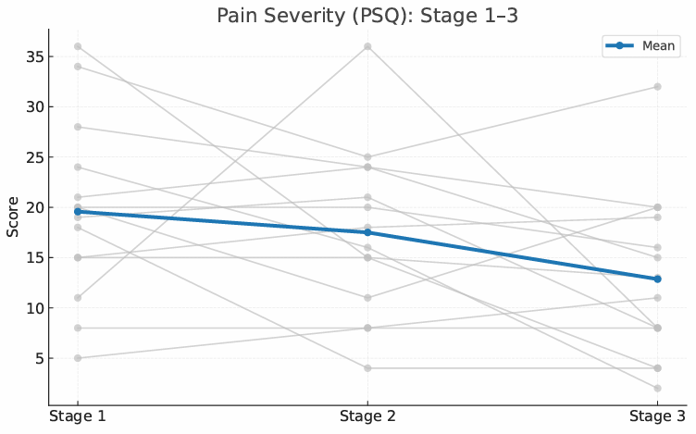

Figure 6: Distribution of PSQ scores across Stages 1–3 (box plot)
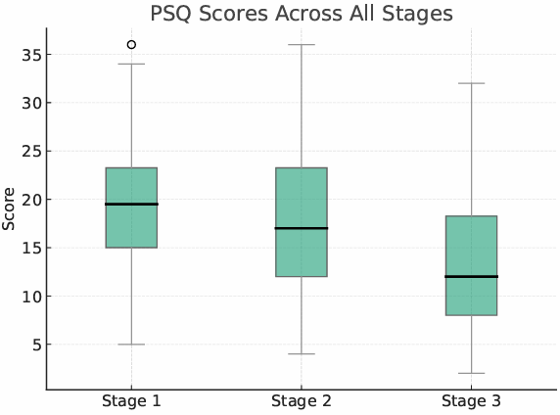

4.2.3: Pain Interference (as measured by the PIQ)
PIQ scores decreased by a mean of 18.79 points between Stage 2 and Stage 3 (95% CI −29.87 to −7.70). The large effect size and a 95% CI entirely below zero indicate a statistically significant reduction (t (13) = 3.66, p = 0.003; Cohen’s dz = 0.98). Eleven participants (78.5%) exceeded the published >6-point MCID threshold (Reed et al., 2024; Wang et al., 2025), while one participant demonstrated a slight worsening and one showed no change. Individual participant trajectories and score distributions are presented in Figures 7 and 8. Figure 8 indicates the presence of a single higher PIQ value at Stage 3, reflecting inter-individual variability within the sample. Comparisons with Stage 1 are not presented because Stage 2 (post-SHC) was prespecified as the analytic baseline. This decision reflects the study’s focus on PE non-responders and was intended to minimise regression-to-the-mean effects.
Figure 7: Individual PIQ trajectories from Stage 2 to Stage 3 (spaghetti plot)
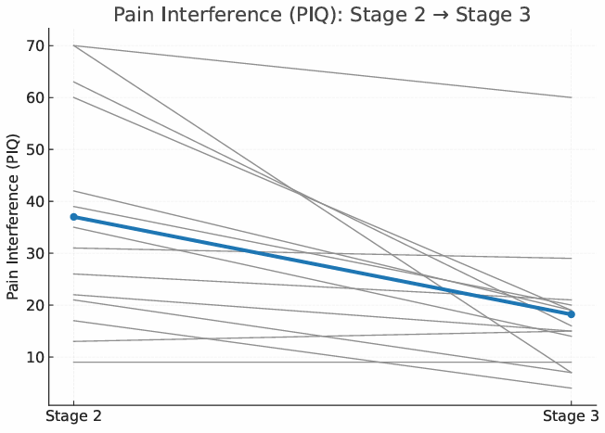

Figure 8: Distribution of PIQ scores at Stages 2 and 3 (box plot)
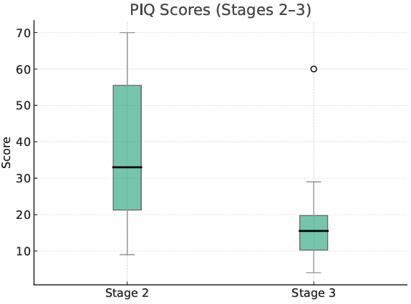
A scatterplot was used to explore the association between changes in PSEQ and PIQ between Stage 2 and Stage 3 (Figure 9). Each point represents an individual participant’s paired change scores. Visual inspection suggested a strong inverse linear relationship, with greater improvements in PSEQ tending to coincide with larger reductions in PIQ. Pearson’s correlation coefficient suggested a large negative association (r = −0.90); however, given the small sample size (n = 14), this finding is presented descriptively and should be interpreted cautiously.

Figure 9: Scatterplot showing the relationship between change in PSEQ and change in PIQ between Stage 2 and Stage 3. Each point represents an individual participant. The solid line represents the linear regression fit. Pearson’s correlation coefficient is shown.
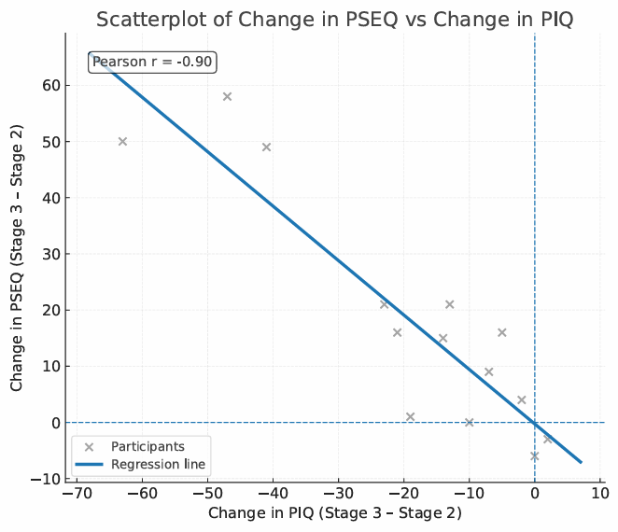
4.2.4: Pain Self-Efficacy (as measured by the PSEQ)
PSEQ scores increased by a mean of 17.93 points between Stage 2 and Stage 3 (95% CI 6.03 to 29.83), representing a statistically significant improvement (t(13) = 3.25, p = 0.007; Cohen’s dz = 0.87). Nine participants (64.3%) exceeded the published MCID threshold for PSEQ (≥7-point improvement alongside a move to a less impaired category; Tardif et al., 2017), with five participants demonstrating particularly large gains (≥15–20 points). As eligibility required all participants to be pain-education non-responders, Stage 2 data was used as the baseline for analysis. Individual participant trajectories and the distribution of PSEQ scores at Stages 2 and 3 are shown in Figures 10 and 11. Figure 11 indicates the presence of two lower PSEQ values at Stage 3, reflecting inter-individual variability within the sample. Figure 9 illustrates the relationship between changes in PSEQ and PIQ (see section 4.2.3).

Figure 10: Individual PSEQ trajectories from Stage 2 to Stage 3 (spaghetti plot)
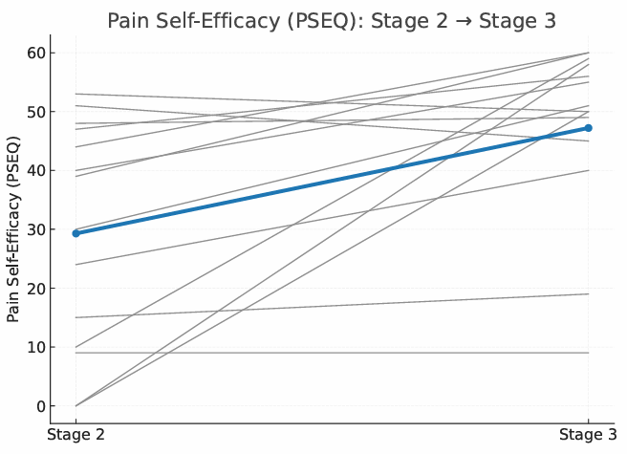
Figure 11: Distribution of PSEQ scores at Stages 2 and 3 (box plot)
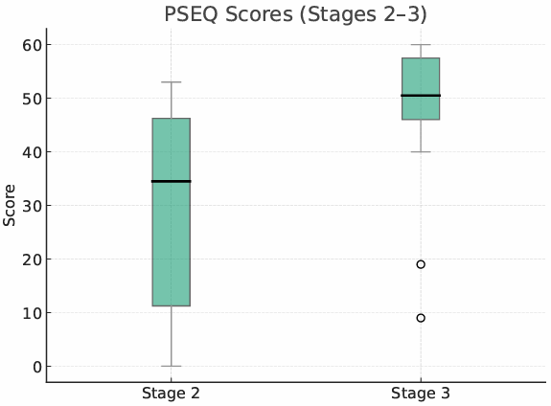

4.2.5: Overall change in PGI-C
All participants (n=14) completed the PGI-C scale following communication of their MRI findings. Scores ranged from 1 (“no change or worse”) to 7 (“a great deal better”), with the distribution of responses shown in Figure 12. In total, 42.9% (n = 6) of participants reported a meaningful improvement (scores 5–7). Classifying PGI-C scores between 5–7 as clinically meaningful is consistent with IMMPACT recommendations (Dworkin et al., 2008). A further 35.7% (n = 5) reported slight or modest improvement that did not meet the threshold set by IMMPACT for meaningful change (scores 3–4). The remaining 21.4% (n = 3) reported no improvement or worsening (scores 1–2). The mean PGI-C score was 4.21, with a median of 4, indicating that, on average, participants perceived some improvement following communication of their MRI findings.
Figure 12: Distribution of Patient Global Impression of Change (PGI-C) scores

Key:
- No change (condition has got worse).
- Almost the same, hardly any change at all.
- A little better, but no noticeable change.
- Somewhat better, but change has not made any real difference.
- Moderately better, and a slight but noticeable change.
- Better and a definite improvement that has made a real and worthwhile difference.
- A great deal better, and a considerable improvement that has made all the difference.

In summary, participants (pain education non-responders) demonstrated reductions in pain severity and PI alongside substantial improvements in PSE following a lumbar MRI with clinical reporting and multimodal communication. Improvements were most pronounced for PI and PSE, with large effect sizes and the majority of participants exceeding published thresholds for clinically meaningful change. PGI-C indicated that many participants perceived some degree of improvement following MRI communication. These findings provide the basis for interpretation in the subsequent discussion chapter.
CHAPTER 5: DISCUSSION

5.1: Overview of key findings
The aim of this study was to explore whether undergoing a lumbar MRI, alongside clinical reporting and multimodal communication, was associated with changes in PI and PSE in adults with CNSLBP who had not demonstrated a clinically meaningful response to pain education (PE). Given the within-participant observational design and absence of a comparator group, findings are interpreted as associations rather than causal effects.

The primary findings were improvements in function (PI) and confidence (PSE) following MRI exposure in PE non-responders. Mean PI scores decreased markedly between post–SHC completion (Stage 2) and post–MRI communication (Stage 3), with the majority of participants (78.5%) exceeding the published MCID threshold. Similarly, PSEQ scores demonstrated a statistically significant improvement, with nearly two-thirds of participants (64.3%) achieving clinically meaningful change. Improvements in PSE were inversely associated with changes in PI, suggesting that gains in confidence coincided with reduced pain-related functional interference. As the cohort was defined by non-response at Stage 2, this time point represented an appropriate baseline for evaluating post-MRI change.

In contrast, changes in pain severity were more modest and less certain. Although mean PSQ scores decreased by an amount exceeding the published MCID, the 95% CI crossed zero and the change was not statistically significant, indicating inter-individual variability. This pattern suggests that improvements in PI and PSE occurred largely independently of pain reduction. Global perceived change supported these findings, with approximately 43% of participants reporting a clinically meaningful improvement following MRI communication.

5.2: Interpretation of findings:
In this study, MRI exposure refers not to imaging alone, but to the combined process of undergoing MRI following completion of a standardised PE programme and receiving clinically framed findings communicated verbally, visually, and in written form. MRI was therefore treated as a communication-based exposure rather than a purely diagnostic investigation.

The findings suggest that MRI exposure may influence functional and psychosocial outcomes, indicating that MRI can shape beliefs, confidence, and behaviour. In this context, the communication of MRI findings may operate in a manner similar to PE, with the potential to either reinforce invalidation or enhance cognitive reassurance, depending on how information is framed (Shavit et al., 2025; Linskens et al., 2023). This interpretation aligns with theoretical frameworks that conceptualise CNSLBP as an information problem, in which persistent symptoms are maintained by beliefs about bodily fragility that can be modified through precise, credible, and contextually framed information (Wand et al., 2022).

A plausible mechanistic explanation for the observed findings is that MRI exposure provided reassurance, contributing to increased PSE and reduced PI. This explanation is consistent with a hypothesised mechanism whereby MRI exposure may reduce residual structural threat beliefs, thereby increasing self-efficacy and enabling functional engagement without requiring pain reduction. However, given the uncontrolled observational design, these mechanisms remain inferential.

Self-efficacy is closely linked with reassurance-based mechanisms and functional outcomes in CNSLBP populations (Moseley & Butler, 2015; Dube et al., 2021). Consistent with this, the present study demonstrated an inverse association between changes in PSEQ and PIQ scores, whereby greater gains in confidence coincided with larger reductions in pain-related functional interference. Such relationships are well established within biopsychosocial pain models, which emphasise threat reduction and self-efficacy as key drivers of functional engagement (Ryum et al., 2023). This inverse relationship also reinforces the decision to prioritise PI as a primary outcome, as functional interference appears more sensitive to reassurance-related changes in confidence than pain intensity alone.

This proposed mechanism aligns with national and international guidance for CNSLBP management, which emphasises reassurance and effective communication as core components of first-line care (NICE NG59, updated 2020; ACSQHC, 2022). Although this framework underpins recommendations for pain management programmes (BPS, 2021), it has not previously been examined empirically as a mechanistic link between MRI exposure, increased confidence, and improved function in individuals who do not respond to PE alone. The present findings therefore extend existing guidance by showing how appropriately framed imaging may support functional improvement through confidence-based mechanisms.
In contrast, changes in pain severity were modest and uncertain, with improvements failing to reach statistical significance despite exceeding published MCID thresholds at a group level. The dissociation between pain severity and functional improvements reinforces guidance that meaningful gains in confidence and function can occur independently of pain reduction (BPS, 2021), highlighting the importance of selecting outcomes aligned with reassurance and self-management mechanisms, particularly when these are central aims of care for individuals with CNSLBP (NICE NG59, updated 2020; ACSQHC, 2022).

Importantly, these improvements occurred in a cohort explicitly selected for non-response to prior PE. Although delayed effects cannot be excluded, PE is generally expected to influence beliefs and confidence soon after delivery (Moseley & Butler, 2015). The findings therefore suggest that MRI exposure may provide an additional form of reassurance by addressing residual concerns around validation and structural safety that persist despite PE.

Finally, participants with self-reported mental health diagnoses demonstrated greater response variability, including both improvement and deterioration. Although underpowered for formal subgroup analysis, this pattern aligns with evidence that psychosocial comorbidity in chronic pain is associated with greater heterogeneity of treatment response (Turk & Okifuji, 2002). Psychological factors such as anxiety and depression influence how health information is interpreted and how reassurance is received (Moseley & Butler, 2015; Vlaeyen et al., 2016), which may contribute to differential responses to communication-based interventions. These findings do not imply that MRI is inherently reassuring; rather, reassurance appears contingent on patient selection and he manner in which findings are communicated.
5.3: Comparison with existing literature; aligning with Themes identified in Table 9
The findings of the present study contrast with much of the existing observational and systematic review evidence examining the potential harms and benefits of an MRI in CNSLBP (Theme 1) (Jacobs et al., 2020; Sajid et al., 2021; Shraim et al., 2021; Witherow et al., 2022). Within that literature, MRI exposure has frequently been associated with more negative beliefs about the spine, increased fear related to structural damage, and escalation of low-value care, including further investigations and interventions. These associations underpin national and international guideline recommendations advising against routine imaging for CNSLBP (NICE, NG59, updated 2020; ACSQHC, 2022).

A key limitation of much of the existing literature is that MRI is typically examined as an early diagnostic investigation rather than as a communication process embedded within a biopsychosocial care pathway. In many studies reporting adverse outcomes, MRI is introduced prior to receiving structured PE or specialist assessment. In these contexts, findings are often communicated via image reports alone, with limited contextualisation or reassurance (Theme 2). Under these conditions, incidental or age-related findings may be interpreted as evidence of structural damage, reinforcing threat-based beliefs rather than providing reassurance.

The present study focused on a subgroup rarely examined in the MRI literature: individuals with CNSLBP who had already completed guideline-consistent PE but had not demonstrated a clinically meaningful response. In this context, MRI was introduced following unsuccessful first-line reassurance strategies. This is clinically important as qualitative evidence suggests that individuals with CNSLBP often seek imaging for reassurance regarding the structural safety of their spine (Theme 3) (Lullo et al., 2025; Rizzo et al., 2024), and that reassurance attempts are more likely to fail when patients hold entrenched structural beliefs shaped by prior damage-focused explanations encountered within healthcare settings (Darlow et al., 2013; Andersen et al., 2025). In such cases, educational messages may be perceived as generic or inapplicable, leading to disengagement rather than reassurance, with individuals frequently reporting that such information “does not apply” to them (Bunzli et al., 2015).

Within this context, MRI delivered after unsuccessful PE may function as a secondary reassurance exposure rather than a diagnostic test. When carefully framed, imaging may help address residual concerns regarding structural safety, supporting threat reduction and belief change in line with contemporary pain science models (Moseley & Butler, 2015). In practical terms, MRI may provide visible confirmation of safety that complements, rather than replaces, prior educational explanations, with reassurance arising from perceived validation and reduced uncertainty rather than identification of pathology.

In contrast to earlier studies reporting deterioration following imaging, the present study did not demonstrate overall deterioration in PI or PSE at a group level, despite individual variability. This finding may reflect the timing of MRI within the care pathway, the selective inclusion of PE non-responders, and the structured, clinically contextualised multimodal communication used. This approach contrasts with the uncontextualised reporting described in prior studies and may help explain why MRI exposure in the present cohort was not associated with worsening functional or psychosocial outcomes.
Ethical considerations further distinguish the present study from prior work examining MRI communication. Rather than withholding imaging or reframing reports post-hoc, the present approach sought to minimise harm through pre-MRI education, preserving diagnostic transparency while improving understanding of the limitations and typical findings of an MRI. This aligns with principles of informed consent, honesty, and non-maleficence (World Medical Association, 2013; BMA, 2025) and addresses a key evidence gap identified in a recent systematic review which found no studies evaluating PE delivered prior to MRI exposure (Witherow et al., 2022). This places the present study as a novel contribution to the literature.

Differences in outcome selection may further explain discrepancies between the present findings and earlier studies. Whereas much of the existing literature prioritises pain intensity or healthcare utilisation, the present study examined PI and PSE; constructs more closely aligned with reassurance-based mechanisms and functional recovery central to CNSLBP management (Dworkin et al., 2008). Reassurance may therefore influence outcomes indirectly by reducing perceived threat and increasing confidence to engage in activity, without requiring pain reduction (Bandura, 1997; Moseley & Butler, 2015).

Overall, the present findings refine existing evidence by demonstrating that the psychosocial impact of MRI in CNSLBP is context dependent, shaped by patient selection and communication practices. Rather than supporting or refuting MRI use in absolute terms, the study shows that imaging-related harms and benefits depend on how and when MRI is delivered, particularly among individuals who have not responded to first-line educational reassurance.
5.4: Clinical implications
Consistent with current national and international guideline recommendations, the results do not support indiscriminate use of an MRI for CNSLBP (NICE NG59, updated 2020; ACSQHC, 2022). Instead, the findings suggest that the psychosocial harms and benefits associated with MRI are not inherent to the imaging modality itself, but are shaped by patient selection, timing within the care pathway, and communication practices. The implications of this study are considered at the level of individual clinical practice, service and pathway design, and ethical and policy considerations, with specific reference to the SAS pathway.

5.4.1: Individual clinician level implications
At the level of individual clinical practice, the findings support reframing MRI in CNSLBP from a purely diagnostic investigation to a communication-based reassurance intervention. For individuals who have not responded to guideline-consistent PE, MRI exposure, when delivered within a biopsychosocial framework, may support reassurance by addressing uncertainty and increasing confidence to engage in activity. This approach aligns with national, international and IASP guidance that prioritise PE as first-line care in CNSLBP, while also recognising that educational reassurance may be insufficient for some individuals (IASP, 2021; NG59, 2020; ACSQHC, 2022).

Effective communication is central to this process. Clinicians who contextualise age-related or incidental findings and link MRI results to biopsychosocial explanations may reduce perceived threat and facilitate belief change. This interpretation aligns with contemporary pain science theories, in which reassurance operates through threat reduction and enhanced self-efficacy, rather than symptom elimination (BPS, 2021; Moseley & Butler, 2015).

For some individuals who remain concerned about structural safety despite completion of guideline-consistent PE, non-response may reflect unresolved threat beliefs rather than a lack of information. For these patients, repeated verbal education may be experienced as unhelpful, whereas MRI exposure, when carefully framed, may function as a complementary reassurance strategy that addresses residual uncertainty. This highlights the importance of tailoring reassurance strategies to individual needs rather than assuming that additional information alone will resolve concern.

5.4.2: Service and pathway level implications
At a service level, the findings support key features of the SAS pathway, in which MRI is considered only after completion of guideline-consistent PE and specialist assessment. This contrasts with primary care and direct-access pathways, where imaging is often obtained earlier and communicated with limited contextualisation, increasing the risk that findings are interpreted as evidence of structural threat. In this context, structured patient selection within the SAS may reduce the likelihood that incidental findings reinforce unhelpful beliefs.

Within the SAS, MRI findings are communicated using a multimodal approach that incorporates verbal explanation, visual review of images, and a written clinical report. This approach is consistent with NICE guidance, which emphasises selective use of imaging and clear clinical contextualisation (NICE NG59, updated 2020). Presenting information across multiple modalities improves comprehension and retention of complex health information (Houts et al., 2006) and may function as a harm-mitigation strategy by supporting biopsychosocial explanations and reducing misinterpretation of incidental findings. This is particularly relevant in chronic pain care, where inconsistent messaging has been associated with disengagement and reduced self-management (Darlow et al., 2013; Bunzli et al., 2015). Emerging evidence further supports the inclusion of contextualising statements within imaging reports themselves, explicitly highlighting the prevalence and limited clinical relevance of degenerative findings (Jenkins et al., 2021; Rajasekaran et al., 2021).

From a service-design perspective, the findings suggest that blanket avoidance of MRI may overlook a subgroup of PE non-responders for whom imaging, when appropriately framed, may support reassurance and functional engagement. This does not imply expanding MRI access but rather optimising its use. Accordingly, the present study demonstrates that MRI can be integrated into a specialist pathway as a reassurance-focused communication exposure, addressing residual uncertainty while supporting confidence and function without escalation of low-value care.

A potential refinement to the SAS pathway may include addressing MRI clinical reports directly to patients, rather than copying them into correspondence sent to their GP. This approach has been found to enhance patient ownership and engagement with care (Murtagh et al., 2019; Ong et al., 2018). Deliberate use of neutral, validating, and non-judgemental language within MRI reports may further reduce iatrogenic harm and support reassurance (Cox & Fritz, 2022).
Targeted use of MRI in selected patients may therefore support both patient-centred care and efficient use of healthcare resources by reducing low-value or potentially harmful imaging. Given the recognised financial cost of lumbar MRI within publicly funded healthcare systems, aligning imaging use with clearly defined therapeutic objectives is particularly important for responsible service planning.

Despite guideline recommendations advising against routine imaging for CNSLBP, patients attending specialist services frequently expect further investigation (Farmer et al., 2024). This mismatch between expectations and guideline-recommended care presents a challenge for services such as the SAS, particularly given that patient satisfaction is influenced by the discrepancy between what is expected and what is experienced during care (Vroom, 1964) and that higher patient satisfaction in physiotherapy care has been associated with greater adherence to treatment and lifestyle recommendations (Rossettini et al., 2018). Addressing imaging expectations through clear communication, shared decision-making, and, where appropriate, MRI exposure may therefore support engagement with guideline-recommended activity-based management strategies central to CNSLBP care (Zhou et al., 2024).

5.4.3: Ethical and Guideline implications
At a policy level, the present findings refine rather than contradict national and international guideline recommendations advising against routine imaging for CNSLBP (NICE NG59, updated 2020; ACSQHC, 2022). While indiscriminate MRI use remains unsupported, the findings demonstrate that the psychosocial impact of imaging varies according to patient selection, timing, and communication practices.
By demonstrating that MRI exposure delivered after guideline-consistent PE and accompanied by clinically framed, multimodal communication was not associated at a group level with deterioration in PI or PSE, the present study supports a more nuanced interpretation of how existing guidance may be applied in specialist contexts. Specifically, recommendations cautioning against routine imaging need not exclude the selective, ethically justified use of MRI as a secondary reassurance strategy in individuals who have not responded to first-line education, provided imaging is delivered within a biopsychosocially informed service.

This approach aligns with EBP by integrating best available evidence with clinical expertise and patient preferences. In line with NICE guidance on shared decision making (NICE NG197, 2021), imaging decisions should be made collaboratively through explicit discussion of potential benefits, harms, and alternatives. This framework is particularly relevant in the present study, where participants expressed a preference for MRI following unsuccessful first-line education. Framing MRI within a shared decision-making process therefore supports ethical justification and helps to minimise imaging-related harm. Pre-MRI education may further reduce the risk of perceived invalidation when imaging does not identify structural pathology, supporting a transition away from pathoanatomical interpretations known to be unhelpful in CNSLBP (Bunzli et al., 2015).

Unlike approaches that attempt to mitigate imaging-related harm by withholding information, the present study prioritised pre-MRI education alongside clinically contextualised, transparent communication of findings. This aligns with NICE chronic pain guidance (NG193, 2021), which emphasises that imaging results should be clearly explained and used to support reassurance rather than reinforce concern about structural damage. By preparing patients in advance and contextualising findings within a biopsychosocial framework, this approach supports patient autonomy while reducing the risk of iatrogenic harm, consistent with ethical principles of informed consent, honesty, and non-maleficence (WMA, 2013; BMA, 2025).

Notably, a recent SR identified a lack of studies evaluating education delivered prior to MRI exposure (Witherow et al., 2022). By addressing this evidence gap, the present findings support the ethical justification of MRI as a secondary reassurance strategy for individuals who have not benefited from first-line education; provided imaging is delivered within a biopsychosocially informed service.

5.4.4: Summary of Clinical implications
Overall, the clinical implications of this study indicate that the value of an MRI in CNSLBP is context dependent, shaped by patient selection, timing within the care pathway, and communication practices. Rather than supporting or refuting MRI use in absolute terms, the findings support the selective use of MRI within specialist services such as the SAS as a second-line reassurance strategy for selected PE non-responders, provided delivery remains biopsychosocially framed and carefully communicated.

5.5: Strengths
A key strength of this study is its novelty. To the author’s knowledge, it is the first study to examine MRI as a secondary reassurance strategy in individuals with CNSLBP who have completed guideline-recommended PE but failed to demonstrate a clinically meaningful response. By focusing on this under-studied subgroup, the study addresses an important evidence gap and reflects a common clinical dilemma within specialist pain services, where reassurance needs may persist despite education (Darlow et al., 2013).

Embedding the study within routine SAS clinical care strengthens ecological validity and supports applicability to real-world specialist spinal services. Data was collected through a standardised clinical pathway, and MRI exposure was delivered as a structured communication process incorporating pre-MRI education and consistent verbal, visual, and written explanation of findings. This addresses a key limitation of prior imaging research, in which communication is often unmeasured or highly variable.

The study demonstrates strong alignment between its aims, hypothesised mechanism, and outcome selection. The design was informed by a biopsychosocial communication framework, with primary outcomes (PI and PSE) selected to reflect functional impact and confidence rather than pain severity alone. This strengthens construct validity, as reassurance-based interventions are not expected to produce immediate reductions in pain severity.

The use of a well-defined and clinically relevant sample further supports internal validity. Restricting inclusion to PE non-responders reduced heterogeneity related to spontaneous improvement or delayed educational effects, allowing clearer interpretation of changes observed following MRI communication. Consecutive sampling within the SAS pathway, alongside transparent reporting of inclusion and exclusion criteria, minimised selection bias. The predefined use of Stage 2 as the analytic baseline further reduced the risk of regression to the mean effects in a cohort selected for poor response to education.

Finally, the study benefitted from complete data capture, with no loss to follow-up and no missing outcome data across all three stages. The use of validated PROMs with established psychometric properties, alongside a PGI-C, supports robust interpretation of both functional outcomes and patient-perceived change.

5.6: Limitations
Several limitations should be considered when interpreting the findings of this study. First, the within-participant observational design, in the absence of a comparator group, limits causal inference (von Elm et al., 2007). Although PI and PSE improved following MRI exposure, these changes cannot be attributed specifically to MRI communication and may instead reflect natural symptom fluctuation, contextual effects, or expectancy-related influences. Because eligibility was based on limited improvement following PE rather than extreme baseline scores, classic regression to the mean cannot be assumed; however, regression to the mean and natural variability in CNSLBP remain plausible alternative explanations for observed change (Pinto et al., 2025). Accordingly, the findings should be interpreted as associations rather than evidence of treatment efficacy.
Second, the small sample size (n = 14) limits statistical precision and generalisability. Although effect sizes and 95% CI were emphasised in line with estimation-focused recommendations (Cumming, 2014), uncertainty remains regarding the magnitude of the observed effects. The study was also underpowered for subgroup analyses, meaning that the potential influences of demographic or psychosocial characteristics could only be explored descriptively. In addition, outcomes were assessed shortly after MRI communication, limiting inference regarding durability and raising the possibility that findings reflect short-term reassurance effects rather than sustained functional change.

Third, the pragmatic nature of the study introduces the potential for time varying confounding. The interval between Stage 2 and Stage 3 varied across participants, and unmeasured changes occurring during this period, such as symptom fluctuation, changes in activity, or external influences, cannot be disentangled from the effects of MRI communication itself. This further constrains causal interpretation.

Fourth, reliance on PROMs introduces the possibility of response bias, including expectancy effects and social desirability. This is particularly relevant in the context of clinician-delivered reassurance, where participants may align responses with perceived therapeutic intent (Darlow et al., 2013; Bishop et al., 2012). Although expectancy effects may have contributed to observed improvements, expectancy itself can be understood as part of the reassurance and meaning-making process rather than a competing explanation, particularly within communication-based interventions (Benedetti et al., 2018). The PGI-C is also susceptible to recall bias and cannot distinguish which components of the MRI communication process contributed to perceived change. In addition, the study did not include an IMMPACT-recommended measure of emotional functioning, such as pain-related fear or catastrophising, which may have provided further insight into reassurance-related mechanisms.

Fifth, reassurance, the commonly cited mechanism underpinning MRI in CNSLBP, was not measured directly. Instead, PSE was used as a theoretically informed proxy, consistent with contemporary pain models that conceptualise reassurance as operating through confidence and threat reduction (Moseley & Butler, 2015), and with recommendations to use indirect outcomes when assessing reassurance-related processes (Young et al., 2025). Accordingly, conclusions regarding reassurance mechanisms remain inferential.

Finally, the study was conducted within a single specialist spinal service using a structured pathway and standardised communication approach, which may limit transferability to other settings. The selective inclusion of participants who expressed a preference for MRI introduces the potential for self-selection bias, which may have amplified reported benefit. While this approach aligns with EBP by incorporating patient preferences (NICE NG197, 2021), it also reinforces the need for cautious interpretation of the findings.

5.7: Implications for future research
Future research is needed to clarify the role of MRI as a secondary reassurance strategy in CNSLBP. Comparative designs, such as controlled cohort studies or pragmatic randomised trials, are required to strengthen causal inference by comparing biopsychosocially framed MRI communication with continued non-imaging reassurance in PE non-responders. Such designs would help distinguish the effects of MRI communication from natural symptom fluctuation, regression to the mean, and contextual influences.

Larger, adequately powered studies would improve the certainty of effect estimates and allow exploration of which individuals are most likely to benefit, including the influence of psychological distress and baseline structural beliefs. Longer-term follow-up is also required to determine whether observed improvements in PI and PSE are sustained over time.
Future studies should also explicitly examine how shared decision-making processes influence patient outcomes following imaging, as collaborative decision processes are rarely reported despite NICE NG197 (2021) recommendations. This is particularly relevant given that many patients actively seek access to imaging (Farmer et al., 2024; Bunzli et al., 2015), and that unmet expectations are closely linked to patient dissatisfaction and reduced adherence to guideline-recommended care (Vroom, 1964; Rossettini et al., 2018; Zhou et al., 2024).

Finally, future studies should examine the timing and delivery of MRI within care pathways, including comparisons of imaging delivered before or after PE and across different communication approaches. Incorporating direct measures of reassurance alongside qualitative or mixed-methods exploration of patient interpretations of MRI findings would help clarify underlying mechanisms. Assessment of communication delivery and replication across diverse clinical settings is also needed to strengthen transferability.

CHAPTER 6: CONCLUSIONS

The aim of this study was to explore whether undergoing a lumbar MRI, alongside clinical reporting and multimodal communication, was associated with changes in PI and PSE in adults with CNSLBP who had not demonstrated a clinically meaningful response to guideline recommended PE.

Using a within-participant observational design embedded within a specialist spinal service, this study found that MRI exposure, conceptualised as a communication process rather than a diagnostic test, was associated with clinically meaningful improvements in function and confidence, despite minimal change in pain intensity. These findings were consistent with the stated hypothesis.

Overall, the psychosocial impact of MRI appears less inherent to imaging itself and more dependent on patient selection, timing within the care pathway, prior education, and communication practices. When delivered selectively after guideline-recommended PE and framed within a biopsychosocial model, MRI may function as a secondary reassurance intervention for selected PE non-responders, supporting confidence and functional engagement. These findings do not challenge existing guideline recommendations that caution against routine imaging for CNSLBP but suggest that a more nuanced interpretation may be warranted within specialist services for selected pain-education non-responders, where imaging is used selectively and delivered with ethically justified, biopsychosocially contextualised communication.
Nevertheless, given the observational design, small sample size, and short-term follow-up, the findings should be regarded as hypothesis-generating rather than definitive evidence of effectiveness. Further research using comparative designs, larger samples, longer-term follow-up, and direct measures of reassurance is required to clarify mechanisms, durability, and which patients are most likely to benefit.

In conclusion, this dissertation contributes novel evidence that MRI, when embedded within a structured biopsychosocial pathway, may function as a secondary reassurance intervention for individuals with CNSLBP who do not respond to first-line PE. This work informs both clinical practice and future research by reframing MRI from a purely diagnostic tool to a potential communication-based reassurance intervention within specialist spinal care.

References

Aaron, R.V., Ravets, S.G., Carnahan, N.D., Bhattiprolu, K., Harte, N., McCaulley, C.C., Vitalii, L., Rogers, A.B., Wegener, S.T. and Dudney, J. (2025). Prevalence of Depression and Anxiety Among Adults with Chronic Pain: A Systematic Review and Meta-Analysis. JAMA network open, [online] 8(3), p.e250268. doi: https://doi.org/10.1001/jamanetworkopen.2025.0268.

Ahmed, S.K., Mohammed, R.A., Nashwan, A.J., Ibrahim, R.H., Abdalla, A.Q., Ameen, B.M., and Khadir, R.M. (2025). Using Thematic Analysis in Qualitative Research. Journal of Medicine, Surgery, and Public Health, [online] 6(6), p.100198. doi: https://doi.org/10.1016/j.glmedi.2025.100198.

Akyirem, S., Salifu, Y., Bayou, J., Duodu, P.A., Bossman, I.F. and Aboah‐Offei, M. (2022). An Integrative Review of the Use of the Concept of Reassurance in Clinical Practice. Nursing Open, [online] 9(3), pp.1515–1535. doi: https://doi.org/10.1002/nop2.1102.

Alhowimel, A., Alotaibi, M., Coulson, N. and Radford, K. (2020). Psychosocial consequences of diagnosing nonspecific low-back pain radiologically: a qualitative study. Physiotherapy Theory and Practice, pp.1–7. doi: https://doi.org/10.1080/09593985.2020.1802799.

Andersen, T.C., Wilhelmsen, M. and Lian, O.S. (2025). ‘The MRI-scan says it is completely normal’: Reassurance attempts in clinical encounters among patients with chronic musculoskeletal pain. Health: An Interdisciplinary Journal for the Social Study of Health, Illness and Medicine. doi: https://doi.org/10.1177/13634593241290185.

Austin, P.C. (2009). Balance diagnostics for comparing the distribution of baseline covariates between treatment groups in propensity-score matched samples. Statistics in Medicine, [online] 28(25), pp.3083–3107. doi: https://doi.org/10.1002/sim.3697.

Australian Commission on Safety and Quality in Health Care (ACSQHC). (2022).
Low Back Pain Clinical Care Standard. (Accessed: 30 September 2025).
Available at: https://www.safetyandquality.gov.au/standards/clinical-care-standards/low-back-pain-clinical-care-standard
Bagg, M.K., Wand, B.M., Cashin, A.G., Lee, H., Huebscher, M., Stanton, T.R., O’Connell, N.E., O’Hagan, E.T., Rizzo, R.R.N., Weegee, M.A., Rabey, M., Goodall, S., Saing, S., Lo, S.N., Luomajoki, H., Herbert, R.D., Maher, C.G., Moseley, G.L. and McAuley, J.H. (2022). Effect of Graded Sensorimotor Retraining on Pain Intensity in Patients with Chronic Low Back Pain. JAMA, 328(5), p.430. doi: https://doi.org/10.1001/jama.2022.9930.
Balza, R., Mercaldo, S.F., Huang, A.J., Husseini, J.S., Jarawa, M., Simeone, F.J., Vicentino, J.R.T. and Palmer, W.E. (2024). Impact of Patient-reported Symptom Information on the Interpretation of MRI of the Lumbar Spine. Radiology, 313(1). doi: https://doi.org/10.1148/radiol.233487.

Benedetti, F., Carlino, E. and Pollo, A. (2010). How Placebos Change the Patient’s Brain. Neuropsychopharmacology, [online] 36(1), pp.339–354. doi: https://doi.org/10.1038/npp.2010.81.

Booth, A., Clarke, M., Dooley, G., Ghersi, D., Moher, D., Petticrew, M. and Stewart, L. (2012). The nuts and bolts of PROSPERO: an international prospective register of systematic reviews. Systematic Reviews, 1(1). doi: https://doi.org/10.1186/2046-4053-1-2.

Borelli, E., Benozzo, F., Ballota, D., Bandiera, E., Luppi, M., Cacciari, C.A. and Lui, F. (2023).
Words hurt: common and distinct neural substrates underlying nociceptive and semantic pain. Frontiers in Neuroscience, 17, p.1234286. doi: https://doi.org/10.3389/fnins.2023.1234286.

Boutron, I., Altman, D.G., Moher, D., Schulz, K.F. and Ravaud, P. (2017). CONSORT Statement for Randomized Trials of Nonpharmacologic Treatments: A 2017 Update and a CONSORT Extension for Nonpharmacologic Trial Abstracts. Annals of Internal Medicine, 167(1), p.40. doi: https://doi.org/10.7326/m17-0046.

Braun, V. and Clarke, V. (2006). Using Thematic Analysis in Psychology. Qualitative Research in Psychology, 3(2), pp.77–101. doi: https://doi.org/10.1191/1478088706qp063oa.

Braun, V. and Clarke, V. (2021). Thematic Analysis. [online] SAGE Publications Inc. Available at: https://us.sagepub.com/en-us/nam/thematic-analysis/book248481.

Brinjikji, W., Luetmer, P.H., Comstock, B., Bresnahan, B.W., Chen, L.E., Deyo, R.A., Halabi, S., Turner, J.A., Avins, A.L., James, K., Wald, J.T., Kallmes, D.F. and Jarvik, J.G. (2015). Systematic Literature Review of Imaging Features of Spinal Degeneration in Asymptomatic Populations. American Journal of Neuroradiology, 36(4), pp.811–816. doi: https://doi.org/10.3174/ajnr.a4173.

British Medical Association (2025). BMA Medical ethics and human rights Core Ethics Guidance. [online] Available at: https://www.bma.org.uk/media/iurldd5z/core-ethics-guidance-updated-feb-2025.pdf.

Bunzli, S., Smith, A., Schütze, R. and O’Sullivan, P. (2015). Beliefs underlying pain-related fear and how they evolve: a qualitative investigation in people with chronic back pain and high pain-related fear. BMJ Open, 5(10), p.e008847. doi: https://doi.org/10.1136/bmjopen-2015-008847.

Chen, C.X., Kroenke, K., Stump, T.E., Kean, J., Carpenter, J.S., Krebs, E.E., Bair, M.J., Damus, T.M. and Monahan, P.O. (2017). Estimating minimally important differences for the PROMIS pain interference scales: results from 3 randomized clinical trials. Pain, 159(4), pp.775–782. doi: https://doi.org/10.1097/j.pain.0000000000001121.

Cleeland, C.S. and Ryan, K.M. (1994). Pain assessment: global use of the Brief Pain Inventory. Annals of the Academy of Medicine, Singapore, [online] 23(2), pp.129–138. Available at: https://pubmed.ncbi.nlm.nih.gov/8080219/.

Cochrane Effective Practice and Organisation of Care (EPOC). (2017). Describing interventions in EPOC reviews (Resources for review authors). Available at: https://epoc.cochrane.org/sites/epoc.cochrane.org/files/uploads/Resources-for-authors2017/describing_interventions_in_epoc_reviews.pdf (Accessed 1st October 2025).

Cormier, A., Lowry, V., Lavigne, P., Roy, J., Yannick Tousignant‐Laflamme, Perreault, K., Martel, M., Decory, S. and François Desmeules (2024). Low back pain patients’ experience and expectations: A qualitative study focusing on physiotherapist and physician care. Musculoskeletal care, 22(2). doi: https://doi.org/10.1002/msc.1896.

Cox, W.A.S., Cavanagh, P. and Bello, F. (2020). What are the benefits and risks of sharing patients’ diagnostic radiological images with them? A cross-sectional study of the perceptions of patients and clinicians in the UK. BMJ Open, [online] 10(1), p.e033835. doi: https://doi.org/10.1136/bmjopen-2019-033835.

Creswell, J. and Poth, C. (2018). Qualitative Inquiry and Research Design. [online] SAGE Publications Ltd. Available at: https://uk.sagepub.com/en-gb/eur/qualitative-inquiry-and-research-design/book266033.

Critical Appraisal Skills Programme (CASP). (2024). CASP Qualitative Studies Checklist. Available at: https://casp-uk.net/casp-tools-checklists/ (Accessed: 1 June 2025).

Critical Appraisal Skills Programme (CASP). (2024). CASP Cohort Study Checklist. Available at: https://casp-uk.net/casp-tools-checklists/cohort-study-checklist/ (Accessed: 1 June 2025).
Critical Appraisal Skills Programme (CASP). (2024). CASP Randomised Controlled Trial Checklist. Available at: https://casp-uk.net/casp-tools-checklists/randomised-controlled-trial-rct-checklist/ (Accessed: 1 June 2025).

Critical Appraisal Skills Programme (CASP). (2022). CASP Systematic Review Checklist. Available at: https://casp-uk.net/images/checklist/documents/CASP-Systematic-Review-Checklist/CASP-Systematic-Review-Checklist-Fillable-Form.pdf (Accessed: 1 June 2025).

Cumming, G. (2014). The new statistics: Why and how. Psychological Science, 25(1), pp.7–29. doi: https://doi.org/10.1177/0956797613504966.

Cumpston, M.S., McKenzie, J.E., Welch, V.A. and Brennan, S.E. (2022). Strengthening Systematic Reviews in Public health: Guidance in the Cochrane Handbook for Systematic Reviews of Interventions, 2nd Edition. Journal of Public Health, [online] 44(4). doi: https://doi.org/10.1093/pubmed/fdac036.

Darlow, B., Dowell, A., Baxter, G.D., Mathieson, F., Perry, M. and Dean, S. (2013). The Enduring Impact of What Clinicians Say to People with Low Back Pain. The Annals of Family Medicine, 11(6), pp.527–534. doi: https://doi.org/10.1370/afm.1518.

De Cassai, D.C., Dost, B., Tuggar, S. and Boscolo, A. (2025). Methodological Standards for Conducting High-Quality Systematic Reviews. Biology, [online] 14(8), p.973. doi: https://doi.org/10.3390/biology14080973.

De Paepe L, Crombec A, Martin, K.R., Bennett, D.L.H. and Scott, W. (2025). An analysis of the relevance of the Brief Pain Inventory interference items for measuring pain-related disability. Journal of Pain, [online] 38, pp.105588–105588. doi: https://doi.org/10.1016/j.jpain.2025.105588.

Deyo, R.A., Mirza, S.K., Turner, J.A. and Martin, B.I. (2009). Overtreating Chronic Back Pain: Time to Back Off? The Journal of the American Board of Family Medicine, [online] 22(1), pp.62–68. doi: https://doi.org/10.3122/jabfm.2009.01.080102.

Doménech-Fernández, J., Angulo, A.E., Peñalver-Barrios, L., Rio-González, E.D., Herrero, R., García-Palacios, A., Martinez-Diaz, M., Iago Garreta-Catala, Diez-Ulloa, M.A. and Baños-Rivera, R.M. (2025). Catastrophizing and Fear Avoidance Beliefs in Chronic Low Back pain: a cross-sectional Study. European Journal of Physical and Rehabilitation Medicine, [online] 61(2). doi: https://doi.org/10.23736/s1973-9087.25.08419-9.
Downie, F., McRitchie, C., Monteith, W. and Turner, H. (2019). Physiotherapist as an alternative to a GP for musculoskeletal conditions: a 2-year service evaluation of UK primary care data. British Journal of General Practice, [online] 69(682), pp. e314–e320. doi: https://doi.org/10.3399/bjgp19x702245.

Dworkin, R.H., Turk, D.C., Weyrich, K.W., Beaton, D., Cleeland, C.S., Farrar, J.T. et al. (2008).
Interpreting the clinical importance of treatment outcomes in chronic pain clinical trials: IMMPACT recommendations. The Journal of Pain, 9(2), pp.105–121.
doi: https://doi.org/10.1016/j.jpain.2007.09.005.

Dubé, M.-O., Langevin, P. and Roy, J.-S. (2021). Measurement properties of the Pain Self-Efficacy Questionnaire in populations with musculoskeletal disorders: a systematic review. PAIN Reports, 6(4), p.e972. doi: https://doi.org/10.1097/pr9.0000000000000972.

Farmer, C., Bourne, A., Haas, R., Wallis, J., O’Connor, D. and Buchbinder, R. (2022). Can modifications to how medical imaging findings are reported improve quality of care? A systematic review. Clinical Radiology. doi: https://doi.org/10.1016/j.crad.2022.02.011.

Farmer, C., Haas, R., Wallis, J., O’Connor, D. and Buchbinder, R. (2024). Are clinically unimportant findings qualified as benign in lumbar spine imaging reports? A content analysis of plain X-ray, CT and MRI reports. PLOS ONE, 19(3), p.e0297911. doi: https://doi.org/10.1371/journal.pone.0297911.

Farrar, J.T., Young, J.P., Lamoreaux, L., Werth, J.L. and Poole, M.R. (2001). Clinical importance of changes in chronic pain intensity measured on an 11-point numerical pain rating scale. Pain, 94(2), pp.149–158. doi: https://doi.org/10.1016/s0304-3959(01)00349-9.

Ferrari, S., Vanti, C., Pellizzer, M., Dozza, L., Manicone, M. and Palestrina, P. (2019). Is there a relationship between self-efficacy, disability, pain and sociodemographic characteristics in chronic low back pain? A multicentre retrospective analysis. Archives of Physiotherapy, 9(1). doi: https://doi.org/10.1186/s40945-019-0061-8.

Ford, I. and Norrie, J. (2016). Pragmatic Trials. New England Journal of Medicine, [online] 375(5), pp.454–463. doi: https://doi.org/10.1056/nejmra1510059.

Foster, N.E., Anema, J.R., Cherkin, D., Chou, R., Cohen, S.P., Gross, D.P., Ferreira, P.H., Fritz, J.M., Koes, B.W., Peul, W.C., Turner, J.A., Maher, C.G., Buchbinder, R., Hartvigsen, J., Underwood, M. and van Tulder, M. (2018). Prevention and treatment of low back pain: evidence, challenges, and promising directions. The Lancet, 391(10137), pp.2368–2383.
doi: https://doi.org/10.1016/S0140-6736(18)30489-6

Green, J. and Thorogood, N. (2018). Qualitative Methods for Health Research, 4th ed. [online] researchonline.lshtm.ac.uk. London, UK: Sage. Available at: https://researchonline.lshtm.ac.uk/id/eprint/4649388.

Greenhalgh, T., Howick, J. and Maskrey, N. (2014). Evidence Based medicine: a Movement in crisis? British Medical Journal, [online] 348, pp. g3725–g3725. doi: https://doi.org/10.1136/bmj.g3725.

Guyatt, G.H., Oxman, A.D., Kunz, R., Atkins, D., Brozek, J., Vest, G., Alderson, P., Glasziou, P., Falck-Yatter, Y. and Schünemann, H.J. (2011). GRADE guidelines: 2. Framing the question and deciding on important outcomes. Journal of Clinical Epidemiology, [online] 64(4), pp.395–400. doi: https://doi.org/10.1016/j.jclinepi.2010.09.012.

Hall, A.M., Aubrey-Bassler, K., Thorne, B. and Maher, C.G. (2021). Do not routinely offer imaging for uncomplicated low back pain. BMJ, n291. doi: https://doi.org/10.1136/bmj.n291

Han, C., Hancock, P.M. and Maher, P.C. (2022). Reconsidering non-specific low back pain: Where to from here? The Spine Journal. doi: https://doi.org/10.1016/j.spinee.2022.08.001.

Haslam-Larmer, L., Norman, K.E., Patey, A.M., Thomas, I.M., Hartvigsen, J., Ivers, N.M., Jenkins, H. and French, S.D. (2025). ‘It’s hard to trust an individual, it’s easier to trust an image’—patients with low back pain want imaging as a means of coping with uncertainty. BMC Primary Care, 26(1), pp.332–332. doi: https://doi.org/10.1186/s12875-025-02998-5.

Harbour, R. and Miller, J. (2001). A new system for grading recommendations in evidence-based guidelines. BMJ, 323(7308), pp.334–336. doi: https://doi.org/10.1136/bmj.323.7308.334.

Hartvigsen, J., Hancock, M.J. and Kongsted, A. (2018). What low back pain is and why we need to pay attention. The Lancet, [online] 391(10137), pp.2356–2367. doi: https://doi.org/10.1016/s0140-6736(18)30480-x.

Herman, P.M., Qureshi, N., Arick, S.D., Edelen, M.O., Hays, R.D., Rodriguez, A., Weir, R.L. and Coulter, I.D. (2022). Definitions of Chronic Low Back Pain from a Scoping Review, and Analyses of Narratives and Self-Reported Health of Adults with Low Back Pain. The Journal of Pain, [online] 24(3). doi: https://doi.org/10.1016/j.jpain.2022.10.012.

Hernán, M. and Robins, J. (2024). Causal Inference: What If. [online] Available at: https://content.sph.harvard.edu/wwwhsph/sites/1268/2024/01/hernanrobins_WhatIf_2jan24.pdf. (Accessed 1st November 2025).

Heuch, I., Heuch, I., Hagen, K. and Zwart, J.-A. (2024). Overweight and Obesity as Risk Factors for Chronic Low Back pain: a new follow-up in the HUNT Study. BMC Public Health, [online] 24(1). doi: https://doi.org/10.1186/s12889-024-20011-z.

Higgins, J. and Thomas, J. (2024). Cochrane Handbook for Systematic Reviews of Interventions (current version) | Cochrane. [online] Cochrane.org. Available at: https://www.cochrane.org/authors/handbooks-and-manuals/handbook/current.

Hoffmann, T.C., Glasziou, P.P., Boutron, I., Milne, R., Perera, R., Moher, D., Altman, D.G., Barbour, V., Macdonald, H., Johnston, M., Lamb, S.E., Dixon-Woods, M., McCulloch, P., Wyatt, J.C., Chan, A.-W. and Michie, S. (2014). Better reporting of interventions: template for intervention description and replication (TIDieR) checklist and guide. BMJ, 348, g1687. doi: https://doi.org/10.1136/bmj.g1687.

Holopainen, R. (2021). Biopsychosocial framework – pain impacting life on multiple biopsychosocial domains. European Journal of Physiotherapy, [online] 23(5), pp.268–269. doi: https://doi.org/10.1080/21679169.2021.1970966.

Hooten, W.M. (2016). Chronic Pain and Mental Health Disorders. Mayo Clinic Proceedings, [online] 91(7), pp.955–970. doi: https://doi.org/10.1016/j.mayocp.2016.04.029.

Hopewell, S., Chan, A.-W., Collins, G.S., Hróbjartsson, A., Moher, D., Schulz, K.F., Tann, R., Aggarwal, R., Berkowitz, M., Berlin, J.A., Bhandari, N., Butcher, N.J., Campbell, M.K., Chitabe, R.C.W., Farmer, A., Fergusson, D.A., Golub, R.M., Goodman, S.N. and Hoffmann, T.C. (2025). CONSORT 2025 statement: updated guideline for reporting randomised trials. The Lancet, [online] 405(10489). doi: https://doi.org/10.1016/S0140-6736(25)00672-5.

Houts, P.S., Doak, C.C., Doak, L.G. and Loscalzo, M.J. (2006). The role of pictures in improving health communication: a review of research on attention, comprehension, recall, and adherence. Patient Education and Counselling, [online] 61(2), pp.173–190. doi: https://doi.org/10.1016/j.pec.2005.05.004.
Hurst, H. and Bolton, J. (2004). Assessing the clinical significance of change scores recorded on subjective outcome measures. Journal of Manipulative and Physiological Therapeutics, 27(1), pp.26–35. doi: https://doi.org/10.1016/j.jmpt.2003.11.003.

Hwang, J., Louie, P.K., Phillips, F.M., An, H.S. and Samardzic, D. (2018). Low back pain in children: a rising concern. European Spine Journal, 28(2), pp.211–213. doi: https://doi.org/10.1007/s00586-018-5844-1.

Immpact.org. (2024). IMMPACT. [online] Available at: https://www.immpact.org/. (Accessed on 1st October 2025).

International Association for the Study of Pain (IASP). (2021). The global burden of low back pain: fact sheet. [online] Available at: https://www.iasp-pain.org/resources/fact-sheets/the-global-burden-of-low-back-pain/ (Accessed: 30 September 2025).

International Association for the Study of Pain (IASP). (2021). Back pain education: key messages and recommendations. Available at: https://www.iasp-pain.org/resources/fact-sheets/back-pain-education/ (Accessed: 30 September 2025).

Jacobs, J.C., Jarvik, J.G., Chou, R., Boothroyd, D., Lo, J., Nevada, A. and Barnett, P.G. (2020). Observational Study of the Downstream Consequences of Inappropriate MRI of the Lumbar Spine. Journal of General Internal Medicine, 35(12), pp.3605–3612. doi: https://doi.org/10.1007/s11606-020-06181-7.

Jenkins, H.J., Corrêa, L., Brown, B.T., Ferreira, G.E., Nim, C., Aspinall, S.L., Wareham, D., Choi, J., Maher, C.G. and Hancock, M.J. (2025). Long-term effectiveness of non-surgical interventions for chronic low back pain: a systematic review and meta-analysis. The Lancet Rheumatology. [online] doi: https://doi.org/10.1016/s2665-9913(25)00064-5.

Jenkins, H.J., Kongsted, A., French, S.D., Jensen, T.S., Dokter, K., Hartvigsen, J. and Hancock, M. (2022). Patients with low back pain presenting for chiropractic care who want diagnostic imaging are more likely to receive referral for imaging: a cross-sectional study. Chiropractic & Manual Therapies, 30(1). doi: https://doi.org/10.1186/s12998-022-00425-5.

Jenkins, H.J., Kongsted, A., French, S.D., Jensen, T.S., Dokter, K., Hartvigsen, J. and Hancock, M. (2021). What are the effects of diagnostic imaging on clinical outcomes in patients with low back pain presenting for chiropractic care: a matched observational study. Chiropractic & Manual Therapies, 29(1). doi: https://doi.org/10.1186/s12998-021-00403-3.
Kamper, S. (2020). Generalizability: Linking evidence to practice. Journal of Orthopaedic & Sports Physical Therapy, 50(1), pp.45–46. doi: https://doi.org/10.2519/jospt.2020.0701.

Karran, E.L., Hillier, S.L., Yau, Y.-H., McAuley, J.H. and Moseley, G.L. (2018). A quasi-randomised, controlled, feasibility trial of GLITtER (Green Light Imaging Interpretation to Enhance Recovery)—a psychoeducational intervention for adults with low back pain attending secondary care. Peer, [online] 6, p.e4301. doi: https://doi.org/10.7717/peerj.4301.

Kasch, R., Truchman, J., Hancock, M.J., Maher, C.G., Otto, M., Nell, C., Reichwein, N., Bülow, R., Chenot, J.-F., Hofer, A., Wassailed, G. and Schmidt, C.O. (2022). Association of Lumbar MRI Findings with Current and Future Back Pain in a Population-based Cohort Study. Spine, [online] 47(3), pp.201–211. doi: https://doi.org/10.1097/BRS.0000000000004198.

Keller, S., Bann, C.M., Dodd, S.L., Schein, J., Mendoza, T.R. and Cleeland, C.S. (2004). Validity of the Brief Pain Inventory for Use in Documenting the Outcomes of Patients With Noncancer Pain. The Clinical Journal of Pain, 20(5), pp.309–318. doi: https://doi.org/10.1097/00002508-200409000-00005.

Kerckhove, N., Lambert, C., Corteva, A., Pereira, B., Escalier, A. and Duale, C. (2020). Cross-Sectional Study of Prevalence, Characterization and Impact of Chronic Pain Disorders in Workers. The Journal of Pain. doi: https://doi.org/10.1016/j.jpain.2020.11.005.

Khalatbari-Soltani, S. and Blyth, F.M. (2022). Socioeconomic position and pain: a topical review. Pain. Advance online publication. doi: https://doi.org/10.1097/j.pain.0000000000002634

Kim, G.-U., Chang, M.C., Kim, T.U. and Lee, G.W. (2020). Diagnostic Modality in Spine Disease: A Review. Asian Spine Journal, 14(6), pp.910–920. doi: https://doi.org/10.31616/asj.2020.0593.

Kwame, A. and Petricka, P. (2021). A literature-based study of patient-centred care and communication in nurse-patient interactions: Barriers, facilitators, and the way forward. BMC Nursing, [online] 20(158), pp.1–10. doi: https://doi.org/10.1186/s12912-021-00684-2.

Lepri, B., Romani, D., Storrie, L. and Barbari, V. (2023). Effectiveness of Pain Neuroscience Education in Patients with Chronic Musculoskeletal Pain and Central Sensitization: A Systematic Review. International Journal of Environmental Research and Public Health, [online] 20(5), p.4098. doi: https://doi.org/10.3390/ijerph20054098.
Liu, C., Qin, X., Kang, M., Zhou, R., Hui, J., Gou, Y., Liu, Y., Shi, P., Wang, B. and Zhang, F. (2024). Assessing the Association of Smoking and Alcohol Consumption with Chronic Pain in Depression and Anxiety Disorders. International Journal of Mental Health and Addiction. doi: https://doi.org/10.1007/s11469-024-01357-2.

Lo, C.K.-L., Mertz, D. and Loeb, M. (2014). Newcastle-Ottawa Scale: comparing reviewers to authors’ assessments. BMC Medical Research Methodology, 14(1). doi: https://doi.org/10.1186/1471-2288-14-45

Luis, R.F., Oliveira, J.S., Vaccarino, V., Ross, J.S. and Wallach, J.D. (2025). Confounder Selection in Observational Studies in High-Impact Medical and Epidemiological Journals. JAMA Network Open, [online] 8(7), pp. e2524176–e2524176. doi: https://doi.org/10.1001/jamanetworkopen.2025.24176.

Lullo, G., Giannotta, G., Tamburini, A., Mourad, F., Esposto, M., Giovannico, G., Hoegh, M. and Cloetta, M. (2025). ‘Do I need an imaging?’ exploring why patients with non-specific chronic low back pain request diagnostic instrumental evaluation: a phenomenological qualitative study. Musculoskeletal Science and Practice, [online] 80, p.103416. doi: https://doi.org/10.1016/j.msksp.2025.103416.

Lunny, C., Kanji, S., Thabet, P., Anna-Bettina Heidrich, Bourikas, K.I. and Pieper, D. (2024). Assessing the methodological quality and risk of bias of systematic reviews: primer for authors of overviews of systematic reviews. BMJ medicine, [online] 3(1), pp. e000604–e000604. doi: https://doi.org/10.1136/bmjmed-2023-000604.

Malterud, K., Siersma, V.D. and Guassora, A.D. (2016). Sample Size in Qualitative Interview studies: Guided by Information Power. Qualitative Health Research, 26(13), pp.1753–1760. doi: https://doi.org/10.1177/1049732315617444

Machin, D., Campbell, M.J., Tan, S.B. and Tan, S.H. (2018). Sample Sizes for Clinical, Laboratory and Epidemiology Studies. [online] doi: https://doi.org/10.1002/9781118874905.

Maughan, E.F. and Lewis, J.S. (2010). Outcome measures in chronic low back pain. European Spine Journal, 19(9), pp.1484–1494. doi: https://doi.org/10.1007/s00586-010-1353-6.

Mayer, R.E. (2009). Multimedia Learning. Cambridge University Press, 2(2). doi: https://doi.org/10.1017/cbo9780511811678.

Miettinen, T., Kautiainen, H., Mantella, P., Linton, S.J. and Kalso, E. (2019). Pain interference type and level guide the assessment process in chronic pain: Categorizing pain patients entering tertiary pain treatment with the Brief Pain Inventory. PLOS ONE, 14(8), p.e0221437. doi: https://doi.org/10.1371/journal.pone.0221437.

Mintz, I., Weisman, A., Springer, S. and Gottlieb, U. (2020). Individuals with back and neck pain on medical forums: What do they mention? What do they fear? European Journal of Pain, 24(10), pp.1915–1922. doi: https://doi.org/10.1002/ejp.1639.

Morgan, R.L., Whaley, P., Thayer, K.A. and Schünemann, H.J. (2018). Identifying the PECO: a Framework for Formulating Good Questions to Explore the Association of Environmental and Other Exposures with Health Outcomes. Environment International, 121(1), pp.1027–1031. doi: https://doi.org/10.1016/j.envint.2018.07.015.

Moseley, L.G., Leake, H.B., Bootsma, A.J., Watson, J.A., Butler, D.S., van der Mee, A., Stinson, J.N., Harvie, D., Palermo, T.M., Meeks, M. and Ryan, C.G. (2024). Teaching Patients About Pain: The Emergence of Pain Science Education, its Learning Frameworks and Delivery Strategies. The Journal of Pain, [online] 25(5). doi: https://doi.org/10.1016/j.jpain.2023.11.008.

National Institute for Health and Care Excellence (NICE). (2023). Back pain – low (without radiculopathy): diagnosis – assessment. Clinical Knowledge Summaries. Available at: https://cks.nice.org.uk/topics/back-pain-low-without-radiculopathy/diagnosis/assessment/ (Accessed: 1 July 2025).

National Institute for Health and Care Excellence (NICE). (2021). Chronic pain (primary and secondary) in over 16s: assessment of all chronic pain and management (NG193). Available at: https://www.nice.org.uk/guidance/ng193 (Accessed: 29 September 2025).

National Institute for Health and Care Excellence (NICE). (2016). Low back pain and sciatica in over 16s: assessment and management (NG59). [online] Available at: https://www.nice.org.uk/guidance/ng59 (Last updated: December 2020; Accessed: 30 September 2025).

Nicholas, M.K. (2007). The pain self-efficacy questionnaire: Taking pain into account. European Journal of Pain, 11(2), pp.153–163. doi: https://doi.org/10.1016/j.ejpain.2005.12.008.

Norris, E.C., Halaska, C., Sachs, P.B., Lin, C.-T., Sanfilippo, K. and Hance, J.M. (2022). Patients Viewing Their Radiology Images Online: Post-Intervention Results (Preprint). JMIR Formative Research. doi: https://doi.org/10.2196/29496.

O’Hagan, E.T., Cashin, A.G., Traeger, A.C. and McAuley, J.H. (2023). Person-centred education and advice for people with low back pain: Making the best of what we know. Brazilian Journal of Physical Therapy, 27(1), p.100478. doi: https://doi.org/10.1016/j.bjpt.2022.100478.

O’Keeffe, M., Ferreira, G.E., Harris, I.A., Darlow, B., Buchbinder, R., Traeger, A.C., Zadro, J.R., Herbert, R.D., Thomas, R., Belton, J. and Maher, C.G. (2022). Effect of diagnostic labelling on management intentions for non‐specific low back pain: a randomised scenario‐based experiment. European Journal of Pain, 26(7). doi: https://doi.org/10.1002/ejp.1981.

Okoye, K. and Hosseini, S. (2024). T-test Statistics in R: Independent Samples, Paired Sample, and One Sample T-tests. R Programming, pp.159–186. doi: https://doi.org/10.1007/978-981-97-3385-9_8.

Ostelo, R.W.J.G., Deyo, R.A., Stratford, P., Waddell, G., Croft, P., Von Korff, M., Bouter, L.M. and de Vet, H.C. (2008). Interpreting Change Scores for Pain and Functional Status in Low Back Pain. Spine, 33(1), pp.90–94. doi: https://doi.org/10.1097/brs.0b013e31815e3a10.

O’Sullivan, P.B., Caneiro, J.P., O’Keeffe, M., Smith, A., Dankert, W., Fersum, K. and O’Sullivan, K. (2018). Cognitive Functional Therapy: An Integrated Behavioural Approach for the Targeted Management of Disabling Low Back Pain. Physical Therapy, [online] 98(5), pp.408–423. doi: https://doi.org/10.1093/ptj/pzy022.

Page, M.J., McKenzie, J.E., Bossuyt, P.M., Bourton, I., Hoffmann, T.C., Mulrow, C.D., Shamsher, L., Tetzlaff, J.M., Akl, E.A., Brennan, S.E., Chou, R., Glanville, J., Grimshaw, J.M., Hróbjartsson, A., Lalu, M.M., Li, T., Loder, E.W., Mayo-Wilson, E., McDonald, S. and McGuinness, L.A. (2021). The PRISMA 2020 statement: An updated guideline for reporting systematic reviews. British Medical Journal, [online] 372(71). doi: https://doi.org/10.1136/bmj.n71.

Pincus, T., Holt, N., Vogel, S., Underwood, M., Savage, R., Walsh, D.A. and Taylor, S.J.C. (2013). Cognitive and affective reassurance and patient outcomes in primary care: A systematic review. Pain, [online] 154(11), pp.2407–2416. doi: https://doi.org/10.1016/j.pain.2013.07.019.

Pinto, R.Z., Kongsted, A., Silva, S., Hayden, J.A., Downie, A. and Saragiotto, B.T. (2025). Recent highlights in low back pain research, Part I: Diagnosis and Prognosis. Journal of Physiotherapy, [online] 72(1), pp.23–32. doi: https://doi.org/10.1016/j.jphys.2025.12.002.

Pike, A., Patey, A.M., Lawrence, R.N., Aubrey-Bassler, K., Grimshaw, J.M., Sameh Mortazhejri, Dowling, S., Yamile Jasiri, Bhatia, S., D’Arcy Duquette, Gionet, E., Kirkham, K.R., Levinson, W., Johnston, B.T., Miklas, K., Parfrey, P.S., Pariseau, J., Sikorski, T., Taljaard, M. and Wachis, W.P. (2022). Barriers to following imaging guidelines for the treatment and management of patients with low-back pain in primary care: a qualitative assessment guided by the Theoretical Domains Framework. BMC Primary Care, 23(1). doi: https://doi.org/10.1186/s12875-022-01751-6.

Pinto, D., Kotter, E., Mildenberger, P. and Martí-Bonatti, L. (2023). ESR paper on structured reporting in radiology—update 2023. Insights into Imaging, 14(1). doi: https://doi.org/10.1186/s13244-023-01560-0.

Rajasekaran, S., Dilip Chand Raja, S., Pushpa, B.T., Ananda, K.B., Ajoy Prasad, S. and Rishi, M.K. (2021). The catastrophizing effects of an MRI report on the patient and surgeon and the benefits of ‘clinical reporting’: results from an RCT and blinded trials. European Spine Journal, 30. doi: https://doi.org/10.1007/s00586-021-06809-0.

Rampakakis, E., Ste-Marie, P.A., Samalas, J.S., Karelis, A., Shir, Y. and Fitzcharles, M.-A. (2015). Real-life assessment of the validity of patient global impression of change in fibromyalgia. RMD Open, 1(1), p.e000146. doi: https://doi.org/10.1136/rmdopen-2015-000146.

Raymond, J., Fahed, R. and Dassault, T.E. (2024). Ethical Problems of Observational Studies and Big Data Compared to Randomized Trials. The Journal of Medicine and Philosophy A Forum for Bioethics and Philosophy of Medicine, [online] 49(4), pp.389–398. doi: https://doi.org/10.1093/jmp/jhae021.

Reed, D.E., Stump, T.E., Monahan, P.O. and Kroenke, K. (2024). Comparable Minimally Important Differences and Responsiveness of Brief Pain Inventory and PEG Pain Scales across 6 Trials. Journal of Pain, 25(1), pp.142–152. doi: https://doi.org/10.1016/j.jpain.2023.07.028.

Regev, G.J., Roi Treister, Brill, S., Dror Ofir, Salame, K., Zvi Lidar, Morsi Khashan, Litvin, R. and Hochberg, U. (2023). Low Back Pain Patients’ Perceptions Regarding Their Own Radiology Reports: Pre-Intervention Survey. Journal of Pain Research, Volume 16, pp.933–941. doi: https://doi.org/10.2147/jpr.s396844.
Ritchie, J., Lewis, J., Nicholls, C.M. & Ormston, R. (2014).
Qualitative Research Practice: A Guide for Social Science Students and Researchers. 2nd edition. SAGE Publications. Available at: https://us.sagepub.com/en-us/nam/qualitative-research-practice/book237434.

Rizzo, R., Wand, B.M., Leake, H.B., O’Hagan, E.T., Traeger, A.C., Gustin, S.M., Moseley, G.L., Sharma, S., Cashin, A.G., Bagg, M.K., McAuley, J.H. and Bunzli, S. (2024). Why might fears and worries persist after a pain education–grounded multimodal intervention for chronic back pain? A qualitative study. PAIN Reports, [online] 9(6), pp. e1197–e1197. doi: https://doi.org/10.1097/pr9.0000000000001197.

Rohrer, J.M. (2018). Thinking Clearly About Correlations and Causation: Graphical Causal Models for Observational Data. Advances in Methods and Practices in Psychological Science, 1(1), pp.27–42. doi: https://doi.org/10.1177/2515245917745629.

Rossettini, G., Latini, T.M., Palese, A., Jack, S.M., Restoril, D., Gamzatti, S. and Testa, M. (2018). Determinants of patient satisfaction in outpatient musculoskeletal physiotherapy: a systematic, qualitative meta-summary, and meta-synthesis. Disability and Rehabilitation, [online] 42(4), pp.460–472. doi: https://doi.org/10.1080/09638288.2018.1501102.

Ryum, T.J, Stiles, T.C. (2023). Changes in pain catastrophizing, fear-avoidance beliefs, and pain self-efficacy mediate changes in pain intensity on disability in the treatment of chronic low back pain. Pain reports, 8(5), pp. e1092–e1092. doi: https://doi.org/10.1097/pr9.0000000000001092.

Sackett, D.L., Rosenberg, W.M.C., Gray, J.A.M., Haynes, R.B. and Richardson, W.S. (1996). Evidence Based Medicine: What It Is and What It Isn’t. British Medical Journal, [online] 312(7023), pp.71–72. doi: https://doi.org/10.1136/bmj.312.7023.71.

Sajid, I.M., Pakeman, A. and Frost, K. (2021). Unintended consequences: quantifying the benefits, iatrogenic harms and downstream cascade costs of musculoskeletal MRI in UK primary care. BMJ Open Quality, 10(3), p.e001287. doi: https://doi.org/10.1136/bmjoq-2020-001287.

Saunders, B., Sim, J., Kingstone, T., Baker, S., Waterfield, J., Bartlam, B., Burroughs, H. and Jinks, C. (2018). Saturation in Qualitative Research: Exploring Its Conceptualization and Operationalization. Quality & Quantity, 52(4), pp.1893–1907. doi: https://doi.org/10.1007/s11135-017-0574-8.

Schmid, A.B., Tampin, B., Baron, R., Nanna Brix Finnerup, Hansson, P., Aki Hietaharju, Kika Konstantinou, Chung-Wei Christine Lin, Markman, J.D., Price, C., Smith, B.H. and Slater, H. (2023). Recommendations for terminology and the identification of neuropathic pain in people with spine-related leg pain. Outcomes from the NeuPSIG working group. PAIN, 164(8), pp.1693–1704. doi: https://doi.org/10.1097/j.pain.0000000000002919.

Shraim, B.A., Shraim, M.A., Ibrahim, A.R., Elgamal, M.E., Al-Omari, B. and Shraim, M. (2021). The association between early MRI and length of disability in acute lower back pain: a systematic review and narrative synthesis. BMC Musculoskeletal Disorders, 22(1). doi: https://doi.org/10.1186/s12891-021-04863-9.

Sharma, S., Traeger, A.C., Reed, B., Hamilton, M., O’Connor, D.A., Hoffmann, T.C., Bonner, C., Buchbinder, R. and Maher, C.G. (2020). Clinician and patient beliefs about diagnostic imaging for low back pain: a systematic qualitative evidence synthesis. BMJ Open, 10(8), e037820. doi: https://doi.org/10.1136/bmjopen-2020-037820.

Shavit, R., Kushnir, T., Nudelman, Y. and Springer, S. (2025). The perception of individuals with low back pain regarding reassuring information: Insights based on physiotherapists messages. PLoS one, [online] 20(9), p.e0323580. doi: https://doi.org/10.1371/journal.pone.0323580

Shin, S. and Kim, H. (2023). Carryover Effects of Pain Neuroscience Education on Patients with Chronic Lower Back Pain: A Systematic Review and Meta-Analysis. Medicina, [online] 59(7), p.1268. doi: https://doi.org/10.3390/medicina59071268.

Simonsen, G.D., Jensen, T.S. and Kongsted, A. (2021). Reassuring patients with low back pain in primary care consultations: does it happen, and does it matter? The Clinical Journal of Pain. Advance online publication. doi: https://doi.org/10.1097/AJP.0000000000000946

Smith, S.M., Dworkin, R.H., Turk, D.C., McDermott, M.P., Eccleston, C., Farrar, J.T., Rowbotham, M.C., Bhagwagar, Z., Burke, L.B., Cowan, P., Ellenberg, S.S., Evans, S.R., Freeman, R.L., Garrison, L.P., Iyengar, S., Jadad, A., Jensen, M.P., Junor, R., Kamp, C. and Katz, N.P. (2020). Interpretation of chronic pain clinical trial outcomes: IMMPACT recommended considerations. Pain, 161(11), pp.2446–2461. doi: https://doi.org/10.1097/j.pain.0000000000001952.

Song, C.-Y., Chen, C.-H., Chen, T.-W., Chiang, H.-Y. and Hsieh, C.-L. (2022). Assessment of Low Back Pain: Reliability and Minimal Detectable Change of the Brief Pain Inventory. The American Journal of Occupational Therapy, 76(3). doi: https://doi.org/10.5014/ajot.2022.044420.
Tan, G., Jensen, M.P., Thornby, J.I. and Shanti, B.F. (2004). Validation of the brief pain inventory for chronic non-malignant pain. The Journal of Pain, 5(2), pp.133–137. doi: https://doi.org/10.1016/j.jpain.2003.12.005.

Tardif, H., Arnold, C., Hayes, C. and Eagar, K. (2017). Establishment of the Australasian Electronic Persistent Pain Outcomes Collaboration. Pain Medicine, p. pnw201. doi: https://doi.org/10.1093/pm/pnw201.

Taylor, S. and Bishop, A. (2019). Patient and public beliefs about the role of imaging in the management of non-specific low back pain: A scoping review. Physiotherapy. doi: https://doi.org/10.1016/j.physio.2019.08.014.

The British Pain Society (2021). Guidelines for Pain Management Programmes for Adults an evidence-based Review Prepared on Behalf of the British Pain Society. [online] Available at: https://www.britishpainsociety.org/static/uploads/resources/files/PMP_guidelines_8QD8FJF.pdf. (Accessed: 30 September 2025).

Tong, A., Sainsbury, P. and Craig, J. (2007). Consolidated criteria for reporting qualitative research (COREQ): a 32-item checklist for interviews and focus groups. International Journal for Quality in Health Care, [online] 19(6), pp.349–357. doi: https://doi.org/10.1093/intqhc/mzm042.

Toye, F., Seers, K., Allcock, N., Briggs, M., Carr, E., Andrews, J. and Barker, K. (2013). A meta-ethnography of patients’ experience of chronic non-malignant musculoskeletal pain. [online] PubMed. Southampton (UK): NIHR Journals Library. Available at: https://pubmed.ncbi.nlm.nih.gov/25642538/.

Tringale, M., Stephen, G., Boylan, A.-M. and Heneghan, C. (2022). Integrating Patient Values and Preferences in healthcare: a Systematic Review of Qualitative Evidence. BMJ Open, [online] 12 pp.1–13. Available at: https://www.ncbi.nlm.nih.gov/pmc/articles/PMC9677014/.

Twisk, J., Bosman, L., Hoekstra, T., Reinhart, J., Welton, M. and Heymans, M. (2018). Different ways to estimate treatment effects in randomised controlled trials. Contemporary Clinical Trials Communications, [online] 10, pp.80–85. doi: https://doi.org/10.1016/j.conctc.2018.03.008.

von Elm, E., Altman, D.G., Egger, M., Pocock, S.J., Gøtzsche, P.C. and Vandenbroucke, J.P. (2007). The Strengthening the Reporting of Observational Studies in Epidemiology (STROBE) statement: guidelines for reporting observational studies. The Lancet, 370(9596), pp.1453–1457. doi: https://doi.org/10.1016/s0140-6736(07)61602-x.

Wand, B.M., Cashin, A.G., McAuley, J.H., Bagg, M.K., Orange, G.M. and Moseley, G.L. (2022). The Fit-for-Purpose Model: Conceptualizing and Managing Chronic Nonspecific Low Back Pain as an Information Problem. Physical Therapy, [online] p. pzac151. doi: https://doi.org/10.1093/ptj/pzac151.

Wang, S., Yao, S., Xiao, P., Shang, L., Xu, C. and Ma, J. (2025). Quantitative Analysis of the Minimum Clinically Important Difference in the Brief Pain Inventory After Total Knee Arthroplasty. Journal of pain research, [online] 18, pp.803–813. doi: https://doi.org/10.2147/JPR.S501219.

Ward, Z.J. and Goldie, S.J. (2024). Global Burden of Disease Study 2021 estimates: implications for health policy and research. Lancet, 403(10440). doi: https://doi.org/10.1016/s0140-6736(24)00812-2.

Williams, A.C. de C., Fisher, E., Hearn, L. and Eccleston, C. (2020). Psychological Therapies for the Management of Chronic Pain (excluding headache) in adults. Cochrane Database of Systematic Reviews, [online] 8(8). doi: https://doi.org/10.1002/14651858.cd007407.pub4

Witherow, J., Jenkins, H.J., Elliott, J., Ip, G., Maher, C.G., Magnussen, J. and Hancock, M.J. (2022). Characteristics and effectiveness of interventions that target the reporting, communication, or clinical interpretation of lumbar imaging findings: a systematic review. American Journal of Neuroradiology, 43(3), pp.493–500. doi: https://doi.org/10.3174/ajnr.a7432

WHO (2023). WHO guideline for non-surgical management of chronic primary low back pain in adults in primary and community care settings. [online] www.who.int. Available at: https://www.who.int/publications/i/item/9789240081789.

Woby, S.R., Urmston, M. and Watson, P.J. (2007). Self-efficacy mediates the relation between pain-related fear and outcome in chronic low back pain patients. European Journal of Pain, 11(7), pp.711–718. doi: https://doi.org/10.1016/j.ejpain.2006.10.009.

Wood, L. and Hendrick, P.A. (2019). A systematic review and meta-analysis of pain neuroscience education for chronic low back pain: Short-and long-term outcomes of pain and disability. European Journal of Pain, 23(2), pp.234–249. doi: https://doi.org/10.1002/ejp.1314
World Medical Association (2013). World Medical Association Declaration of Helsinki: Ethical Principles for Medical Research Involving Human Subjects. JAMA, [online] 310(20), pp.2191–2194. doi: https://doi.org/10.1001/jama.2013.281053.

World Health Organization (WHO). (2019). International Classification of Diseases 11th Revision (ICD-11): Chronic primary musculoskeletal pain. Available at: https://icd.who.int/browse11/l-m/en#/http://id.who.int/icd/entity/1581976053 (Accessed: 30 September 2025).

Young, A., French, S.D., Traeger, A.C., Hancock, M., Darlow, B., Corrêa, L. and Jenkins, H.J. (2025). Reassurance use and reassurance-related outcomes for low back pain in primary care: A scoping review. The Journal of Pain, p.104753. doi: https://doi.org/10.1016/j.jpain.2024.104753.

Vroom, V. (1964). Work and Motivation | Wiley. [online] Wiley.com. Available at: https://www.wiley.com/en-us/Work+and+Motivation-p-9780787900304.

Zhang, W., Singh, S., Clement, A., Calfee, R.P., Kirstenbosch, J. and Cheng, A.L. (2023). Improvements in Physical Function and Pain Interference and Changes in Mental Health Among Patients Seeking Musculoskeletal Care. JAMA Network open, 6(6), pp. e2320520–e2320520. doi: https://doi.org/10.1001/jamanetworkopen.2023.20520.

Zhang, J. and Yu, K.F. (1998). What’s the Relative Risk? JAMA, 280(19), p.1690. doi: https://doi.org/10.1001/jama.280.19.1690.

Zhou, T., Salman, D. and McGregor, A.H. (2024). Recent clinical practice guidelines for the management of low back pain: a global comparison. BMC musculoskeletal disorders, [online] 25(1), p.344. doi: https://doi.org/10.1186/s12891-024-07468-0.

APPENDIX
Pain Service (encompassing the SAS) Mission Statement
APPENDIX A1

The Pain Service (the Spinal Assessment Service (SAS) is within this directorate) is a Specialist Secondary Care Service that provides expert, evidence based, biopsychosocial assessment and medical and behavioural management services for a wide range of pain conditions. Following expert assessment, we work collaboratively with our clients to come to a clear formulation of the drivers and maintainers for their difficult pain condition and map out a plan for management & recovery.

We work from a knowledge, skills & confidence framework – providing education and advice sessions to improve understanding & knowledge; as well as supporting pain sufferers to develop behavioural and lifestyle skills to address and alter pain drivers and maintainers. We provide numerous opportunities for expert facilitated guided practice to assist pain sufferers in developing the skills and confidence they need to manage their pain and improve their general health and wellbeing.

Driven by service user demand (patient co-design) – we also work to educate and inform HCPs and the general public about the modern neuroscientific understanding of pain and its management, so our whole community can respond to this challenging health condition more appropriately. Members of the team also investigate & research the efficacy of current & potential future treatment options to work towards decreasing the burden of pain for sufferers, their carers and family as well as the community as a whole.

APPENDIX A2
Spinal Assessment Service Referral Pathway
Significant impact / requires further support +/- Pain Clinic / Pain Charity
CES or cord compression suspected, or significant neurological deficit
Yes
No
Secondary Care Management
Primary Care Management
If signed off for 2 weeks or if not improving after 4 weeks, refer to
Spinal Assessment Clinic.

GIVE PATIENT GREEN LIGHT

Patient information Booklet / The Back Book
- Explain and reassure
- Control symptoms
- Advise to stay active and working
- Note Yellow Flags
- Agree a plan
- Manage and Review

Other Red Flags
? Diagnosis
Initial Presentation

Any Red Flags?

Spinal Assessment Service – Physio-led triage service

Bio-Psychosocial assessment

Other Red Flags
? Diagnosis
Non-specific
Spinal pain
Spinal pain
Blue flags
Black Flags
Spinal pain & significant Yellow flags
Refer for appropriate Consultant opinion and assessment

Radicular spinal pain / Spinal Stenosis
Spinal Course or 1:1 follow-up
OT referral
Pain Clinic
Referral
Orthopaedic
Opinion
+/- MRI
Surgical Target
Refer immediately to ED
Pain Consultant Ax
+/- Investigation
+/-Injection
Therapy
+/- Injection
CES or cord compression suspected, or significant neurological deficit

Discuss Pain
Consultant if available
Bleep on call Orthopaedic Reg / ED
‘Spinal Health Course’ Patient Information Leaflet 2025
APPENDIX A3

Why come on the course?
This course is based on up-to-date research & evidence, from the National Low back and Radicular leg Pain Pathway, and National Institute of Clinical Excellence (NICE). Research shows that exercise combined with education is the most effective form of treatment and self-management for spinal pain. This course combines physical and psychological approaches, thereby giving you the skills, knowledge & confidence to improve your management & rehabilitation from spinal pain.

What does the course entail?
There are 5 education sessions, and once you have attended all, there are 3 exercises sessions. The education sessions are up to 2 hours each, with an introduction to movement breaks, and practice of relaxation techniques.

The Following Topics are covered.
Structure & Anatomy of the spine. Posture & lifting. The Neuroscience of Pain. Causes & Investigations. Benefits of Relaxation. Flare-up of pain management.

All sessions are interactive, encouraging participation and questions from those attending. Attending both education sessions is important in order to gain maximum benefit. We ask you to think of a goal that you would like to achieve, it may be something you have been avoiding doing due to your pain. E.g. walking longer distances.

Course Venues & times:
Mondays or Thursdays at the General Hospital, St Helier – 5:00pm – 7:00pm
Fridays at the at Enid Quenault hospital, St Brelade – 12:30pm – 2:30pm

Who runs the course?
The course has been designed by and is run by the Spinal Assessment Service Physiotherapists. A Physiotherapist (it may be the Physiotherapist who initially assessed you) will lead the education sessions, and the Rehab Therapy Instructor will lead the exercises.
Spinal Health Course 2025

Place: PHYSIOTHERAPY GYM, GENERAL HOSPITAL

SESSIONS | Education Session | Practical Session
Session 1: 5pm to 7pm | Anatomy of the Spine.  Posture and lifting. | Exercise
Session 2: 5pm to 7pm | How pain works, what is pain.  The role of relaxation | Exercise
Session 3: 5pm to 7pm | Causes of spinal pain.  The role of Investigations. | Exercise
Session 4: 5pm to 7pm | Managing your spinal pain.  Further support available. | Exercise
Session 5: 5pm to 7pm | Summary and discussion session.  Mindfulness Introduction Session | Mindfulness

This course is an important part of your pain management.
It is important that you attend all the sessions.
For the exercise sessions please wear comfortable clothing and footwear.
We will be performing lying down exercises and will supply mats but if you wish to bring your own mat and/or small cushion then please do so.

Thank you for reading and adhering to this information, we look forward to seeing you on the course.
SAS Audit Data analysis from BPI Pre & Post SHC attendance; 2022
APPENDIX A4
This includes PSQ (BPI 1), PIQ (BPI 2) & PSEQ
Raw data not available

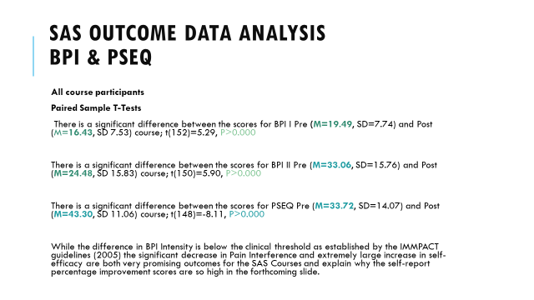

SAS exclusion criteria for attendance on the SHC: as informed by the BPS Pain Management Programme (PMP) guidelines (2021)
APPENDIX A5

SAS exclusion criterion for attendance on the SHC | How assessed & identified
Patient declined or unable to attend | Within clinical consultation
Any condition not presenting clinically as CNSLBP / CPMP | Within clinical consultation
Diagnostic uncertainty / awaiting further investigation | Within clinical consultation
Too frail; as determined by a Rockwood Frailty Score >4 | Within clinical consultation
Unstable Cardiovascular disease | Within clinical consultation
English language not at the required level to benefit from attending | Within clinical consultation
Server hearing or visual impairments without reasonable adjustment | Within clinical consultation
Completed the course in the past 5 years | Within clinical consultation
Severe psychiatric instability | Within clinical consultation
Active substance misuse | Within clinical consultation
Learning difficulty that would affect participation | Within clinical consultation
<18 years old | Within clinical consultation
Not able to commit to attending all sessions offered | Within clinical consultation

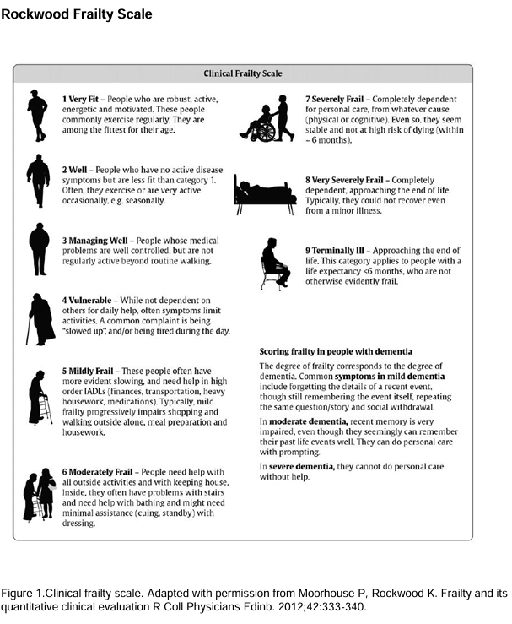
APPENDIX A6
Standard SAS clinical pathway for patients with CNSLBP
APPENDIX A7
Assessed by a Specialist Physiotherapist in Spinal Triage.
Clinical opinion is CNSLBP. Outcome scores completed: PIQ, PSEQ, PSQ.
Patient is written to explaining the clinical impression and agreed care plan.
Attendance on the Spinal Health Course is recommended.

In conjunction with (optional):

Hydrotherapy programme
Return to work assessment (OT)
Mindfulness sessions
Community gym programme
Outdoor exercise group
Sea swimming group
Radiofrequency Denervation
Pain medication review (Nurse led)
Opted not to attend the SHC
Attended the SHC (8h)
Review in clinic by a Specialist Physiotherapist in Spinal Triage:
Clinical opinion remains CNSLBP

Outcome scores completed:
Improved outcome scores (PIQ & PSEQ)
Confident to self-manage: Discharge to GP

No MCID in outcome scores (PIQ & PSEQ).
Patient concerned about diagnosis and has expressed a preference for imaging for reassurance purposes

Discussed in SAS MDT; if appropriate, a routine Lx MRI is requested.
If not appropriate, then option to access the Pain Service for further support or discharge to GP

MRI findings are discussed in the SAS MDT
Patient is written to by the Pain Consultant outlining the clinically relevant findings: clinical reporting

Patient is reviewed in clinic and shown images.
Findings are discussed are explained within the clinical context of CNSLBP.

Confident to self-manage: Discharge to GP
LBP is limiting recovery and return to work / normal ADL
Option to access the pain service for further support or discharge to GP

Discuss in SAS MDT and refer into Pain Service MDT.
For consideration of 8-day Pain Management Program (PMP)
Discharge to Pain Service or GP
Home exercises provided.
Discharge to GP

Tables with specific guidelines for NSLBP treatment recommendations and Imaging recommendations
APPENDIX B1

NICE LBP treatment Guidelines (updated 2020)
Ref. | Modality | Details
1.1.3 | Assessment | Based on risk stratification, reassurance should be given.
1.2.1 | Education | Provide advice, information and reassurance. Encourage normal activity.
1.2.2 | Exercise | Provide exercise guidance. Consider a group exercise programme
1.2.3 | Orthotics | Do not offer
1.2.6 | Manual Therapy | Consider if provided alongside exercise +/- psychological therapy.
1.2.8 | Acupuncture | Do not offer
1.2.9 | Electrotherapy | Do not offer
1.2.13 | Psychological therapy | Consider if provided alongside exercise +/- Manual therapy.
1.2.14 | Combined physical & psychological program | Consider if:  Significant psychosocial obstacle limiting recovery  Previous recommended treatments have failed
1.2.15 | Return to work support | Promote and facilitate return to work programmes  Promote and facilitate normal activities of daily living.

NICE guidelines for imaging LBP (updated 2020)
Ref. | Guideline details
1.1.4 | Do not routinely offer imaging in a non-specialist setting for people with low back pain with or without sciatica.
1.1.6 | Consider imaging in specialist settings of care (for example, a musculoskeletal interface clinic) for people with low back pain with or without sciatica only if the result is likely to change management.

LOWER BACK PAIN: Clinical Standard Care.
APPENDIX B2
Australian Commission, 2022.

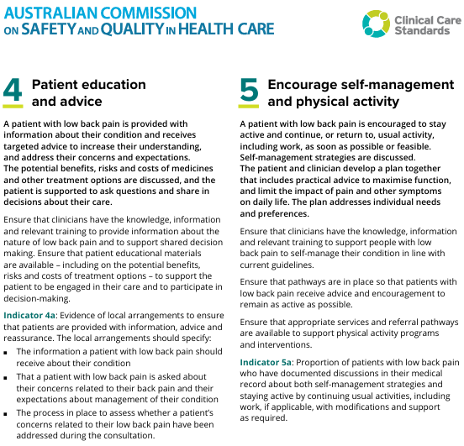

Red Flags Symptoms and Signs (NICE LBP guidelines, updated 2025)
APPENDIX B3
Assessment | Diagnosis | Back pain - low (without radiculopathy) | CKS | NICE

Cauda equina syndrome
- Sudden-onset bilateral or unilateral radicular leg pain progressing to bilateral pain; severe or progressive neurological deficit such as motor weakness of knee ankle or foot.
- Recent-onset difficulty initiating micturition or impaired sensation of urinary flow; urinary retention and/or overflow urinary incontinence (late signs).
- Recent-onset loss of sensation of rectal fullness; faecal incontinence (late sign).
- Recent-onset erectile dysfunction or sexual dysfunction.
- Perianal or perineal sensory loss (saddle anaesthesia or paraesthesia).
- Unexpected laxity of the anal sphincter.
- Gait disturbance or difficulty walking.

Spinal fracture
- Sudden onset of severe central spinal pain which is relieved by lying down.
- A history of major trauma (such as a road traffic collision or fall from a height), minor trauma, or even just strenuous lifting in people with osteoporosis.
- Structural deformity of the spine (such as a step from one vertebra to an adjacent vertebra).
- Point tenderness over a vertebral body.

Cancer
- Age 50 years or over.
- Gradual onset of symptoms or progressive pain.
- Severe unremitting lumbar pain; thoracic back pain; night spinal pain preventing sleep; spinal pain aggravated by straining (for example coughing, sneezing, or defaecation).
- Mechanical pain (aggravated by standing, sitting or moving).
- No symptomatic improvement after 4–6 weeks of conservative treatment.
- Unexplained weight loss.
- Claudication (muscle pain or cramping in legs when walking or exercising).
- Past history of cancer (breast, lung, prostate, renal, and gastric cancer are more likely to metastasize to the spine).

Infection (such as discitis, vertebral osteomyelitis, spinal or epidural abscess)
- Fever; systemically unwell.
- Recent infection.
- Diabetes mellitus.
- History of intravenous drug use.
- HIV infection, use of immunosuppressant drugs, or other cause of immunocompromise.
Brief Pain Inventory (BPI):
APPENDIX C1
Pain Severity Questionnaire (PSQ) & Pain Interference Questionnaire (PIQ)

Cleeland, C. S. (1991). Brief Pain Inventory Short Form (BPI-SF) [Database record]. American Psychological Association. https://doi.org/10.1037/t04175-000

Pain Self-Efficacy Questionnaire (PSEQ
APPENDIX C2

Nicholas, M. K. (2007). The Pain Self-Efficacy Questionnaire: Taking pain into account. European Journal of Pain, 11(2), 153–163. doi: 1016/j.ejpain.2005.12.008
PSEQ scoring
Description | Score Range
Server | 0
Moderate | 20
Mild | 31
Minimal | 41
Patients’ Global Impression of Change (PGI-C) Scale
APPENDIX C3
PATINET NAME

DATE

PHYSIO NAME

PHYSIO SIGNATURE

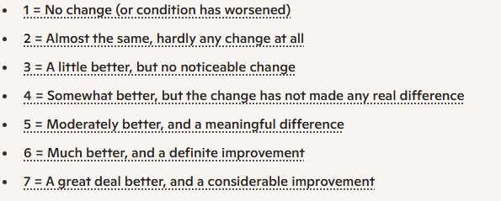
Please circle the sentence (1 - 7) that most appropriately matches how much of a change you have experienced in your symptoms since undergoing your MRI and having the finding explained to you:

Hurst, H. and Bolton, J. (2004). Assessing the clinical significance of change scores recorded on subjective outcome measures. Journal of Manipulative and Physiological Therapeutics, 27(1), pp.26–35. doi: https://doi.org/10.1016/j.jmpt.2003.11.003.

MRI clinical report following SAS MDT meeting (cc patient)
APPENDIX D1

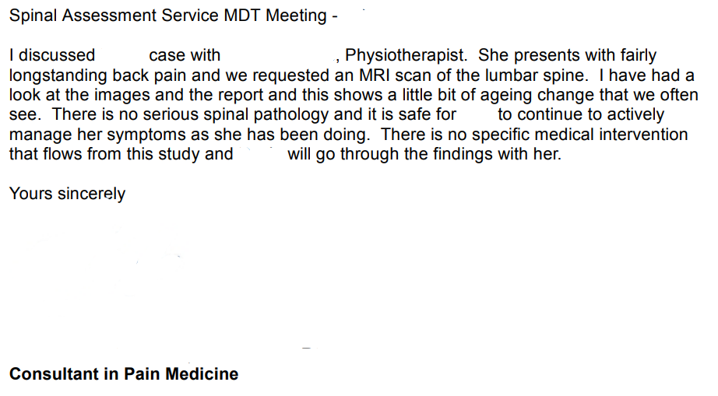

MRI Image report (corresponds to the clinical report above)

PROCEDURE: MRI Spine lumbar and sacral

CLINICAL INDICATION: Clinical Details: long standing back pain, no nerve root pain. BAC routine
Requested by:

FINDINGS:
Standard sequences performed and in the absence of plain films normal segmentation is assumed.
There is loss of disc hydration and height at L5-S1 with minor posterior disc bulge and small right of midline annulus tear.
Normal vertebral body marrow signal and alignment.
No main canal, lateral recess or foramina radicular impingement at any level.
Normal distal cord terminating at T12/L1. Unremarkable visible upper pelvis and retro peritoneum.

CONCLUSION:
Very early dehydration of L5-S1 disc with minor posterior bulge and small right of midline annulus tear but no other abnormality.

REPORTED BY:

CLBP: example initial assessment clinic letter (cc patient)
APPENDIX D2
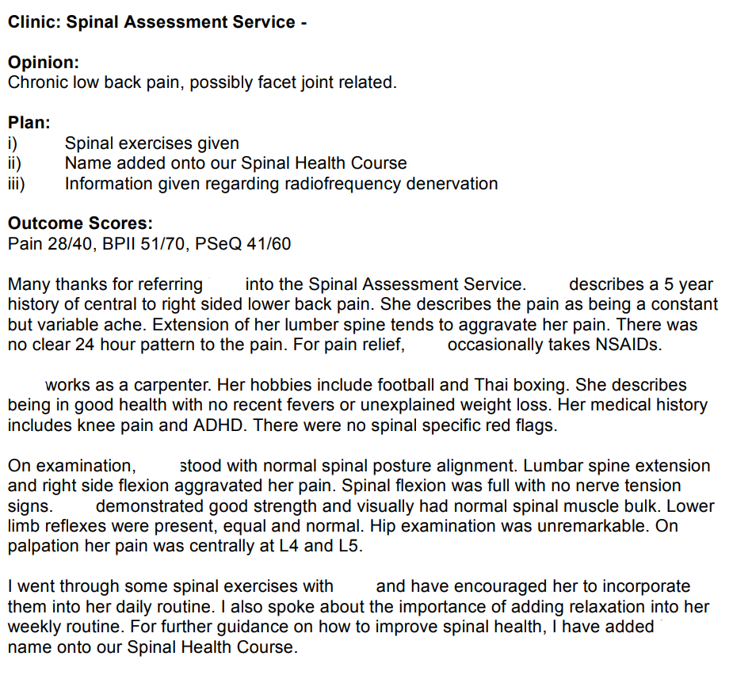
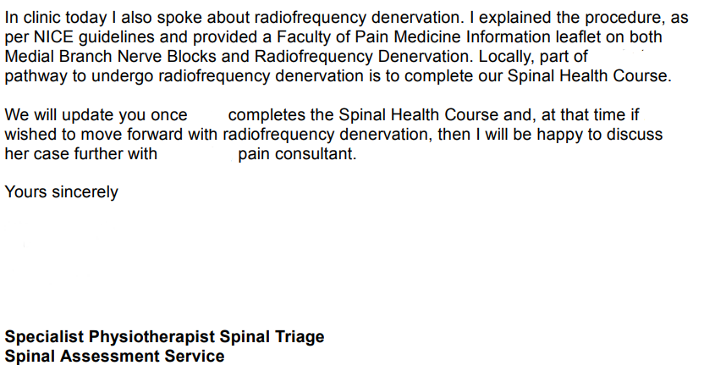
Example clinic letter on completion of SHC:
APPENDIX D3
with information on MRI (cc patient)

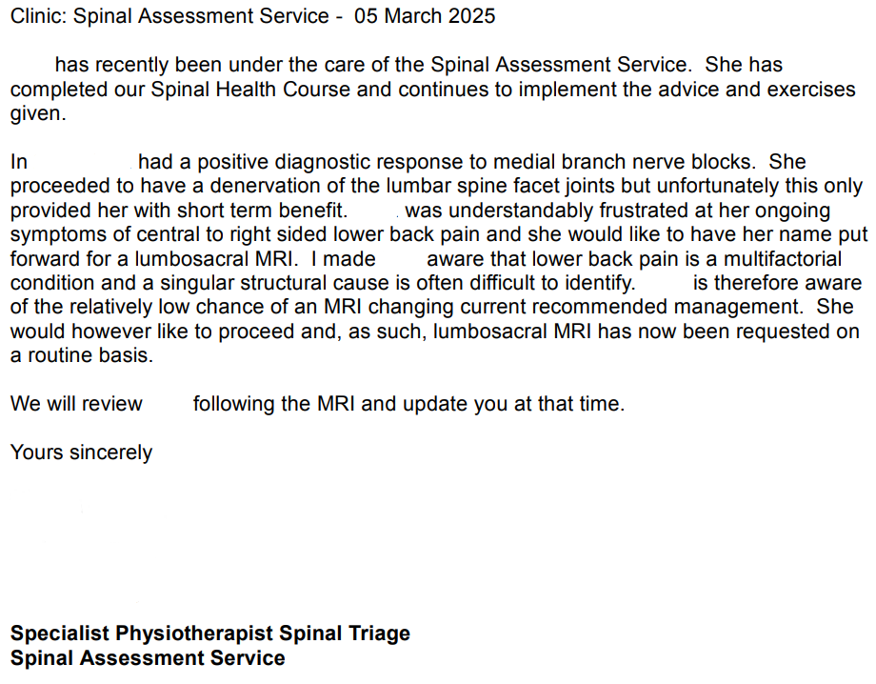

Example clinic letter following MRI (cc patient)
APPENDIX D4
(explained visually, verbally and in written format)

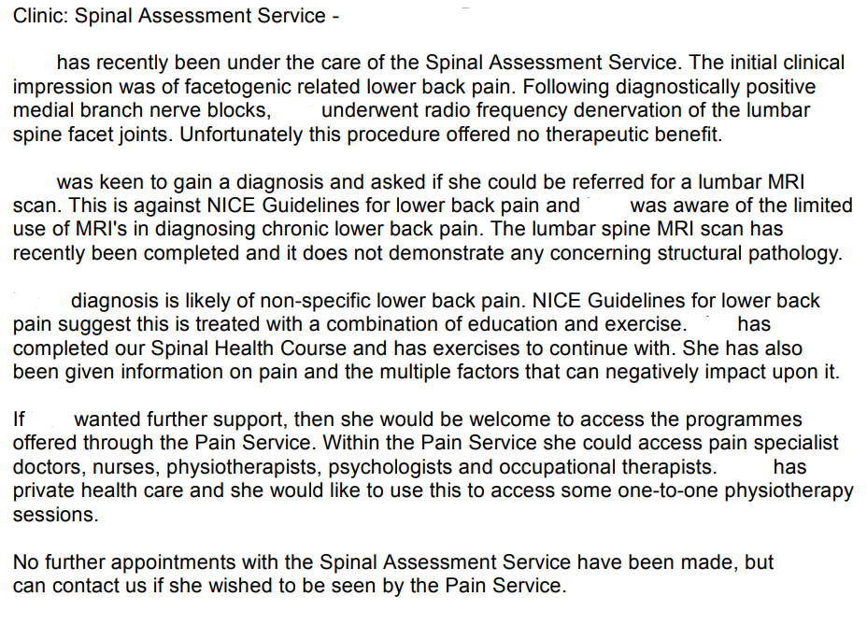



APPENDIX E1
Do you have any questions or concerns that you would like to discuss during your assessment?

…………………………………………………………………………………………………...............................................................................................

LIFESTYLE AND GENERAL HEALTH

Spinal pain can be influenced by many different factors, including some related to your health and general lifestyle. The below questions can help us assist you with your pain.

- Diet and Weight: How much do you weigh? …….... How tall are you? ………...

By providing these figures we can calculate your Body Mass Index (BMI)
Did you know? The risk of developing musculoskeletal disorders, such as spinal pain, increases with a high BMI.

- Alcohol: How much alcohol do you consume per week? ………………………………………

Did you know? Drinking too much alcohol can harm bone development, general health and healing in body areas that includes the spine. This is by affecting hormone production and impairing vitamin absorption.

- Smoking: Do you smoke? YES NO If yes, how many per day? …….....

Did you know? Smoking accelerates the rate of spinal disc degeneration as the nicotine in smoke restricts blood flow, this limits the spread of essential nutrients.

- Mental Health: Do you suffer from a mental health condition, such as anxiety, stress or depression? YES NO

Did you know? When the body is under stress, it may affect how the brain produces pain as well as making our muscles tense.

- Are you in paid employment? YES NO

If yes, please provide a brief job description ..............................................................................
Letter of Invitation to Participants
APPENDIX E2

My name is David Roberts, and I am a Specialist Physiotherapist in Spinal Triage. I work within the Spinal Assessment Service (SAS), and I am based at the Enid Quinault Health Centre, Jersey. I am currently studying towards an MSc in Pain Management at Cardiff University. As part of this course, I am required to complete a research project on a subject that is relevant to Pain Management. The title of my research project is:

Does a lumbar spine MRI reduce pain interference and improve self-efficacy in patients with chronic non-specific lower back pain (NSLBP) who have undergone a program of spinal education as exercise?

It is vital that you understand why the research is being done, and what it will involve, before you decide whether you would like to take part or not. Please carefully read the following information about this study so that you can make an informed decision. Do not hesitate to ask if there is anything that is not clear or if you would like more information.

Background information

Non-specific lower back pain (NSLBP) is defined as pain that is not attributed to a recognisable, known, specific pathology. It is a multifactorial problem that can be influenced by physical, psychological and social factors (Hartvigsen et al. 2018). According to the Lancet Global Burden of Disease 2021 report, approximately 85% of lower back pain can be classified as being non-specific.

National guidelines recommend that treatment for NSLBP should include a combination of education and exercise. This is provided by our 6-week Spinal Health Course. This course offers evidence-based information on the spine, as well as practical guidance on exercise and relaxation. Within the Spinal Health Course, the benefits, limitations and risks of undergoing MRI for NSLBP are discussed.

Chronic non-specific lower back pain (CNSLBP) is pain that has been ongoing for more than 3-months. In clinical guidelines for patients with CNSLBP, reassurance is a key element. The purpose of reassuring patients is to change their views on their illness and, thereby, their actions. However, when symptoms persist, reassurance can be difficult to achieve.
What is the purpose of this study?

The purpose of this study is to determine whether or not individuals requesting further imaging of the spine, that present clinically with CNSLBP, and have completed our spinal health course, and have been provided with visual, verbal and written explanation of their MRI findings experience a change in self-reported pain self-efficacy, and pain interference.

Can anyone take part in this study?

You are invited to take part in this research project because you are under the care of the SAS. Only patients under the care of the SAS, with a clinical diagnosis of CNSLBP, who have completed our Spinal Health Course, and are requesting that their name is put forward for a lumbar spine MRI are included. To help ensure your safety and the accuracy of the study, certain individuals may not be eligible to participate. Please notify me ASAP as you will not be able to take part if any of the following apply to you:
- You are currently pregnant
- You have a history of cancer
- You have a history of trauma related to your spine
- You have undergone previous spinal surgery
- There is a suspected osteoporotic (fragility) fracture
- You are experiencing crescendo pain (pain that is rapidly worsening)
- You are experiencing acute low back pain (less than 3 months in duration)
- You have been diagnosed with, or are suspected of having spondylopathy
- You are experiencing pain that radiates down your leg due to spinal involvement
- You are feeling generally unwell or systemically unwell
- You already have a previously available MRI related to your current back condition
- MRI is contraindicated (this will be discussed with you in clinic on an individual basis)

What is required of me if I take part?

There is no change to the normal pathway for CNSLBP currently offered to you by the SAS. You will have already completed questionnaires on completion of the spinal health course. Once you have had your MRI you will receive written correspondence from us outlining its findings (as per current pathway). You will then be seen in clinic, and the images will be discussed with you (as per current pathway). At this time, you will be asked to fill out repeat questionnaires (this is not required if you opt not to be a part of this research).

Are there any risks to being involved with this study?

There are no specific risks of participating in this study as the only change in pathway is for you to fill out an additional questionnaire whilst in clinic, when attending your follow up appointment.

With regards to undergoing MRI for NSLBP, you would have been made aware by your physiotherapist, both when attending the educational sessions of our spinal health course, and within 1:1 clinical appointment, that undergoing a lumbar spine MRI in cases of NSLBP is not indicated. This is because lower back pain is often a multifactorial condition and MRI findings often do not alter treatment recommendations.

If you had concerns regarding the results of your MRI an appointment could be made for you to see the Pain Consultant, Spinal Orthopaedic Consultant, or relevant specialist (this would be available to you whether you take part in the study or not). For further information, please see the attached NHS leaflet regarding undergoing MRI in cases of NSLBP.

Do I have to take part?

This study is entirely voluntary. After reading this information sheet it is completely up to you whether to take part or not. If you decide to take part, you will be given this information sheet to keep and you will be required to sign a consent form. You will be free to withdraw at any time without giving a reason. Your decision to participate / not participate in this study will have no effect on the treatment offered to you within Jersey healthcare Services.

Will the information from this study be kept confidential? What will happen to the results?

All information that is collected from you during the course of this study will be kept strictly confidential. Your name will be replaced with a participant number, and it will not be possible to identify you in any reporting of the data gathered. The results from this study will be statistically analysed and discussed before being submitted for marking. You will not be identifiable in any publications.

The findings from this research may be published in a medical journal or presented at professional conferences. If you wish, we can send you a summary of the findings once the study is complete. If you would like to be forwarded the findings from the study, please tick here:
Thanks for taking the time to read through this information sheet. If you have any further questions, then please ask. I have attached some relevant contact details overleaf. If you are happy that all your questions have been answered, and would like to participate in this study, then please complete the attached questionnaire and consent form.

Relevant Contact Details

Name of Researcher: David Roberts
Address: Spinal Assessment Service. Enid Quinault Health Centre, St Brelade, Jersey
Email: d.roberts@health.gov.je

Name of supervisor: Sharon Norman
Address: Cardiff University School of Medicine, Cardiff University, Cardiff
Email: NormanSE@cardiff.ac.uk

- If you would like to contact an independent person, who knows about this study, then you are welcome to contact Paul Michel. His contact details are given below:

Name of advisor: Paul Michel
Address: Spinal Assessment Service. Enid Quinault Health Centre, St Brelade, Jersey
Email: Pa.michel@health.gov.je

Consent Form
APPENDIX E3

Title of Project: Does a lumbar spine MRI reduce pain interference and improve self-efficacy in patients with chronic non-specific lower back pain (NSLBP) who have undergone a program of spinal education as exercise?

Name of Researcher: David Roberts

Please initial box

- I confirm that I have read and understand the
information sheet for the above study and have
had the opportunity to ask questions.

- I understand that my participation is voluntary
and that I am free to withdraw at any time, without
giving a reason.

- I agree to take part in this study.

Your Name Date Signature

Researcher Date Signature

Patient Label

APPENDIX E3

Spinal Assessment Service

DATE:
CLINICIAN NAME:
CLINICIAN SIGNATURE:
Please mark the site of your pain on these drawings. If your pain spreads from one site to another site or sites please show this by means of arrows. If you can, please also indicate the type of pain e.g burning or tingling. Please also note any areas of numbness.
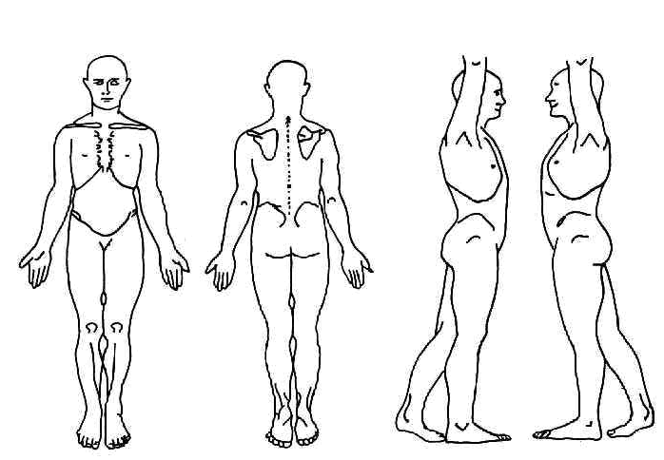
MRI Patient Information & Checklists (contraindications & Cautions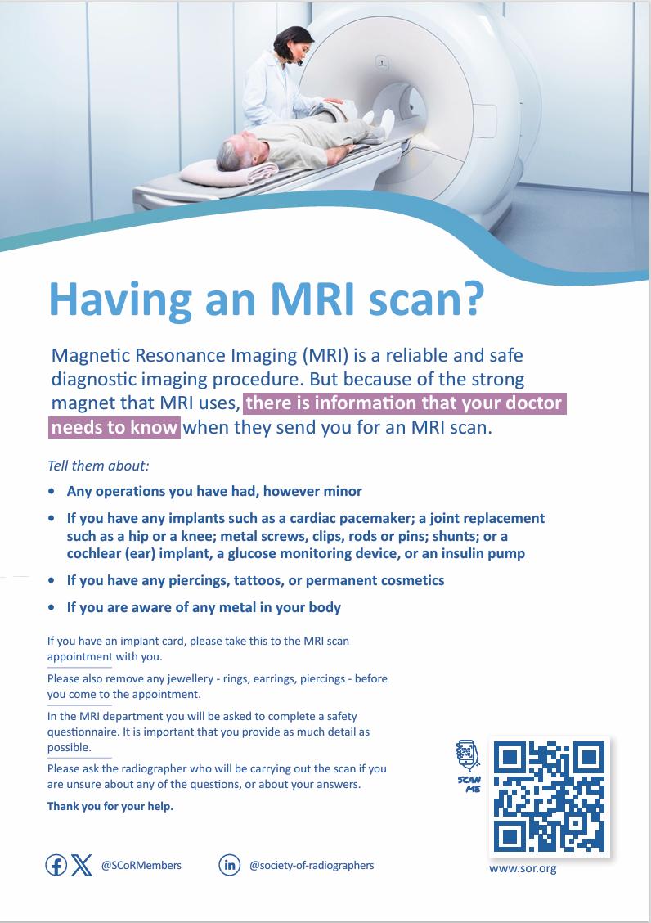
APPENDIX F1
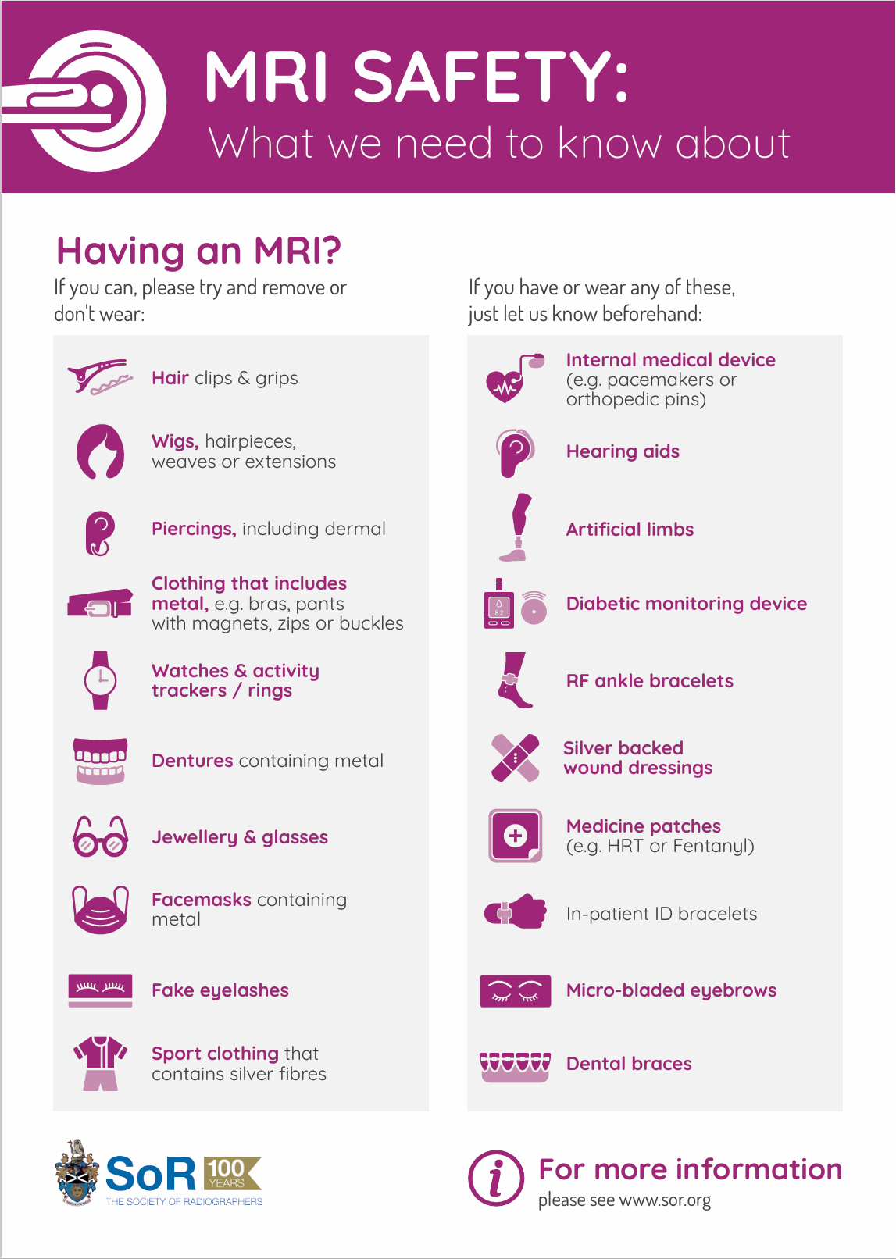

APPENDIX F2
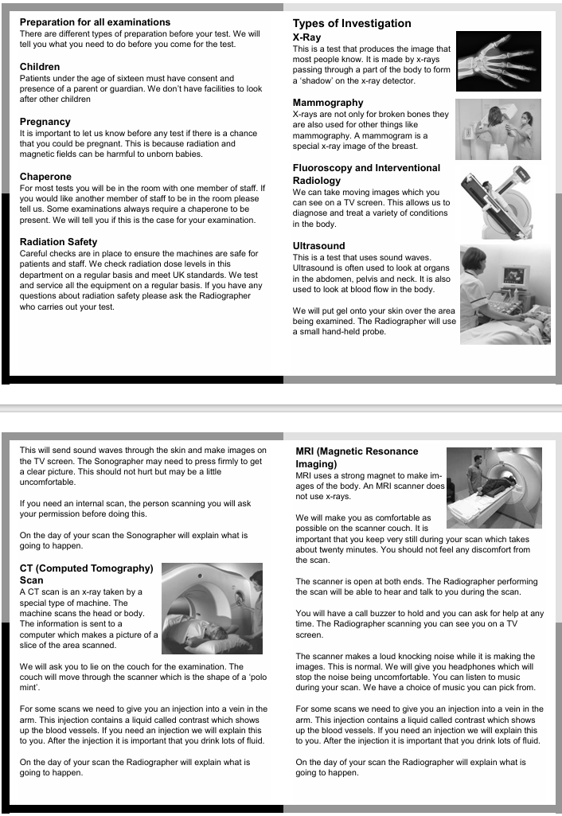
APPENDIX F3
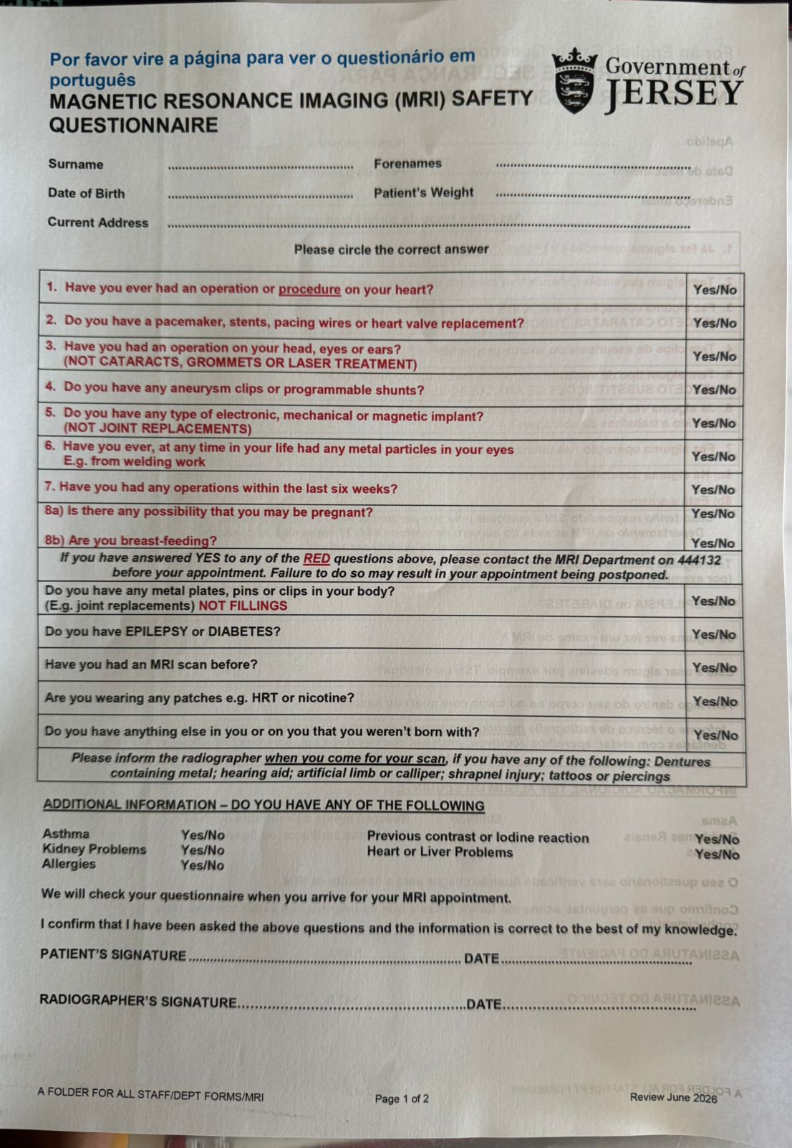

APPENDIX G1

Research Ethics Committee
Research Ethical Review Application

HCJ REC reference:

What is a REC?
A REC is a Research Ethics Committee, whose task it is to consider the ethics of proposed research projects which will involve human participants, and which will take place, generally, within Health & Care Jersey (HCJ). The key duty of the REC is to protect the interests of research participants whilst at the same time facilitating ethical research. The committee reviews research applications and gives an opinion on whether the research has any ethical issues.
PLEASE NOTE:
- This research ethical review application form is intended to be used for:

1.1 HCJ research proposals for:
- Proposed projects where participants are accessed via HCJ.
- Proposed projects where investigator/researchers are employees of HCJ.
- Proposed projects that will be sponsored by HCJ.

1.2 Projects that are part of an NHS multi-centre trial that have already IRAS approval. Please supply a copy of the full IRAS application and HRA REC favourable opinion letter.

1.3 Projects that are part of an academic programme where a scientific review is required from a university REC. Please supply a copy of the university Faculty Research Ethics Committee (FREC) scientific review and agreement to sponsor the research. A university will also require a copy of the HCJ REC review outcome.

- Please read this form and accompanying notes before attempting to complete it in order to avoid unnecessary duplication of answers. Supplementary notes for applicants are included at the end of this application form for guidance on completing the research ethics review application.

- Please complete all sections of this form. Where a section is not relevant to the proposed research project, please write "n/a” in the space provided.

- Cross-referencing of answers is not acceptable e.g. responses such as "refer to protocol" or "see above” must be avoided.

- Please note that a favourable opinion from the HCJ REC does not constitute permission to carry out a research project. A favourable opinion means that the HCJ REC is satisfied that ethical issues in planning the research project have been addressed to the satisfaction of the committee. Permission to carry out research must be obtained from the research site and authorising department head.

The Process of Ethical Review

This process of ethical reviews involves ensuring that any research project should fairly balance the likely benefits to the participant, or society, with the burdens involved and any risk of harm or actual harm to those taking part. It also means ensuring that the research proposal itself is necessary, properly designed, supervised, and conducted and that the outcome will answer the research question asked.

An extremely important part of this process is ensuring that patients or other potential participants are not unfairly pressured into taking part and that they are fully informed about the project and what it will mean for them. Central to this is the requirement to ensure that participants have appropriate information before they undertake the study (i.e. informed consent).

The HCJ REC will undertake ethical review in line with the committee’s Standard Operating Procedures which are aligned to the UK Research Ethics Service (RES) Standard Operating Procedures and other national and international legislation and guidance such as the Clinical Trials Regulations, Mental Capacity Act and the Human Tissue Act.

In reference to data protection, the terms of the Data Protection (Jersey) Law 2018 must be referenced in any research documentation for participants.

Applicant’s Checklist

Title of Study: | Does a lumbar spine MRI reduce pain interference and improve self-efficacy in patients requesting further investigation with chronic non-specific lower back pain who have undergone a program of spinal education as exercise? Cohort study design.
Lead researcher: | David Roberts

This checklist document MUST be completed and submitted as part of the application form. Please ensure ONE copy of each document, as detailed below, is attached as an appendix to this application form in the order that they appear on the list. ALL appendices MUST have dates and version numbers clearly marked. Indicate ‘yes/no’ as applicable and continue your document list on a separate continuation sheet if required.

Document | Enclosed? | Appendix № | Version № | Date
Applicant’s Checklist (this page) | Mandatory
List of references | Mandatory
Summary CV for lead researcher | Mandatory
Research protocol/summary | Mandatory
Letter(s) of invitation to participants | Y
Participant Information Sheet(s) | Y
Participant Consent Form(s) | Y
Information sheets / letters to other relevant personnel | N
Written permission(s) from relevant personnel/organisation (eg. to use facilities as a research site and/or access participants) | Y
Interview schedule(s) or topic guide(s) | N
Validated questionnaire(s) | Y
Non-validated questionnaire(s) | N
Gannt Chart/Timeline | Y
Copies of recruitment advertisement material(s) | N
Risk Assessment form(s) | Y
Copy of DBS Certificate (if applicable) | N
Authorising signature(s) | Y
Have you signed & dated form? | Y
Other documents
Educational course information
Ethics response

Part 1 Applicant details

Applicant name: | David Roberts
Research role: (e.g. Student or staff member) | Staff member
Programme of study or work department: | Spinal Assessment Service (Pain Service)
New application: | X | or Resubmission: |  | (Please X in appropriate box)
Title of study: | Does a lumbar spine MRI reduce pain interference and improve self-efficacy in patients requesting further investigation with chronic non-specific lower back pain who have undergone a program of spinal education as exercise? Cohort study design.
Application version: | 2
Date of application: | 15th August. 1st version 27th June 2025
Date of REC meeting to which application is being submitted: | 30th September

Applicants who are intending to complete the proposed research as part of an academic programme MUST discuss their proposal with their supervisor and have it signed off by their research supervisor before submitting the application for ethical review.

HCJ employees (where the proposed research project is not part of an academic programme) MUST discuss their proposal with the individual who has the authority to agree access to the research site; the application MUST be signed off by the said person before submitting for ethical review.

Once you have completed your application form, please submit it including all appendices (as detailed on the applicant checklist) by email to: the HCJ REC Administrator at: HCSResearchEthicsCommittee@gov.je

Applications must be received by the submission deadline to enable time for review before the HCJ REC meeting, where it will be discussed and an outcome agreed.
Confirmations
I confirm that:

- The information in this application is, to the best of my knowledge, accurate and I take full responsibility for it;

- I undertake to abide by the ethical principles embodied in the good practice guidelines identified in this application;

- I will not start data collection until a university scientific review (if required), a HCJ REC favourable ethical opinion, and permission to use research site are in place, as appropriate;

- If the research receives a favourable ethical opinion, I undertake to adhere, without deviation, to the study as outlined in the application;

- If I need to make any changes to the study, including the timescale, I will inform the HCJ REC before implementing any changes. Where the study is part of an academic programme, I will also seek advice from the university faculty REC;

- I am aware of my responsibility to be up-to-date and compliant with the requirements of the law and relevant guidelines relating to data security;

- I understand that personal data about me as a researcher and this application will be held by the HCJ REC in accordance with GDPR, and that this will be managed according to the principles established in the Data Protection (Jersey) Law 2018;

- I will provide the HCJ REC with an annual update report on the progress of the research;

- I will provide a brief end of project report to the HCJ REC on the completion of my project;

- I will advise the HCJ REC of any publications that are a product of the study;

- All relevant signatures must be obtained before submitting this application. Failure to have all the required signatures will result in your application being returned to you, which may delay your review.

- Applicants should note that it is their responsibility to submit their proposal in sufficient time, particularly when working to tight/strict deadlines.

Applicant: David Roberts

Signed: 

Date: 27/6/2025
Authorising Signatures

Please note:
If you are a student undertaking a research project as part of a course of academic study, BOTH authorising signatures must be completed before an application can be accepted.

If you are undertaking a research project as a staff member, you require a research site (someone who can grant permission to access the site for research purposes) authorisation signature; an academic supervisor signature is not required.

Approval from Academic Supervisor (for student research only)

I confirm that the applicant has discussed their research proposal with me, and that I have read and agree to support this application.

Name: Sharon Norman

Signed: 

Date: 12/08/2025

AND / OR

Approval from individual who is able to provide organisation authorisation to undertake the research, use the research site and access participants.

I confirm that the applicant has discussed their research proposal with me. I understand the purpose of the research and I am aware of all the implications that conducting this research may have. I am in agreement with the research and support this application.

I confirm that I have the authority to provide organisation authorisation for the applicant to undertake the research, use the research site and access participants.

Name: Paul Michel
Signed: 

Date: 30/6/2025

AND / OR

Approval from individual who is able to provide organisation authorisation to undertake the research, use the research site and access participants.

All MRI’s will be approved and requested by the Pain Consultant following discussion of clinical details. This is per current pathway / current standard practice so there is no additional cost. The pathway for requesting routine MRI is outlined in Appendix I.

We align with NICE guideline 1.1.6 for requesting imaging for NSLBP.
1.1.4 | Do not routinely offer imaging in a non-specialist setting for people with low back pain with or without sciatica.
1.1.6 | Consider imaging in specialist settings of care (for example, a musculoskeletal interface clinic) for people with low back pain with or without sciatica only if the result is likely to change management.

There will be no change to current practice (other than to request participants complete a Pain Interference and Pain Self Efficacy questionnaires pre and post MRI). Therefore, there is no change in service access.

Once completed, all MRI findings will be discussed with the Pain Consultant prior to informing patients. If there are any concerns (either before or after seeing a patient) then the applicant (David Roberts) will have the opportunity to discuss this further with the pain consultant (as per current pathway / current standard practice).

All participants will have access to the Pain Service MDT if deemed appropriate (as per current pathway / current standard practice).

There will be no extra MRI requests as a consequence of this research project. Radiology service will not be impacted outside of what is current standard practice. Radiology are in agreement with the current pathway.

I confirm that the applicant has discussed their research proposal with me. I understand the purpose of the research and I am aware of all the implications that conducting this research may have. I am in agreement with the research and support this application.

I confirm that I have the authority to provide organisation authorisation for the applicant to undertake the research, use the research site and access participants.

Name: Dr Chad Taylor
Signed:

Date: 15/9/2025

Part 2: Introduction

- Title of research project:
Does a lumbar spine MRI reduce pain interference and improve self-efficacy in patients requesting further investigation with chronic non-specific lower back pain who have undergone a program of spinal education and exercise? Cohort study design.

- Project Details

Project location: |  | Jersey
Project duration: |  | 10-weeks.
Expected start date: |  | September 2025
Expected end date: |  | November 2025
- Lead researcher
NB. The lead researcher must submit a copy of their current CV (max. 2 sides of A4) with this application. This is to demonstrate research experience to lead a research project.
Student applicants below MSc level should name their research supervisor as the Lead Researcher and themselves as the applicant.
Name of Lead Researcher: |  | David Roberts
Status: (eg.MSc student; Doctoral student; staff researcher; staff member, other – please specify) |  | Msc (physiotherapy pre reg), Currently studying MSc Pain Management, Current staff member GOJ.
Address for correspondence: |  | Pain Service Enid Quinault Health Centre, Jersey
Contact telephone number: |  | 07700715899
Contact email address: |  | d.robets@health.gov.je
Professional position  (if applicable): |  | Physiotherapist
Experience of research methods: |  | Undergraduate (BSc), Pre registration (MSc), Current MSc studies.
- Other individuals who may work on the research project
NB. If there are more than two additional researchers, please note their details on a separate sheet and append to this application. A summary CV (max. 2 sides of A4) for each additional person must accompany this application.
Name: |  | N/A
Status:
Contact telephone number:
Contact email address:
- Academic supervision: (if proposed research is part of an academic
programme of study)

Primary supervisor:  Email address: |  | Sharon Norman  NormanSE@cardiff.ac.uk
Additional supervisor(s):  Email address: |  | Chris Jenkins  JenkinsC38@cardiff.ac.uk
- Who is sponsoring the proposed research?

Spinal Assessment Service; Government of Jersey.
- Good research practice:
Please confirm that the research will be carried out in accordance with the 4 Ethical Principles of Research – autonomy, beneficence, non-maleficence and justice and in accordance with recognised standards of practice as in the Declaration of Helsinki
Y | I agree to undertake the proposed research, as outlined in this application, in accordance with the 4 Ethical Principles of Research and the Declaration of Helsinki.
Please state which other professional codes of conduct you will abide by (if applicable): HCPC. https://www.hcpc-uk.org/globalassets/resources/standards/standards-of-proficiency---physiotherapists.pdf
- Has the research proposal had a review from a previous REC eg IRAS review via HRA REC?

No

If yes, you do not have to complete the remainder if this application and can submit your full IRAS application and outcome in lieu of this.
`

- Has the research proposal had a scientific review from e.g. university faculty REC?

No If yes, include their outcome letter.

Part 3: The research

- Type of research proposed:
Please indicate whether the proposed research is:
Quantitative
Outline of the research:

The purpose of this research is to determine whether or not patients asking for imaging of the spine, that present clinically with CNSLBP, and have completed our spinal health course (therefore have informed consent around the value and limitation of imaging in NSLBP), and have been provided with visual, verbal and written explanation of their MRI findings, experience a change in pain self-efficacy (as determined by the Pain Self Efficacy Questionnaire) and pain interference (as determined by the Brief Pain Inventory Interference questionnaire).
Hypotheses and/or research question(s)/focus to be addressed:

Does a lumbar spine MRI reduce pain interference and improve self-efficacy in patients requesting further investigation with chronic non-specific lower back pain (CNSLBP) who have undergone a program of spinal education and exercise?

Hypothesis: When combined with formal spinal education (>5 hours), patients presenting with NSLBP, who are asking for a Lumbar spine MRI, experience an improvement in pain self-efficacy, and a reduction in pain interference, in patients presenting with CNSLBP.
Rationale, to include a brief synopsis of the background to the research:

NSLBP is defined as pain that is not attributed to a recognisable, known, specific pathology. It is a multifactorial problem that can be influenced by physical, psychological and social factors (Hartvigsen et al. 2018). According to the Lancet Global Burden of Disease 2021 report, approximately 85% of lower back pain can be classified as being non-specific.

National guidelines (NICE, 2016; updated 2020) recommend that treatment for NSLBP should include a combination of education and exercise. This is provided by our 6 session Spinal Health Course. This course offers evidence-based information on the spine, as well as practical guidance on exercise and relaxation. Within the Spinal Health Course, the benefits, limitations and risks of undergoing MRI for NSLBP are discussed.
Chronic non-specific lower back pain (CNSLBP) is pain that has been ongoing for more than 3-months. In clinical guidelines for patients with CNSLBP, reassurance is a key element. The purpose of reassuring patients is to change their views on their illness and, thereby, their actions. However, when symptoms persist, reassurance can be difficult to achieve.

Many service users accessing our service attend with an expectation of achieving a diagnosis. NSLBP is a diagnosis made clinically, with radiographic investigations not believed to be helpful (Alhowimel et al., 2020). Despite this, some service users continue to request further investigation, even after attending all educational programmes offered through our service. This difference between patient expectation, and clinician opinion can negatively impact compliance with evidence based active treatments and beneficial behavioural changes around exercise, diet and stress; thus, negatively impacting patient outcomes, such as returning to work.

Within the author of this research proposals clinical setting, patients whose clinical presentation aligns with CNSLBP are encouraged to attend our Spinal Health Course (appendix). This course covers pain education. It also discusses the limitations of undergoing radiographic investigations for CNSLBP, such as the high prevalence of false positive findings (Brinjikji et al. 2015).

After completion of a program of education and exercise many patients within the author of this research proposals service still record low pain self-efficacy, and high pain interference. This correlates with the research on Pain Education showing a mixed response when applied to CNSLBP (Cuenca-Martinex et al. 2023; Moseley et al., 2025).

A key aim when treating CNSLBP is to provide reassurance that movement is safe. However, when symptoms persist this can be difficult to achieve. The aim of this research proposal is to explore whether the addition of a lumbar MRI, in patients with CNSLBP who have completed a program of education, and are requesting further investigation, reduces pain interference (as measured by BPI – pain interference questionnaire), and increases pain self-Efficacy (measured by the pain self-efficacy questionnaire / PSEQ).

2.1 NICE Guidelines for LBP and imaging
1.1.4 | Do not routinely offer imaging in a non-specialist setting for people with low back pain with or without sciatica.
1.1.6 | Consider imaging in specialist settings of care (for example, a musculoskeletal interface clinic) for people with low back pain with or without sciatica only if the result is likely to change management.

Table 1 outlines the NICE guidelines for imaging individuals with LBP (last updated 2020). The SAS is a specialist setting for people with low back pain; and therefore, by considering imaging we do align with guideline 1.1.6. Imaging is however not routinely offered for LBP within the SAS; with it only being considered if an individual has followed the local pathway set out in figure 1 (APPENDIX).
Study design, to include recruitment & sampling strategy, inclusion/exclusion criteria, sample size:

Study Design | Cohort study
Subjects | Approx. 15
Inclusion Criteria | - Chronic Non-Specific Lower Back Pain (CNSLBP): as determined following an assessment by a grade 10 or above physiotherapist specialising in spinal triage.  - Completion of The Pain service (Enid Quinault health centre) Spinal Health Course (appendix).  - Requesting further investigation.  - 18-55 and resident of Jersey.
Exclusion Criteria | - Conditions that would contradict undergoing MRI  - Pregnancy  - PMH of cancer  - History of Trauma  - Previous spinal surgery  - Suspicion of osteoporotic fracture  - Crescendo pain  - Acute LBP  - Spondylopathy (formal diagnosis or suspicion)  - Spinal related leg pain as defined by (appendix).  - Patient systemically unwell  - Previously available MRI
Outcome measures | - Brief Pain inventory (Pain Interference)  - Pain Self-Efficacy Questionnaire (PSEQ)

  - Proposed method(s) of data collection: SPSS. NVivo
  - Proposed method(s) of data analysis: SPSS. NVivo.
  - Description of site(s) / facilities required: Enid Quinault Heath Centre, Jersey (no change in normal working pattern and location). Government of Jersey building. Clinic room as allocated on weekly site list.
- Ethical issues:

Please summarise what you think are the ethical issues inherent in this study. The questions that follow will give you the opportunity to demonstrate how you will manage these issues in the conduct of your research.
Are there any potential risks or adverse effects to participants? There is no change to current pathway; other than completion of questionnaires post MRI (BPI & PSEQ). Any risk will be mitigated through appropriate safeguarding and clear participant communication.
Are there any particular requirements or abstentions that will be imposed on participants? No. There is no change to current pathways.
What are the potential benefits to participants, or to the wider society? The research aims to expand and understand the evidence base so that clinicians can follow evidence-based treatment pathways. This will allow clinicians evidence-based information on whether a lumbar spine MRI offers reassurance to patients with CNSLBP when first line treatment has included comprehensive spinal education and exercise and the patient is insistent on accessing further investigation.
What are the potential risks or adverse effects to researchers themselves? Nil. No change from current pathway (Pain consultant led).
Where samples will be taken from the participant, please state which samples, the amount and frequency of them & whether the sample would be taken as part of the normal patient care or specifically for the purposes of the research? If a sample would normally be taken as part of usual patient care - will the amount taken be any greater due to the participation in the research? N/A

Where the research involves the use of radioactive isotopes, please confirm that the dosage proposed to be used in the research has been approved by a Radiological Safety Committee or Administration of Radioactive Substances Advisory Committee (ARSAC), and that the person(s) who will administer the dose is/are properly qualified and hold(s) the necessary certificate(s)? N/A

Where the research involves the testing of a medicinal product (or medical device), please state the regulatory status of the drug/device in question. Is the research being conducted under the terms of a product licence, Clinical Trials Certificate (CTC), Clinical Trials Exemption (CTX) or Doctor’s and Dentist’s Exemption (DDX)? N/A

Please indicate whether participants will receive payment or reimbursement for taking part in the research study (including reimbursement of expenses). If so, what amount? N/A / NO
Please state the relationship, if any, which may/will exist between the researcher(s) and potential participants. (Eg. will any of the participants be students, subordinates or colleagues of the investigator, or staff members?) None
- Informed consent:
Will informed consent be obtained from the research participants?

Yes

If ‘YES’, please give details of who will obtain consent and how this will be done, including how long participants will have to decide whether or not to take part. If ‘NO’, please explain why not.

Information leaflet provided. Participants will need to inform researcher of involvement between September – November 2025. Data of participants who request to withdraw after this date but before 1st January 2026 will be excluded from the write up of the Authors dissertation. Should the research be suitable for publication, participants may request their data be removed up until publication submission.

Children: Can you confirm that, where the participant is 16 years old or over, consent to participate in the research will be obtained from the young person themselves. No under 18s seen by service or included in study.
Can you confirm that, where the participant is under 16 years of age but is judged to have the maturity and capacity to understand the nature of the research, consent to participate in the research will be obtained from the young person themselves. No under 18s seen by service or included in study.
Please state the manner in which any apparent objection to participation by a minor will be handled. N/A

Please state whether and how parental consent, or consent of the legal guardian or order/declaration of the court, will be sought in relation to the participation of minors. N/A
NB. Copies of the consent form(s) and Participant Information Sheet(s) to be used in the research must accompany this application as an appendix.

- How will participants who may not adequately understand verbal explanations or written information given in English be enabled to consent? Non English speaking individuals are excluded from the study (due to them not being able to attend our educational program).

- Please state what measures will be taken to ensure that participants are able to withdraw from the research at any time without explanation and without fear of reprisal should they so wish. Information leaflet provided. If a participant asks to withdraw from the study, then any data taken from them will be deleted.
- Confidentiality of data:

What measures will be taken to protect the confidentiality of participants’ data?
- Data will be stored in encrypted files / databases (excel) to prevent unauthorised access.
- Access to participants data will be restricted to authorised personnel who need it for the research.
- Strong passwords will be required for accessing data.
- Direct identifiers will be replaced with pseudonyms to prevent direct identification of participants.
- Only the necessary data will be collected to ensure minimise the risk of privacy breaches.
- Data will be securely disposed of when it is no longer needed (as per “Retention Framework for Research Data and Records” Medical Research Council. See: https://www.ukri.org/wp-content/uploads/2023/03/MRC-100323-RegulatorySupportCentre-RetentionFrameworkResearchDataRecords.pdf
- Caldicott principles for professional standards and good practice will be followed.
Who will have control and act as custodian of the data used in / generated by the research? The Spinal Assessment Service. Caldicott guardian (medical director).
Can you confirm that the data will be retained in accordance with the Data Protection (Jersey) Law 2018? This should be included in any participant documentation.

Yes, I confirm that data, with regard to computer storage and processing of participants’ personal information, will be stored securely and confidentially for no longer than is necessary and comply with the Data Protection (Jersey) Law 2018. As far as possible, the data supplied and generated during the course of the study will remain confidential.

- Vulnerable groups:

Are you specifically recruiting participants from any of the following groups? NO

Children under 16
Pregnant women
The elderly
Persons suffering from mental disorder
Adults with learning disabilities
Prisoners
Young offenders
Other vulnerable groups
Please explain why it is necessary to conduct research involving such participants, and whether the required data could be obtained by any other means. N/A

Please state what special or additional arrangements, if any, will be applied, particularly in relation to Participant Information Sheets and gaining informed consent, to safeguard the interests of such participants. N/A

Please state whether, and if so, how participation in the proposed research may/will be of personal benefit to individual participants. N/A.
- Disclosure statement:

If you are working with vulnerable adults or minors (under the age of 18 years old), please state whether or not you have applied for and/or received a DBS disclosure statement.

No (not working with vulnerable adults)

If ‘YES’, please give the disclosure number and date this was made.

Disclosure number:  Date of disclosure: |  | N/A  N/A

Part 4: Financial and other arrangements

- Please state any financial or other interests (including any conflicts of interest) that the applicant, supervisor(s) or employer has in relation to the conduct of this research. Nil

- Please state the amount of payment, if any, that will be paid to the researcher(s)
[over and above their normal salary]. Nil
- What additional costs will be incurred by HCJ through the conduct of the research, and how are these to be met? Please state the details of any funding which has been secured for the research. Nil

- What arrangements are in place for monitoring the conduct of the research, and dealing with any issues, complaints or adverse effects which may arise from the research?
- Regular communication with academic supervisors.
- Regular planned meetings with colleagues (Medical Pain Consultant,
- Physiotherapy Consultant, and Clinical Leads) within the Spinal Assessment Service and Pain Service (each Monday time-tabled). Additional time can be organised.
- Adverse effects would be recorded via the Datex reporting system.
- Complaints would be directed towards PALS.

CV

Personal Details:

David Colin Roberts

17th January 1983

La Maison Du La Trappe, La Rue Du LA Trappe, St Ouen, Jersey, JE3 2AL

07700715899

Academic Qualifications:

GCSE (1999): 9 A-C grades achieved

A-Levels (2001): Sports Studies (A grade)
Biology (B grade)
Geography (C grade)

BSc (Hons) (2004): Sport Injury Rehabilitation (2; 1)
St Mary’s University, Twickenham

MSc (2007): Physiotherapy (pre-registration: 2; 1).
Queen Margaret University, Edinburgh

MSc (2022-present) Pain Management
Cardiff University, Cardiff

Professional Qualifications:

ITEC diploma in Holistic Massage; 2002

ITEC diploma in Aromatherapy; 2003

AACP Basic Acupuncture Foundation Course; 2011

Registered Professional bodies:

HPC: PH 83815

CSP: 080348

Hobbies & interests

I fish on my sea kayak and when possible, go on surfing, sailing and snowboarding holidays. To keep fit, I cycle or run to work. I also occasionally take part in middle-distance triathlons. I enjoy keeping bees and have completed various courses in this. I am a level 2 qualified football coach and run a girls U12 football team. Most importantly, I am a proud Dad and most of my spare time is spent with my family.

Professional interests

After graduating as a physiotherapist, I spent time working in exercise rehabilitation; this was within football teams, the army, and a rehabilitation centre for Amputees in Cambodia. It quickly became clear that taking a biopsychosocial approach to rehabilitation would yield the most benefit.

My current role as a spinal triage physiotherapist requires me to assess patients for potential serious spinal pathology, whilst also offering reassurance to patients presenting with longstanding, high impact pain with entrenched negative beliefs around the safety of their spine.

During my MSc I explored topics such as pain education. Within this I learnt about the impact that language can have on pain, as well as the importance of taking a patient’s own beliefs and wishes into account when considering a care plan.

Pain Education is often cited as a method to provide reassurance. In some cases, however, this is not sufficient; particularly in individuals who have been given a variety of structural based explanations for why their pain remains ongoing.

Based on the above, I wanted to explore whether offering a lumbar spine MRI to patients who have completed a program of spinal education and are wishing to access further investigation of the spine is beneficial and improving pai self-efficacy and reducing pain interference.

Relevant Employment History

Soccer coach for Major League Soccer (MLS), USA. 2003
Massage Therapist Tignes, France. 2004-2005
Physiotherapist Prey Veng, Cambodia. Red Cross. 2005-2006
Injury Rehabilitation, Aldershot Army Base. 2007
Sports Injury Rehabilitation, Crawley Football Club. 2007
Rotational Physiotherapist Torbay Hospital, Devon (NHS). 2007-2010
Specialist MSK Physiotherapist Paignton and Brixham Hospital (NHS). 2010-2013
MSK Physiotherapist Torquay United Football Club: 2010-2011
MSK Physiotherapist, Jersey Sports & Spinal Clinic (private). 2014-2016
MSK Physiotherapist Jersey General Hospital. 2013-pre
Research Ethics Committee; favourable outcome letter (conditional)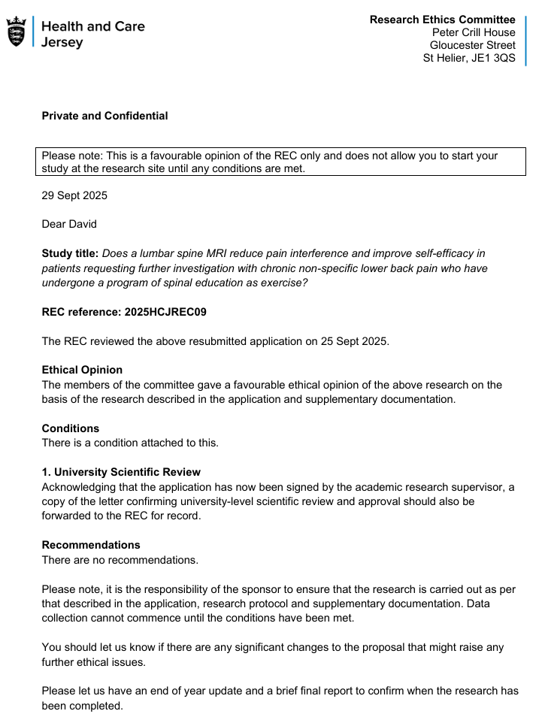 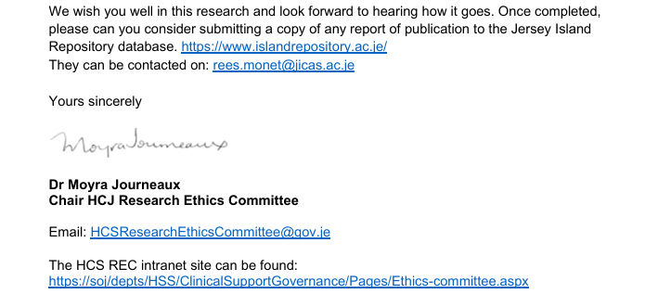
APPENDIX G2
Research Ethics Committee; condition approval
APPENDIX G3

From: HCS Research Ethics Committee <HCSResearchEthicsCommittee@gov.je>
Sent: 10 October 2025 14:21
To: Sharon Norman <NormanSE@cardiff.ac.uk>; David Roberts <RobertsD33@cardiff.ac.uk>; HCS Research Ethics Committee <HCSResearchEthicsCommittee@gov.je>
Subject: RE: REC outcome 2025HSCREC

Hello Sharon,

Thank you for confirming. We needed assurance that the university were happy to sponsor the research as it is outside of the UK.

Most of the student research projects we get have gone through their university ethics panel first. In Jersey our Health REC is aligned to (though not part of) the HRA. Therefore, in Jersey, students would not apply through IRAS for an ethical review, they go through the Jersey Health REC. As part of that review, student research projects are required to have sponsorship from their university. Our on students go through our partner universities for a school/faculty ethics review process and the outcome of this satisfies the Jersey Health REC that the university have approved and therefore are sponsoring the research.

I studied with Cardiff University myself and my research had to go to a university REC before the Island Health REC.

We can accept your email as confirmation of Cardiff University’s sponsorship for outside of UK research.

Best wishes,
Moyra

Dr Moyra Journeaux
Academic Lead (Postgraduate and CPD) | Academic Link for BSc Operating Department Practice
Chair Jersey Health Research Ethics Committee

T: +44(0)1534 442741
E: m.journeaux@health.gov.je m.journeaux@rgu.ac.uk mjourneaux@partner.chester.ac.uk

Faculty of Health Education | Jersey Campus University Education Team
Government of Jersey | Health and Care Jersey | Harvey Besterman Education Centre | Gloucester Street | St Helier | Jersey | JE1 3QS
Research Integrity test: evidence of achieving a pass (>80%)
APPENDIX G4



Check list for participation in study:
APPENDIX H1 I
Participant | CNSLBP | Completed | BPI & PSEQ | No MCID change | Requested further | Meets inclusion | Meets exclusion | Consent to | BPI & PSEQ | PGI-C Scale
Number | on Ax | SHC (all) | Completed | PI & PSE | Investigation | criteria | criteria | be participant | Completed | Completed
1 | Y | Y | Y | Y | Y | Y | Y | Y | Y | Y
2 | Y | Y | Y | Y | Y | Y | Y | Y | Y | Y
3 | Y | Y | Y | Y | Y | Y | Y | Y | Y | Y
4 | Y | Y | Y | Y | Y | Y | Y | Y | Y | Y
5 | Y | Y | Y | Y | Y | Y | Y | Y | Y | Y
6 | Y | Y | Y | Y | Y | Y | Y | Y | Y | Y
7 | Y | Y | Y | Y | Y | Y | Y | Y | Y | Y
8 | Y | Y | Y | Y | Y | Y | Y | Y | Y | Y
9 | Y | Y | Y | Y | Y | Y | Y | Y | Y | Y
10 | Y | Y | Y | Y | Y | Y | Y | Y | Y | Y
11 | Y | Y | Y | Y | Y | Y | Y | Y | Y | Y
12 | Y | Y | Y | Y | Y | Y | Y | Y | Y | Y
13 | Y | Y | Y | Y | Y | Y | Y | Y | Y | Y
14 | Y | Y | Y | Y | Y | Y | Y | Y | Y | Y
TIME LINE: EACH STAGE NEEDS TO BE COMPLETED PRIOR TO PROGRESSING TO THE NEXT

Participant Demographic Data:
APPENDIX H2

Demographics
Participant Number | Age | Gender | Mental health diagnosis | Obesity | Employed | Smoking | Alcohol intake above UK guideline amount | Duration of LBP symptoms (years)
1 | 25 | M | N | N | Y | N | N | 0.9
2 | 54 | F | N | Y | Y | N | N | 4
3 | 49 | F | Y | N | N | N | Y | 2.5
4 | 45 | M | N | N | Y | N | N | 1
5 | 33 | M | Y | N | N | N | N | 2
6 | 37 | F | Y | N | N | N | N | 0.8
7 | 48 | M | N | N | Y | N | N | 10
8 | 54 | M | Y | Y | Y | Y | Y | 15
9 | 53 | F | N | N | N | N | Y | 5
10 | 50 | F | N | Y | N | N | N | 1
11 | 45 | M | Y | N | N | N | N | 1
12 | 29 | M | N | N | Y | N | N | 2
13 | 41 | M | N | N | Y | N | N | 0.9
14 | 51 | F | Y | N | Y | N | N | 3
Mean | 43.85714 |  |  |  |  |  |  | 3.507142857
SD | 9.50188 |  |  |  |  |  |  | 4.135300991

Raw data collected: PSQ, PIQ, & PSEQ
APPENDIX H3

 | Brief Pain Inventory (BPI): Initial Assessment |  |  | Brief Pain Inventory (BPI): On completion of SHC |  |  | Brief Pain Inventory (BPI): Clinical report of MRI
Participant Number | Pain Severity | Pain Interference | Pain Self-Efficacy | Pain Severity | Pain Interference | Pain Self-Efficacy | Pain Severity | Pain Interference | Pain Self-Efficacy
1 | 21 | 49 | 24 | 24 | 42 | 30 | 20 | 19 | 51
2 | 8 | 15 | 49 | 8 | 22 | 47 | 11 | 15 | 56
3 | 19 | 27 | 36 | 21 | 35 | 24 | 8 | 14 | 40
4 | 34 | 59 | 10 | 25 | 70 | 9 | 32 | 60 | 9
5 | 20 | 35 | 11 | 11 | 31 | 15 | 20 | 29 | 19
6 | 5 | 15 | 58 | 8 | 13 | 53 | 8 | 15 | 50
7 | 15 | 21 | 46 | 15 | 26 | 44 | 13 | 21 | 60
8 | 18 | 9 | 52 | 4 | 9 | 51 | 4 | 9 | 45
9 | 11 | 40 | 39 | 36 | 63 | 0 | 8 | 16 | 58
10 | 28 | 44 | 40 | 24 | 39 | 48 | 15 | 20 | 49
11 | 36 | 63 | 5 | 15 | 60 | 10 | 4 | 19 | 59
12 | 24 | 8 | 50 | 16 | 17 | 39 | 2 | 4 | 60
13 | 15 | 14 | 49 | 18 | 21 | 40 | 19 | 7 | 55
14 | 20 | 70 | 0 | 20 | 70 | 0 | 16 | 7 | 50
Mean | 19.57142857 | 33.5 | 33.5 | 17.5 | 37 | 29.28571429 | 12.85714286 | 18.21428571 | 47.21428571
SD | 8.92459252 | 21.05213309 | 19.63807135 | 8.419300172 | 21.14783131 | 19.32486868 | 8.179309195 | 13.74592847 | 15.35817783
Median | 19.5 | 31 | 39.5 | 17 | 33 | 34.5 | 12 | 15.5 | 50.5

Raw data collected: Patients’ Global Impression of Change (PGI-C) Scale
APPENDIX H4
Participant | PGI-C | PGI-C
number | Score | Rating
1 | 5 | Moderately better, and a meaningful difference
2 | 3 | A little better, but no noticeable change
3 | 3 | A little better, but no noticeable change
4 | 2 | Almost the same, hardly any change at all
5 | 7 | A great deal better, and a definite improvement
6 | 5 | Moderately better, and a meaningful difference
7 | 2 | Almost the same, hardly any change at all
8 | 1 | No change (or condition has worsened)
9 | 6 | Much better, and a definite improvement
10 | 4 | Somewhat better, but the change has not made any real difference
11 | 5 | Moderately better, and a meaningful difference
12 | 6 | Much better, and a definite improvement
13 | 4 | Somewhat better, but the change has not made any real difference
14 | 4 | Somewhat better, but the change has not made any real difference
 |  |  | Percentage | PGI-C Rating
 |  |  | 7% | 1. No change (or condition has worsened)
 |  |  | 7% | 2. Almost the same, hardly any change at all
 |  |  | 21% | 3. A little better, but no noticeable change
 |  |  | 28% | 4. Somewhat better, but the change has not made any real difference
 |  |  | 21% | 5. Moderately better, and a meaningful difference
 |  |  | 7% | 6. Much better, and a definite improvement
 |  |  | 7% | 7. A great deal better, and a definite improvement

Scatterplots showing relationship between participant demographics and change to scores for PIQ or PSEQ
APPENDIX H5

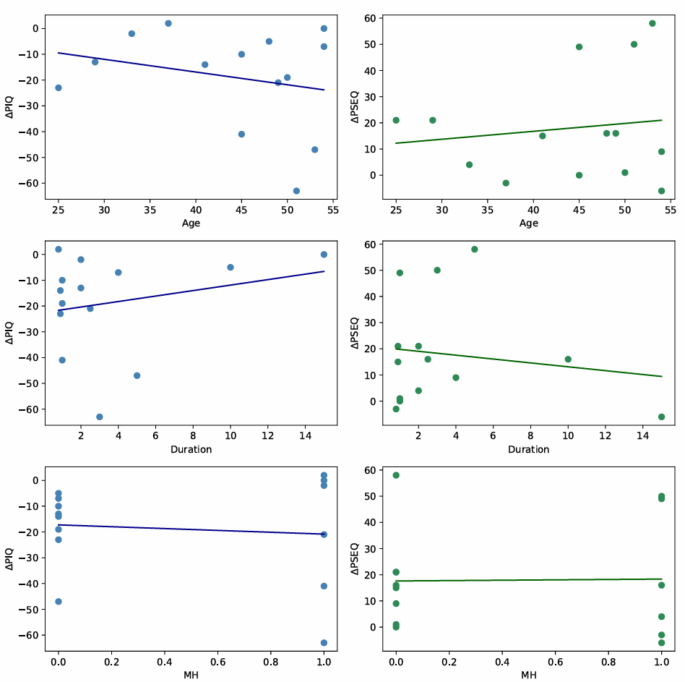

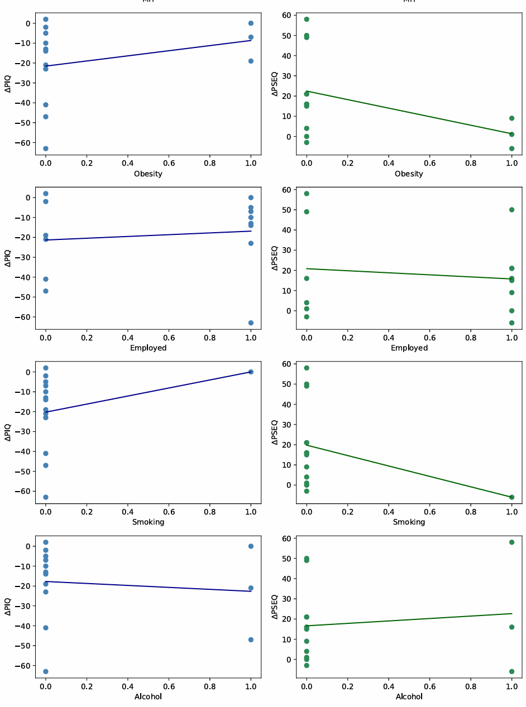

Shapiro–Wilk normality test results (Change Scores: Stage 2 → Stage 3)
APPENDIX H6

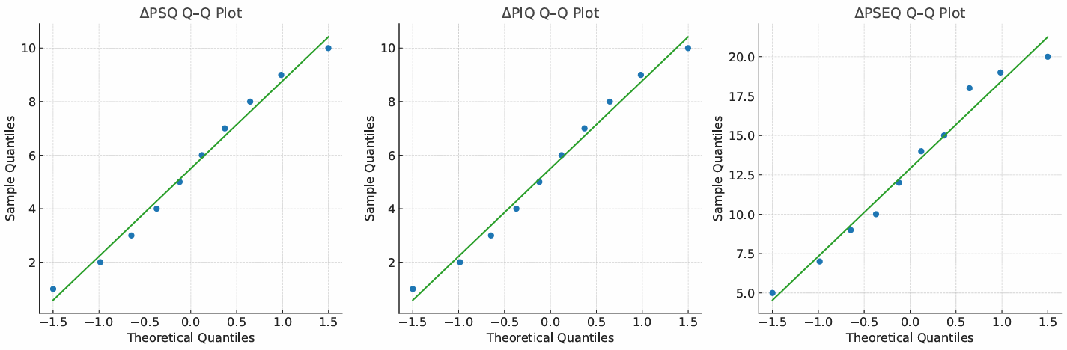
Blank

